BOARD REPORT
AGENDA ITEM: 11
REPORT NUMBER: SLAB-2024-23

Report to: | The Board
Meeting Date: | 20 May 2024
Report Title | Performance Report
Report Category | For Information
Issue status: | Business as usual
Written by: | Adam Ford and Linda Ross
Director responsible: | Adam Ford
Presented by: | Adam Ford
Contact details: | fordad@slab.org.uk

The purpose of this paper is to report on operational performance as at 31st March 2024.

Delivery of Strategic Objectives
Select the Strategic Objective(s) relevant to the issues.
- Our timely, clear and consistent decisions on legal aid applications and accounts deliver a positive customer experience.

Link to Board or Committee Remit
To monitor the performance of the operational departments.

Link to Risk Management
A range of risks that we face may result in our resource being diverted from the delivery of our corporate objective to deliver a high quality customer service. Our benchmarks are a direct way in which we can measure whether this is happening.

Publication of the Paper
The Board has previously agreed that this paper should be published as a matter of course. It will be published on our website in due course.

Executive Summary
Members should note that the figures reported are a three month average, that is they reflect the position January, February and March as a whole.

Applications:
The performance was good however a system issue is currently corrupting figures. The commentary explains the issue and a resolution is being sought from our digital services team.

Accounts:
Overall, the performance has remained broadly in line with expectations with good improvements made in civil legal aid and no areas of concern.
Previous Consideration
Meeting | Detail
Feb 2024 | Applications:  The performance was good and there are no concerns or issues to highlight.  Accounts:  Overall the performance has improved slightly with no areas of concern.

Report

Applications Performance
- Civil Applications
The overall performance in civil applications remains very good with all civil benchmarks recorded as Met or Better Than.

- Criminal Applications
In this period, some system issues negatively affected our performance levels against the benchmarks. The issue (now resolved) affected cases that had been continued for further information late last year. Cases progressed as normal where the requested information was received, but cases in which no response was received within the requested timescales remained under assessment instead of being automatically updated to show a status of ‘not considered’ (NC). Alongside grants and refusals, a status of NC is counted as a first decision for reporting purposes.

In practical terms, the updating of status to NC triggers a reminder to the solicitor to provide the necessary information. The system issue meant that this reminder was not issued. The solicitor was still able to provide the information at any time, at which point a decision would be taken (regardless of whether the case was marked as under assessment or NC). Other than the missed reminder, it is not clear that the issue will have resulted in any detriment to clients, and no issues or complaints were raised with us over our performance levels over the affected period.

From a reporting point of view, the system recorded fewer first decisions in November and December than it should have, with these decisions recorded instead much later than normal (mostly in January, by which point the issue had been resolved, but possibly also into February). This impacts all six criminal applications performance indicators for a four month period.

Because there are fewer NC decisions in December, the average duration was artificially low that month (NC decisions are typically much longer than the average). Fewer NC decisions also means that the grant rate increases as the total number of recorded decisions drops, and fewer concluded cases are recorded as having required Further Work. The opposite impacts can be observed in January’s data and, because performance is reported on the basis of a rolling three month average, this impacts on each period in which either December or January’s data features, that is December to March (the period reported in this paper).

Close review of the more detailed data suggests that underlying performance throughout the period has remained strong, although the solemn benchmarks continue to be challenging.

- Children’s Applications
Overall performance in children’s applications remains good with most benchmarks either Met or Better Than. The system issue referred to above has resulted in one benchmark showing as Worse Than in February and March. As with criminal applications, this has not resulted in any complaints about our performance levels.
- Surveys and Quality
The latest micro Customer Satisfaction survey was carried out in November 2023 and detail update can be found in February 2024 performance board report.
Quality checks across all application types remains high between 98% and 99%.

Accounts Performance
5. Civil Accounts
The overall performance of civil accounts remains very good with four of the five benchmarks reported as either ‘better than’ or ‘met’ and with civil legal aid improving to being reported as ‘better than’ the benchmark for the first time this year. Although negotiations are reported as ‘worse than’ the benchmark this is due to the performance in January having been impacted by a single firm having submitted a high number of negotiations for older cases.
6. Criminal Accounts
The overall performance in criminal accounts remains in line with expectations.
Currently we are reporting one ‘better than, five as ‘met’ and three as ‘worse than’ the benchmarks. Of the three that are reported as ‘worse than’ two of these have been impacted by solicitors taking lengthy periods to respond to us, in particular on cases where the pre-payment exceeds the value of the final account, and we are therefore unable to process the final account until we receive the solicitor’s credit and process it.
The other one reported as ‘worse than’ benchmark (solemn) is a consequence of the increase in the volumes of accounts due to the clearing of backlogs within the system, in particular at the courts.
In setting the benchmarks for this year it was always acknowledged that there would be an impact from the higher level of accounts due to the additional courts being utilised for solemn to support clearing the court backlogs. It was also anticipated that there would be an element of slowdown initially whilst both we and firms were on a learning curve with the fees reforms before we could reap any potential benefits from the improved fee structure.
7. Children’s Accounts
The overall performance of children’s accounts remains very good with all five benchmarks reported as ‘better than’ or ‘met’ benchmark.
8. Surveys and Quality
The latest micro–Customer Satisfaction survey was carried out in November 2023 and detail update can be found in February 2024 performance board report.

Long term sickness has negatively impacted on the independent quality checks. However, the team have implemented additional checking to ensure consistency of decisions as an interim measure.
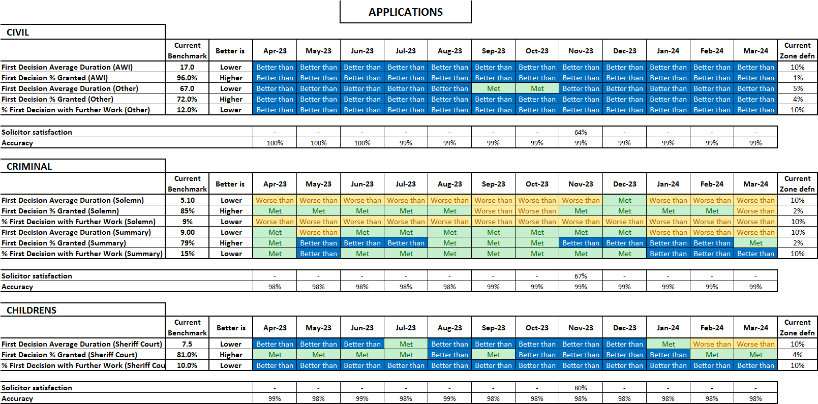

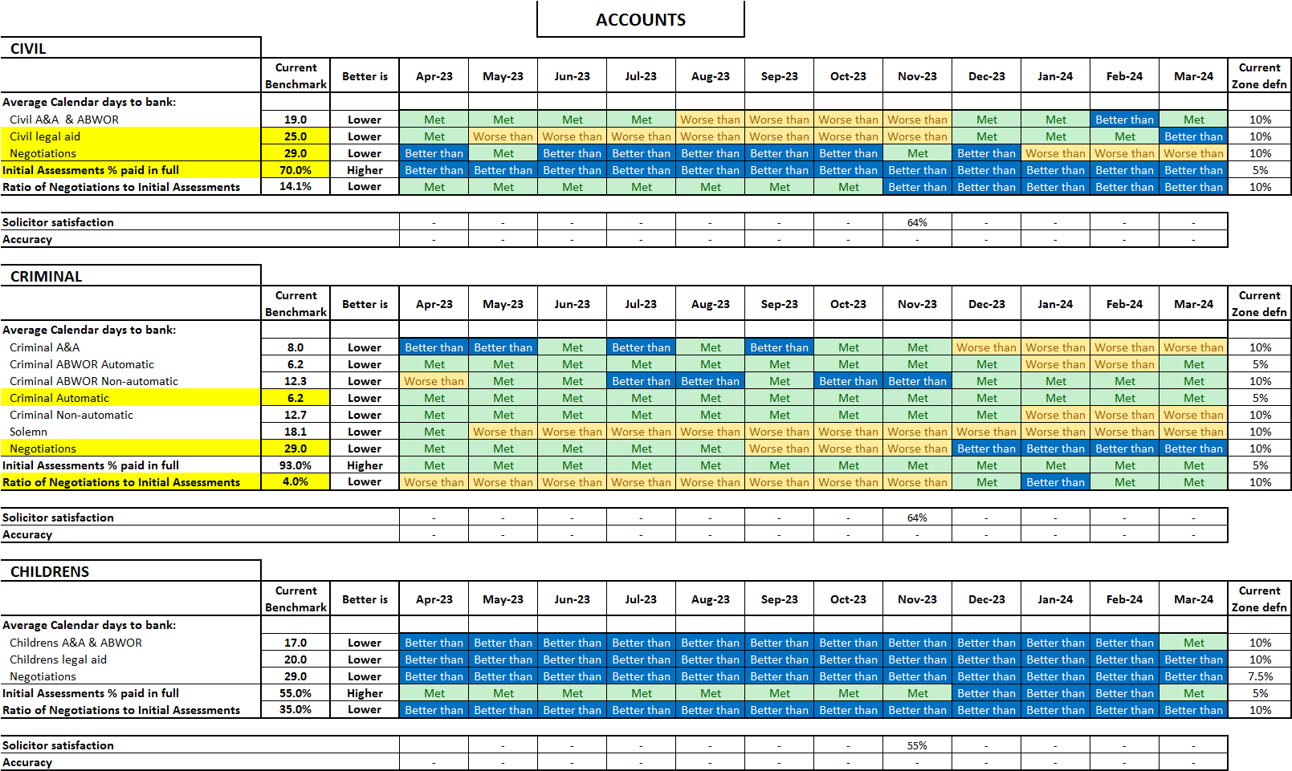

 | Governance Links
1 | Finance and Resources  Resources are key to the delivery of good performance. There are no additional resourcing issues to flag to the Board which have affected the performance reported.
2 | Risk  Applications:  This report gives assurance that we are managing the functional risks identified in relation to:  (i) failure to accurately assess applications and increases in accordance with SLAB's policies and procedures  (ii) failure to take operational decisions within agreed service standards.  Accounts:  This report gives assurance that we are managing the functional risks identified in relation to:  (i) failure to pay solicitors within a timeframe that is acceptable to the profession and enables management of the Legal Aid Fun  (ii) inconsistent approach to assessment of accounts.
3 | Legal and Compliance  No issues of note.
4 | Performance  No issues of note.
5 | Equalities Impact  An impact assessment is not required for this paper.
6 | Privacy Impact and Data Protection  No privacy or data protection issues identified.
7 | Communications and Engagement  This paper has been agreed for publication and we are also publishing separate information regarding our performance via our website.

Conclusion and next steps
Members are asked to note the report.

Appendices
Appendix 1: Guide to the SLAB Operational Performance Overview Report (SOPOR).

Appendix 1

STRUCTURE

In the SOPOR the Key Performance Indicators (KPIs) are grouped by operational area and type of measure.

The first three groups of KPIs are on Applications areas: Civil; Criminal and Children’s, and the bottom three on Accounts areas.

The way we report on KPIs is by tracking them against benchmarks.

In Civil we report Adults with Incapacity cases separately. These are high in volume, and we take decisions on these in a much shorter timescale because the statutory tests are more straightforward. These are separated out to avoid a disproportionate impact on performance statistics.

In Criminal we report on summary and solemn cases separately.

Benchmarks are proposed to try to balance the aim of being challenging but achievable but also the need to manage the risks and uncertainty around the coming year. They are based on performance during the previous year and on the expected operating environment of the year coming.

A rolling 3-month average (a mean) is the basis for calculating and reporting performance. This is compared against a static benchmark with performance (the KPIs) reported in terms of three zones:

- Met (the benchmark)
- Worse than (the benchmark)
- Better than (the benchmark)

A green-yellow-blue colour highlighting scheme is used. Green indicates a benchmark is being met. Yellow highlights the ‘Worse than’ zone and blue highlights the ‘Better than’ zone.

The Met zone is defined initially as the benchmark plus or minus a percentage figure (typically between 1 & 12.5%). The ‘Better than’ and ‘Worse than’ zones are above or below the Met zone – depending on the type of measure. For example with the First Decision % Granted measure, in general, higher figures are better. So the ‘Better than’ zone is above the Met zone, that is above 101% of the benchmark for Civil AWI. But we aren’t necessarily aiming to be as high as possible – we may find issues with accuracy and quality if we get too high or we may need to expend a disproportionate amount of effort to achieve the KPI benchmark.
With the Duration and Further Work ratio measures the ‘Better than’ zones are below the benchmark (less than 95% or 90% of the benchmark depending on the specific KPI zone).

All measures are calculated for the most recent three-month period and the 11 previous results are also shown so that trends over one year can be seen.

DESCRIPTION OF MEASURES IN THE SOPOR

Duration
The key duration shown for applications is the average time, in calendar days, from receipt of a main legal aid application by SLAB, to when we take the first official decision on it. This duration includes all weekends and holidays. It also includes any period where we are asking the solicitor, or applicant, for more information to help us take the decision.

This indicator measures both the workflow performance of SLAB but also the degree to which solicitors and applicants are managing to provide all necessary information.
Simply put lower is better.

In accounts the first instance duration is a very similar measure – it is from registration of the account to the date payment is received into the solicitor’s bank account. It is in calendar days and again includes any period where we are asking the solicitor for more information to help us assess the account.

The negotiation duration is the same measure but for accounts that are follow-up accounts to negotiate sums that we have abated from initial accounts.

Grant/paid in full rate
The first official decision on a legal aid application can be one of three main types: grant; refuse; or not consider due to lack of information. The percent granted measure is the number of grants divided by (indexed) by the total number of first decisions in the period and expressed as a percentage.

This indicator measures the effectiveness with which SLAB and the profession are facilitating solicitors to make appropriate and complete applications.
Simply put higher is better.

In accounts the equivalent measure is the percent of accounts that we can pay all that solicitors are claiming (without abating them).

‘Abatement’ describes the process by which the amount paid by SLAB includes one or more deductions from the amount claimed by a solicitor. This can occur for many different reasons. Subsequent negotiations with firms can result in part or all the sum abated being reinstated, often because we are provided with further information that allows us to be satisfied that a claim is valid or reasonable. This can be additional information (such as vouching) to support a claim, or an explanation to justify a particular activity which had appeared to us on the face of it to be unnecessary, unreasonable or uneconomical.
SLAB needs to protect the Legal Aid Fund from unjustified expenditure; however this needs to be undertaken in a manner that is seen to be fair, transparent and done in a consistent and efficient manner.

Ultimately, we will be using the information on what we finally pay against, the original lodged amount and the initial payment to understand how we can ensure more could be paid at the first instance.

Ratio of Further Work (Negotiation) to First Decision (First Instance)
In applications this indicator is the number of cases requiring further work divided by the total number of first decisions in the period and expressed as a percentage. In accounts it is the number of negotiation accounts paid compared with the number of first instance accounts.

This indicator measures a few different key elements of the process:

- the effectiveness with which SLAB is getting correct applications/accounts in the first instance
- that SLAB is making correct decisions
- the effectiveness with which SLAB is communicating those decisions.

Poor performance in any of those areas could result in an increase in this ratio. Simply put lower is better.

Accuracy
This is measured through sampling of cases in both the applications and accounts areas. Cases are scored with a range of 1 to 4:
1 = Fundamental error – an error caused an incorrect decision to be taken
2 = Non=fundamental error – an error found but this did not result in an incorrect decision
3 = Issue – a correct decision was taken but some of the justification was incaccurate
4 = correct decision with the correct justification

The percentage figure reported is the percent of measurements that are scored 4, that is, correct.

The precise percentage is determined visually to best capture the variation and scale of the specific KPI. A 10% range around 90% can capture more of the KPI datapoints than a 10% range around five days – depending on the KPI. This adjustment is because of the differences in application and account types and processes which produce different distributions for the different measures – some are more variable than others. This is especially so in relation to the size of the measure value.

