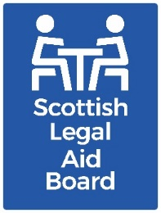 Meeting of Board
Board Room, Thistle House, Edinburgh
Monday 30 September 2024, 10.30am
Please Bring Laptops/iPads

Standing items
- Welcome and apologies
- Declaration of interests
- Minutes for approval
Draft minute of the Board meeting held on 29 July 2024.
Review and noting of minutes
Audit Committee meeting on 26 August 2024
Legal Assistance Policy Committee meeting on 12 August 2024.
Legal Services Cases Committee meeting held on 29 July 2024.

- Outstanding actions
- Chair’s update Oral
- Chief Executive’s update SLAB/2024/38

Finance
- Finance Report – Legal Aid Fund SLAB/2024/39
- Finance Report - SLAB Administration SLAB/2024/40

Operations
- GALA Update SLAB/2024/41
- Criminal Quality Assurance Committee Annual Update Cover Paper SLAB/2024/42
- Criminal Quality Assurance Committee Annual Report SLAB/2024/42a
- Performance Report SLAB/2024/43
- Trends Report SLAB/2024/44

Governance and risk
- Audit Committee Annual Report to the Board SLAB/2024/45

For information
- Meetings with outside bodies SLAB/2024/46
- Agenda Programme SLAB/2024/47

Conclusion
- Dates of next meetings
- Audit Committee: Monday 4 November 2024
- Board: Tuesday 3 December 2024
- Legal Assistance Policy Committee: Monday 25 November 2024
- Legal Services Cases Committee: Monday 28 October 2024, Monday 25 November 2024.

