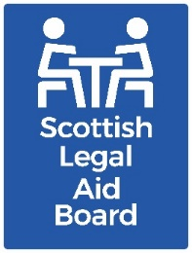 Board report
AGENDA ITEM: 11
REPORT NUMBER: SLAB / 2024 /43
Report details
Report to: The Board
Meeting date: 30 September 2024
Report title: Performance Report
Report category: For information
Issue status: Business as usual
Written by: Adam Ford and Linda Ross
Director responsible: Adam Ford
Presented by: Adam Ford
Contact details: fordad@slab.org.uk
Delivery of Strategic Objectives
1 – Administration: Our timely, clear, and consistent decisions on legal aid applications and accounts deliver a positive customer experience.
Link to Board or Committee remit:
To monitor the performance of the operational departments.
Link to Risk Management:
A range of risks that we face may result in our resource being diverted from the delivery of our corporate objective to deliver a high quality customer service. Our performance benchmarks are a direct way in which we can measure whether this is happening.
Publication of the paper:
The Board has previously agreed that this paper should be published as a matter of course. It will be published on our website in due course.
Executive Summary:
Members should note that the figures reported are a three month average, that is they reflect the position May, June and July as a whole.
Applications: Overall, performance is very good with 13 benchmarks met or better than and one worse than.
Accounts: Overall, the performance is good with 16 benchmarks met or better than and three worse than.
Previous Consideration
Meeting: July 2024
Details: Applications: Overall performance is very good with all benchmarks met or better than.
Accounts: Overall performance has remained broadly in line with expectations with good improvements made in civil legal aid and no areas of concern.

Report

Application Performance

Civil Applications
The overall performance in civil applications remains very good with all civil benchmarks recorded as met or better than. Following the discussion at the last Board meeting on the extent to which the civil teams’ performance consistently exceeds the benchmark, further analysis is being undertaken of the flow of different types of cases to identify whether the trend is likely to continue and, if so, what if any opportunities there may be to temporarily reallocate resources into project or other non-decision-making activity. As matters stand, performance levels are informing our approach to vacancy management in these teams.

Criminal Applications
Performance has remained consistent in criminal applications with all benchmarks met.

Children’s Applications
Overall performance in children’s applications remains good with two benchmarks better than and one worse than. Percentage First Decision with Further Work (Sheriff Court) missed the met benchmark by 1% but there are no areas of concern.

Surveys and Quality
The latest micro customer satisfaction survey was carried out in November 2023 and a detail updated can be found in February 2024 Board performance report. Quality checks across all application types remain high between 98-99%.

Accounts Performance

Civil Accounts
The overall performance of civil accounts remains very good with four of the five benchmarks reported as either ‘better than’ or ‘met’.

Civil A&A and ABWOR continue to be reporting as ‘worse than’. This in the main relates to a large volume firm where they are slow in responding to our questions regarding their claims for fees and outlays, high volumes of claims for outlays in immigration and asylum cases and the impact of annual leave

Criminal Accounts
The overall performance in criminal accounts remains in line with expectations.
Currently we are reporting two ‘better than’, five as ‘met’ and two as ‘worse than’ the benchmarks, with Criminal A&A having improved from ‘worse than’ when last reported to now being ‘met’.
The criminal teams are dealing with the increase in the volumes of accounts due to the clearing of backlogs within the justice system with reduced staffing levels. A review of the resourcing alongside cross-training is anticipated to be able to support better performance overall for accounts, but this will take time.

Children’s Accounts
The overall performance of children’s accounts remains very good with all five benchmarks reported as ‘better than’ or ‘met’ benchmark.
It should be noted that when setting the benchmarks for this year for children’s legal aid and children’s A&A/ABWOR durations, this was against a background of planning to move certain types of accounts from the civil to children’s team. This has partially been done and there is still more to move, so the full impact remains yet to be seen.

Surveys and Quality
No survey or independent quality checks have taken place in the period reported on. However, the team have implemented additional checking in the team to ensure consistency of decisions as an interim measure.

Applicactions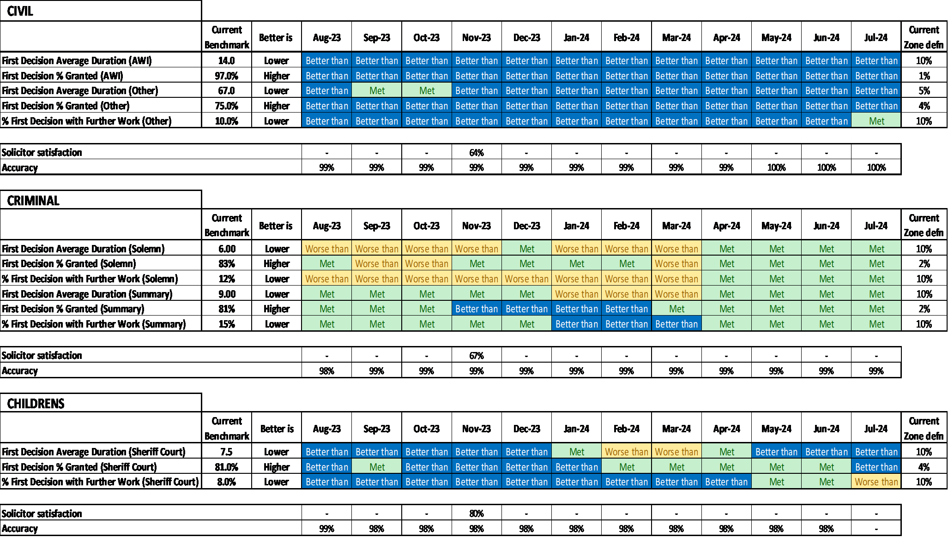
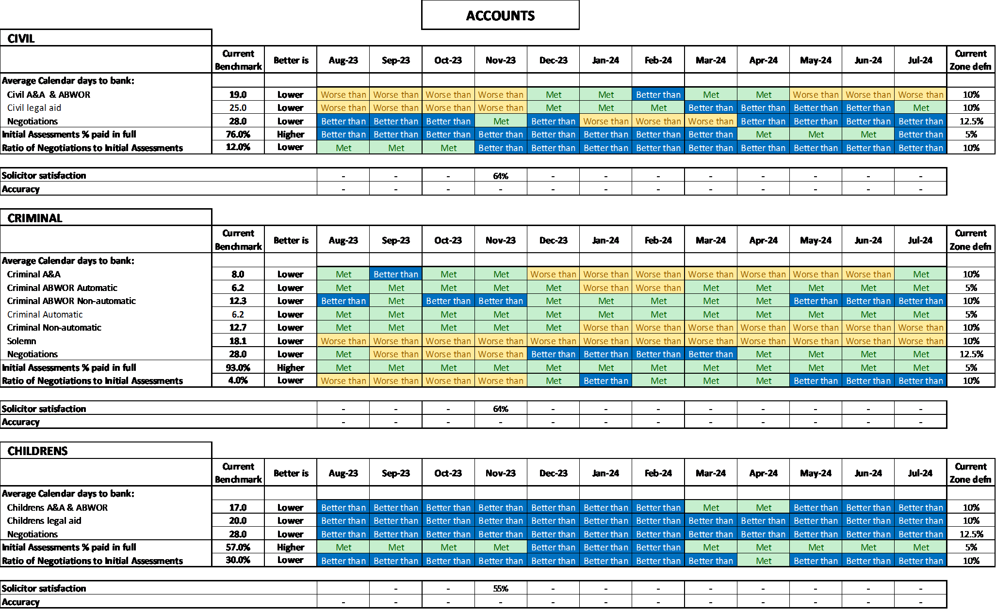
Governance links
- Finance and resources
Resources are key to the delivery of good performance. There are no additional resourcing issues to flag to the Board which have affected the performance reported.
- Risk
This report gives assurance that we are managing the functional risks identified in relation to:
- failure to accurately assess applications and increases in accordance with SLAB's policies and procedures
- failure to take operational decisions within agreed service standards
- failure to pay solicitors within a timeframe that is acceptable to the profession and enables management of the Legal Aid Fund
- inconsistent approach to assessment of accounts.
- Legal and compliance
No issues of note.
- Performance
No issues of note.
- Equalities impact
An impact assessment is not required for this paper.
- Privacy impact and data protection
No privacy or data protection issues identified.
- Communications and engagement
This paper has been agreed for publication and we are also publishing separate information regarding our performance on our website.

Conclusion and next steps
Members are asked to note the performance recorded in this report.

Appendix and/or further reading links
Guide to the SLAB Operational Performance Overview Report (SOPOR).

