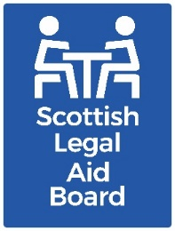 Children’s solicitors’ research: Cases under the ‘Age of Criminal Responsibility (Scotland) Act 2019’

Key findings
Most survey respondents said they were “unlikely” to work on a case related to the Age of Criminal Responsibility (Scotland) Act 2019 (ACRA) in the next year. The most common reason for this was that it was more suitable for criminal practitioners. The interviews suggested that this perception may change, for some, as solicitors become more familiar with ACRA.

Background
ACRA fully commenced on 17 December 2021. It means that children under 12 cannot be charged or arrested, and police cannot use criminal justice legislation for them. Children’s legal assistance is available in relation to Part 4 of the Act (Police investigations). This covers activities such as legal assistance for sheriff court applications, special urgency legal aid, ABWOR and Advice & Assistance. This could mean additional work for solicitors registered for Children’s legal aid.
Part 4 provisions have not been widely used. If they were used this could create challenges for solicitors. Challenges might include an increase in the overall number of clients needing Children’s legal aid, initial unfamiliarity with the new subject matter, or providing a service to older child clients.

Aims and method
The overall research aim for this work was to “understand the current and future supply of children’s legal assistance services, with reference to practitioner motivations and support needs, as well as the impact of the Age of Criminal Responsibility (Scotland) Act 2019”.
The research was undertaken with solicitors who had recent experience of providing Children’s legal aid via:
- a telephone survey.
- semi-structured telephone interviews with 16 private practice solicitors.
- a joint interview with Civil Legal Assistance Office (CLAO) practitioners.

Survey findings
The survey suggested most solicitors had some knowledge of ACRA Part 4 provisions but only one in five thought it was likely that they would advise or act in relation to ACRA proceedings in the next year.
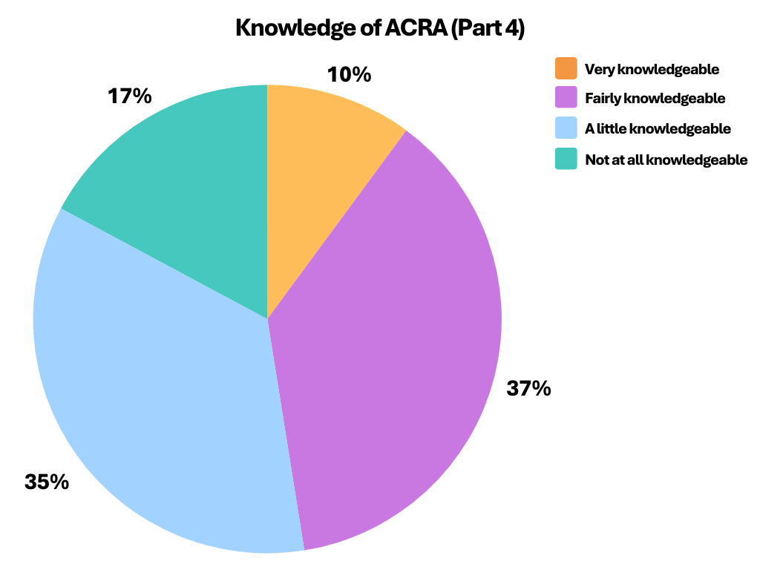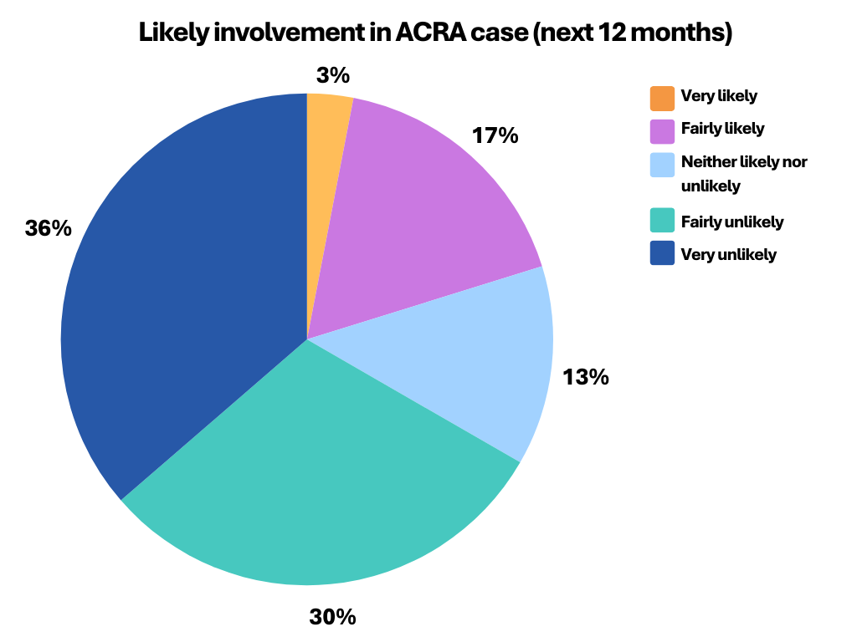
We asked why survey respondents did not expect to do work in relation to the ACRA. In response to this question the most common theme was simply that “the work is not for me”.
Unpacking this further, people often felt that it is generally suited to criminal solicitors, not children’s. Others specified that they did not feel knowledgeable about the criminal law aspects of the work or thought that the work is “specialist” in some way (for example “uncommon”, “for CHIRPs”, or something they “do not do”). Only two people said that did not feel knowledgeable about this client group.
The interviews with solicitors expanded on the findings of the survey.
They broadly reflected the survey, whilst suggesting that Children’s solicitors may be more inclined to do this work once they know more about what it entails. All interviewees were aware of the ACRA. However, the majority had not spent time considering how they would approach ACRA cases, if needed. There was a feeling that this work might be covered by those who are also criminal practitioners.
Others felt that it would be something that Children’s practitioners could undertake. Sometimes this was arrived at after reflection as they considered the issue as part of the interview process.
Interviewees also spontaneously mentioned the need for training to support involvement in ACRA.

Further information
If you would like further information about this research, please contact the Research team at research@slab.org.uk.

