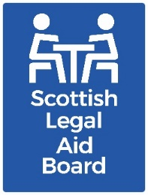 Children’s solicitors’ research: Virtual Hearings

Key findings
Solicitors had mixed views on virtual/hybrid hearings. They mentioned seeing significant benefits as well as significant drawbacks. Whilst virtual hearings could be useful, there were also situations where it was better for participants to attend in person. Other pieces of research on this topic suggest that others in the system, including both professionals and non-professionals, also feel this way.
At interview, solicitors spoke most about the impact of virtual/hybrid Hearings on their clients. They identified more positives for child clients than adult clients. Children and young people were seen as more likely to attend virtual/hybrid Hearings, compared with in-person hearings.
Some issues, such as communication with clients during the Hearing, affected solicitors as well as the client. Solicitors identified poor communication as the main drawback for themselves, and found communicating with clients was less effective in virtual settings.
Virtual Hearings during the pandemic allowed some firms to extend their geographical coverage. However, this was usually not sustainable as hearings returned to in-person.

Background
In-person Children’s Hearings were suspended in March 2020, due to Covid-19 pandemic restrictions. Video conferenced “virtual hearings” were introduced to allow hearings (and other court proceedings) to continue. The technical and administrative norms for these were developed and improved over time.
Children’s Panel Hearings have now returned to in-person by default. If individuals request to attend virtually the Scottish Children’s Reporter Administration (SCRA) will consider whether they have a good reason for virtual attendance, or if this will allow them to participate more effectively.
If SCRA agree that virtual attendance is appropriate they will arrange this, if possible.
Virtual approaches to delivering justice were widely introduced, and scrutinised, during the 2020 pandemic. The Centre for Excellence for Children’s Care and Protection (CELCIS) and the Centre for Youth & Criminal Justice (CYCJ) published findings from a rapid consultation on virtual hearings in August 2020. This included feedback from 20 solicitors and some of the issues raised were reflected in SLAB’s research, for example there are now more opportunities for solicitors and clients to speak privately during the hearing (although this is still not as good as in-person communication when clients are upset).
This is addressed in two pieces of SCRA research (a report on digital poverty and contribution to a book exploring how virtual hearings are viewed by children), conducted with young people and their caregivers, which address the challenges of digital access. The virtual hearings research also identifies both positives and negatives experienced at virtual hearings.

Aims and method
The overall research aim for this work was to “understand the current and future supply of children’s legal assistance services, with reference to practitioner motivations and support needs, as well as the impact of the Age of Criminal Responsibility Act”.
In relation to “communication and promotion methods” the research objectives were to explore the types of communication and promotion methods that firms use, and how often specific methods are used.
In relation to the use of virtual hearings, our objectives were to explore the extent of experience that solicitors had attending virtually, as well as their views on advantages and disadvantages, and their expectations of using them in the future.
The research was undertaken with solicitors who had recent experience of providing Children’s legal aid via:
- a telephone survey.
- semi-structured telephone interviews with 16 private practice solicitors.
- a joint interview with Civil Legal Assistance Office (CLAO) practitioners.

Survey findings
The solicitors interviewed for this research all had experience of both in-person and virtual hearings. They identified “communication” as the main drawback to virtual hearings. This included communication with other professionals and with their clients.
However, solicitors also highlighted the positive aspects of virtual hearings. For them the key positive was being able to work more effectively, which includes saving on travel time and may allow them to take on more work overall. Another advantage is that this sometimes means solicitors can “appear virtually for people when they might not have been able to otherwise”, as noted by a solicitor in Glasgow & Strathkelvin.
Almost all the survey respondents (98%) had attended a virtual hearing, or hybrid Hearing where they attended remotely, in the previous 12 months (around November 2021 to October 2022).
In response to the question “How satisfied or dissatisfied are you with the experience of attending virtually?”, half were satisfied with the experience of attending virtually, with just over one-third dissatisfied.
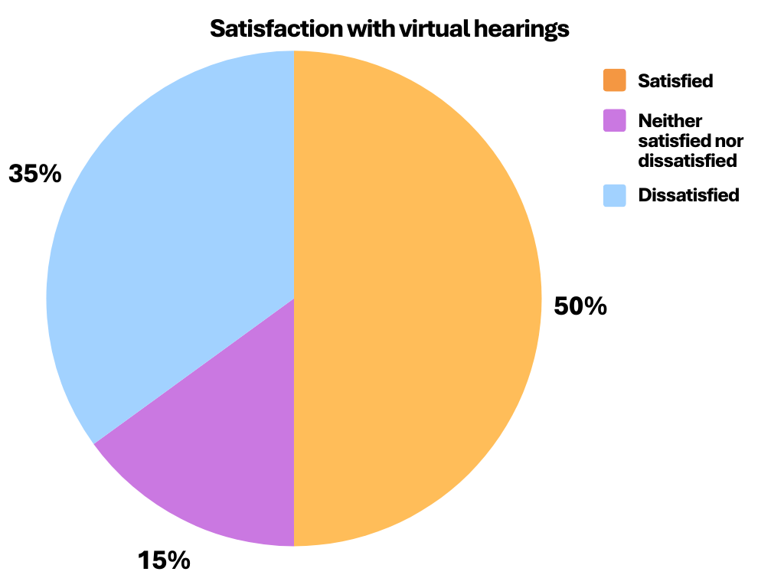

Virtual with clients
The interview questions explored quality and ease of communication between solicitors and their clients. Most interviewees expanded this to include their impression of the client’s experience generally.
Generally, interviewees felt that virtual hearings have benefits in some circumstances, and often said they should be retained as an option where needed. A number noted that virtual hearings increased participation from children and young people.
However, there are also drawbacks compared with in-person hearings. The interviews suggest that solicitors feel that virtual hearings have more benefits for child clients than for adult child clients.
The interviews highlighted that there are various strands to communication. For instance, clients need to be able to access a virtual setting in a way that allows meaningful interactions; and the quality of communication in a virtual setting needs to be equivalent to that in-person.
Accessing virtual hearings was a problem for some clients (adults and children). This was most commonly due to lacking the physical resources needed to connect, such as internet access and sufficient data or a phone with a camera adequate to view a meeting. Lack of technical knowledge or skills was also mentioned.
Unsurprisingly, access problems were noted as being more acute during the pandemic. However, even when everyone was able to connect, the quality of interaction was often seen as worse than in an in-person hearing. This was sometimes due to issues with the new technology, which does not always work well. However, poor quality interaction was more frequently attributed to not having in-person dynamics. This was most noticeable with clients, and adult clients were mentioned more frequently than children or young people in relation to negatives of virtual hearings.
“Quite often clients will only recently have received the papers, there might be reports that they might struggle to be able to access and understand. … at a virtual Hearing you don’t have that same opportunity to have that discussion with them in that face-to-face space in advance of the Hearing” (Partner, South Strathclyde, Dumfries & Galloway).
Poor quality interactions were often felt to be worse when the hearing was contentious. The Hearings system allows clients to leave a room, or virtual space, to speak to their solicitor. Interviewees noted that this does happen regularly in virtual hearings. Interviewees felt that a virtual space did not provide the same experience when a client was stressed or upset.
“I had a client in tears this morning. [In person] there’s an opportunity to go out with them into another room and further advise them or speak to them, whereas when it’s online there’s just not the opportunity to do that. Sometimes you can ask for the Hearing to be paused while you turn off your camera and perhaps phone them, but it’s not quite the same” (Partner, South Strathclyde, Dumfries & Galloway).
Being virtual can also add an extra barrier when hearings are already difficult. Hearings with a large number of people involved are an example.
“Recently I was acting for a grandparent where they had residential contact with the child. So that was three family members, three solicitors, two support workers, two social workers because there was a handover. And that was a difficult Hearing to conduct, to ensure that everyone was being heard. When there’s a number of participants it can be problematic… that can be controlled more in a face-to-face environment” (Partner, Glasgow & Strathkelvin).
Although it is not always possible, joining a virtual hearing from the same location as a client was felt to make a big difference, helping clients to feel more relaxed and confident.
Solicitors also highlighted that, where the hearing is dealing with “emotive subjects” this may put clients not “sitting in the same room” at a disadvantage. One person noted their colleague’s experience of attending in-person in a case where they had previously only attended virtually.
“We’ve got a lot of cases up North now, but… there was one where we’d always appeared in Aberdeen online and then we went to it recently because we were arguing to try and keep contact. And the solicitor came back and said, ‘we have to go to all of those in person, because the influence that we had on the panel was much greater than when it was online’” (Partner, North Strathclyde).
However, the research also identified some advantages for clients in attending virtually. In a very few cases it is important for personal safety. There are also considerations which may be related to protected characteristics, or to personal circumstances.
“[A] client has [pre-school kids in their care]… so, there’s nowhere really for them to go for panels. So, it’s quite helpful to them if [they can stay in the] house to do it, rather than having to traipse them halfway across Edinburgh to a children’s panel” (Solicitor, Lothian & Borders).
Where the topic is not contentious, sometimes virtual hearings can feel less stressful.
“Sometimes you’re in rooms with these massive panel Hearings and they’ve gone on a long time and it’s all very stuffy, and it’s … I don’t know – I think the distance kind of helps a bit. People are relaxed, the parents are more relaxed”. (Partner, Grampian, Highland & Islands)
Solicitors noted that children and young people often preferred attending their hearing virtually. Some felt that this also allowed them to engage more effectively in their hearing.
“The children seem to be a lot more comfortable to attend, and to be involved, because they’re doing it through virtual means rather than actually having to be in the room” (Partner, South Strathclyde, Dumfries & Galloway).
Some solicitors had discussed the reasons for this with the child or young person, whilst others had made conclusions through observing the differences between in-person and virtual/hybrid hearings. Having a generally better experience was seen by solicitors as a key reason why children and young people seemed to prefer virtual hearings. For example, they can be less acrimonious, since there is “less opportunity for people to get into big arguments”. Another reason given was convenience, including not having to attend for the whole time.
Young people (rather than children) were seen as most likely to prefer remote attendance.
“I actually have a lot of teenagers [as clients] … and very rarely will you get them to the panel. You’d have to drag them kicking and screaming, whereas now they can take part remotely… You might not get them sitting there for the full time, but you’ll maybe get – they’ll come in and give their views for example, or say that they agree with something, or don’t agree with it” (Solicitor, Glasgow & Strathkelvin).
Some interviewees felt that the number of children and young people who attended their hearing had risen due to virtual hearings. However not all had this experience, with others saying they had not seen children as much at recent hearings. One put this down to children not attending, or not being so visible, during the pandemic, and not returning.

Virtual with other professionals
Interviewees had less to say about communication with other professionals than they did about communication with clients. Some thought there was no, or very little, difference between virtual, hybrid and in-person hearings when it comes to communication with professionals or panel members. One interviewee suggested that the different protocols required to participate in virtual meetings might have been something solicitors were well placed to adjust to, due to their experience of court protocols.
However, others felt that the virtual setting was generally worse than in-person, including for professionals attending. They identified specific issues, such as: everyone talking over each other or not being able to see everyone, or concern that the subject matter was sometimes not appropriate to be dealt with in an online setting. Others felt that virtual attendance itself is not as high quality as in-person: “it’s not the same as having a discussion in a room”.
Participants also reflected on the missed opportunities for less formal communication before or after a hearing. They described how these were useful to get in touch with a range of other professionals, in particular social workers, who may work in the community but were seen as “difficult to get hold of”. They noted the convenience, for all professionals, of being able to have “a quick few minutes” for a short discussion.
In some instances, this type of communication is convenient to have. At other times it may be more fundamental to the quality of the hearing. One interviewee gave an example:
“It’s not as easy to have a quick chat with the reporter, to maybe let the reporter know, for example, ‘my client’s got [a condition]… you can’t do that on the online calls, because you are then saying it in front of other people that your client doesn’t want you to say it in front of” (Partner, Lothian & Borders).
Many interviewees commented on the importance of having relevant professionals who could successfully manage virtual hearings. It was felt that this makes a significant difference in the quality of any type of hearing. Most of the comments on this reflected positively on those managing or supporting hearings. For example, the Chair ensuring that everyone was included, or asking clients if they wanted to have a break to speak to their solicitor, or the reporter helping everyone to have their say. However, there were also examples where the hearing was not seen as well managed.
Some respondents felt that online hearings were quicker, although there were mixed views on whether this was a positive or a negative. One person also mentioned that the use of written submissions during Covid-19 conditions had been useful, since they made it easier to pin down what the issues were.

Ongoing role of virtual hearings
During the pandemic many interviewees were able to take on work in areas they would not usually have served.
“I ended up with cases all over the place – Dumbarton, Stirling. There was a feeling that we could take on any case from anywhere if we did it virtually” (Partner, South Strathclyde, Dumfries & Galloway).
Not all firms had extended their practice. This was most commonly because they did not have capacity to take on any extra work. Interviewees described a general return to in-person, sometimes with a hybrid element. Solicitors who still attended virtually often did due to travel related time constraints, or to take on a client who would not have been able to get a solicitor otherwise.
Those who had extended their practice did not feel that this was sustainable without virtual access. One described working with SCRA to ensure that they could give a client continuity: “I’m only able to help that client because SCRA have been so good at allowing me to attend virtually”. Sometimes they specified that they would not have been involved if a hybrid approach was not possible.
“If it was a Children’s Hearing and it was virtual then you would do it, but on the basis that it’s a virtual Hearing, with the caveat to the client that ‘if this ever goes to in-person I’ll not be there’” (Partner, Tayside, Central & Fife).
As noted earlier, virtual hearings are also seen as helpful in allowing children and young people to attend their hearings.
“I don’t love [virtual Hearings], but I’m really struck by the impact they have on children, and things that children have said to me about how much happier they are with them. So I think their point of view is the most important thing to me” (Partner, South Strathclyde, Dumfries & Galloway).
Many respondents felt that retaining a range of attendance options would be useful. Interviewees often considered the needs of clients, as well as their own preference, when discussing this. Reasons for this included:
- the importance of in-person attendance at ‘high stakes’ hearings, such as ‘when there is consideration of taking a child away from their parents’
- virtual attendance to allow solicitors to attend where they would not be able to otherwise
- virtual attendance for children and young people who prefer not to attend in person.
Some people agreed that in-person attendance was usually important in disputed, or urgent, situations, but felt there should be consideration of hybrid where these are very contentious. There was also a view that a return to all in-person Hearings was needed. Those who thought this generally expressed stronger views than those who preferred other options, or all options.
“I’m just not sure that you’re able to deliver the same service as you would if you were able to bring those clients in to see you and to be personally with you in that Hearing” (Partner, South Strathclyde, Dumfries & Galloway).

Further information
If you would like further information about this research, please contact the Research team at research@slab.org.uk.

Children’s Hearings (Scotland) Act 2011 (Rules of Procedure in Children’s Hearings) Amendment Rules 2021, Part 5 (20B).
Robert Porter et al, “Experiences of virtual Children’s Hearings: A rapid consultation” (2020) - last accessed 24/01/2025.
Jennie Laurenson, “Digital Poverty and Exclusion in Scotland: Digital Lives of Care Experienced Children” (2024) - last accessed 24/01/2025.
A summary of the findings is provided on SCRA’s website (last accessed 24/01/2025).
Depending on when they responded to the survey.
Assessed by ‘spent larger proportion of time on the topic’, ‘gave a wider range of reasons’, ‘used more frequent use of definite language, such as ‘must’, ‘have to’.

