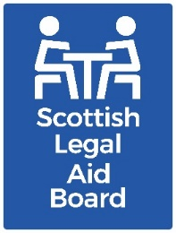 Children’s solicitors’ research: Activities and challenges

Key findings
Around half of the partners surveyed thought the number of firms in their area was “about right”. Most partners thought their firm would still be undertaking children’s legal assistance work in three years’ time. Some individuals also confirmed that they are personally committed to continuing to undertake Children’s legal assistance.
However, people also raised concerns about supply levels, and 46% of partners feel there are “too few” firms in their area. The causes of concern around supply levels includes:
- attracting or retaining new legal aid solicitors
- pay (including in relation to the increased complexity of the work)
- the stressful nature of the work.
Some respondents described having reduced the amount of Children’s work their firm undertakes.

Aims and method
The overall research aim for this work project was to “understand the current and future supply of children’s legal aid services, with reference to practitioner motivations and support needs, as well as the impact of the Age of Criminal Responsibility Act”.
We also asked participants to tell us about the issues that they felt were particularly important to them.
The research was undertaken with solicitors who had recent experience of providing Children’s legal aid via:
- a telephone survey.
- semi-structured telephone interviews with 16 private practice solicitors.
- a joint interview with Civil Legal Assistance Office (CLAO) practitioners.

Survey findings
The responses in this section are mostly from firm partners who took part in the survey. Most of these had been undertaking children’s legal assistance work for over ten years (77%).
Only 4% had been undertaking it for three years or less.
SLAB’s Children’s legal assistance register has comparable data for all solicitors (including partners) who were on the register in November 2023. 59% of those on the register (368 people) joined when registration was first introduced in 2013-14, around ten years ago. 20% (126 people) first registered between April 2021 to November 2023 (a period of slightly less than three years). SLAB monitors registrations, and activity, for all types of legal aid.
The survey found that only a few firms (8%) have a solicitor working full time on Children’s legal assistance. Legal aid (of any type, not just Children’s) is most likely to comprise “75% to 100%” of the firm’s cases (32% said this, although responses were relatively evenly split).
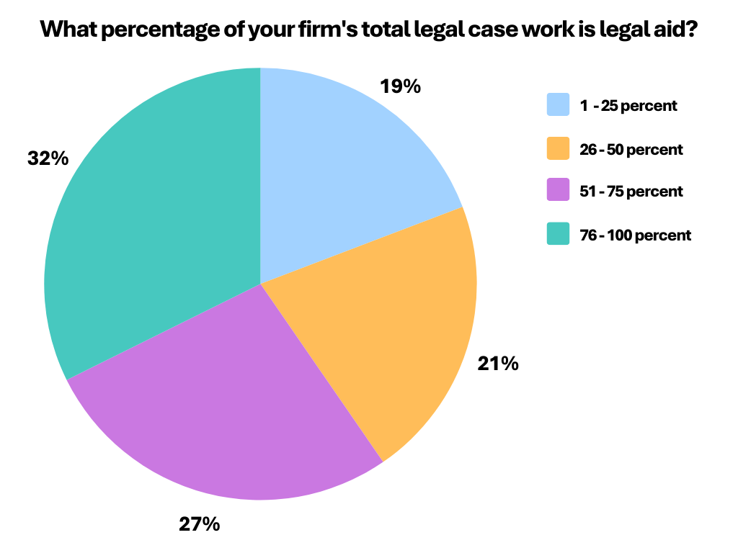
Most partners (76%) thought it was likely that their firm would still be doing children’s legal assistance work in three years’ time. 5% were unsure, with the remaining 19% thinking that their firm would not be undertaking children’s work.
Dissatisfaction with pay rates was the most common reason for no longer expecting to undertake Children’s legal assistance. One respondent said they had already stopped providing it.
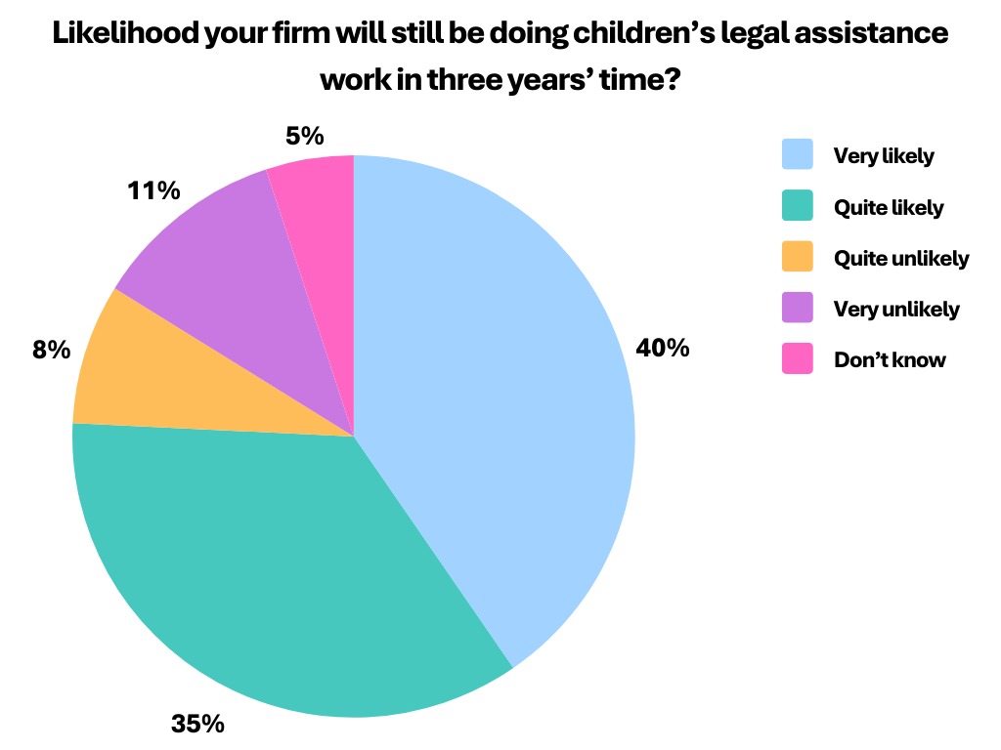
Of the three partners responding from Grampian, Highland & Islands, one felt it was unlikely that they would be providing Children’s legal assistance in three years’ time.
We also asked partners how likely their firm is to be providing any type of legal aid in three years’ time.
Overall, 81% expect their firm will continue providing legal aid for at least three years. 10% think they will not be, with a further 10% unsure.

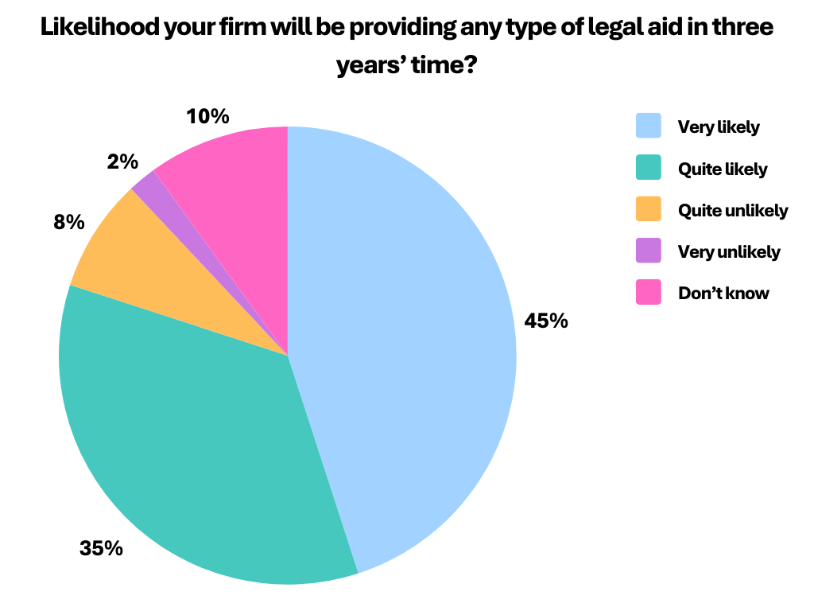
Most people (80%) thought their firm would still be providing legal aid in three years’ time.
10% said this was unlikely, and 10% were unsure.

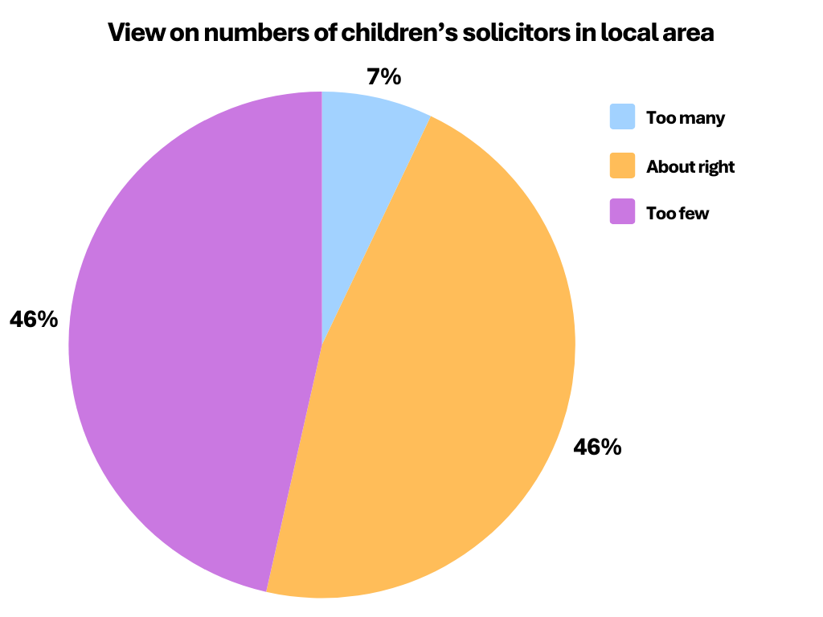
Almost half (46%) of those who gave an opinion thought that there are “too few” Children’s legal aid solicitors in their area.
An equal percentage thought the number was “about right”, with a few feeling that there are “too many” (7%).

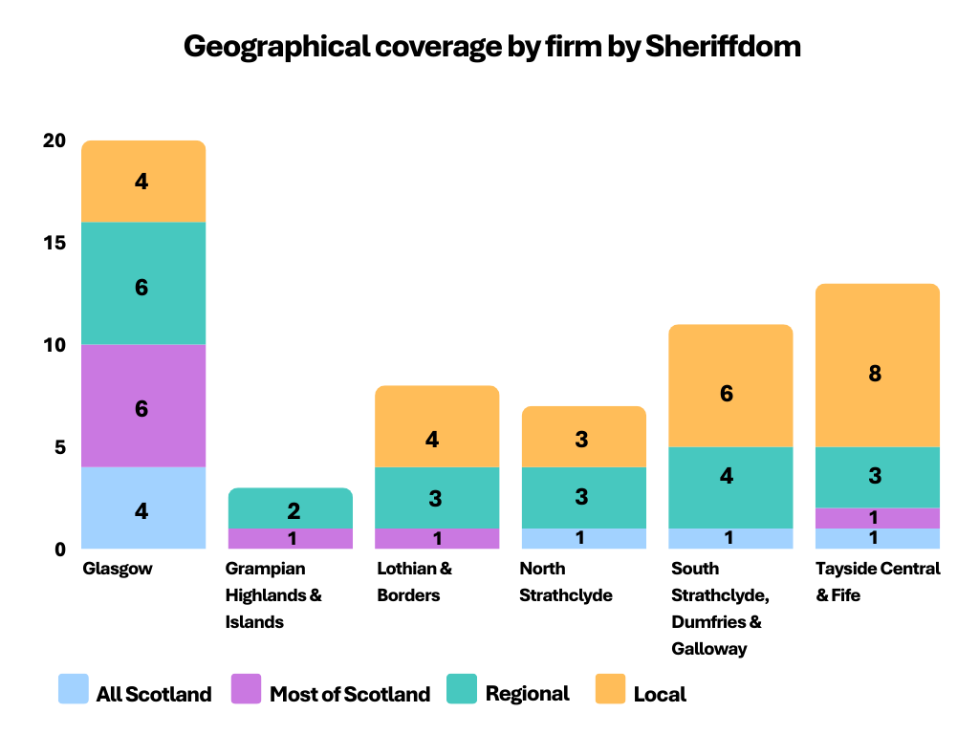
Most respondents said their firm provides a service either locally (40%) or regionally (34%).
However, around a quarter provide a service to most of Scotland (15%) or all of Scotland, including Islands (11%).
A breakdown by Sheriffdom shows that, from the firms surveyed, most Sheriffdoms have at least one respondent firm providing a service to all of Scotland. The exceptions are Lothian & Borders, and Grampian, Highland & Islands.
Respondents in Tayside, Central & Fife were most likely to provide only local services.

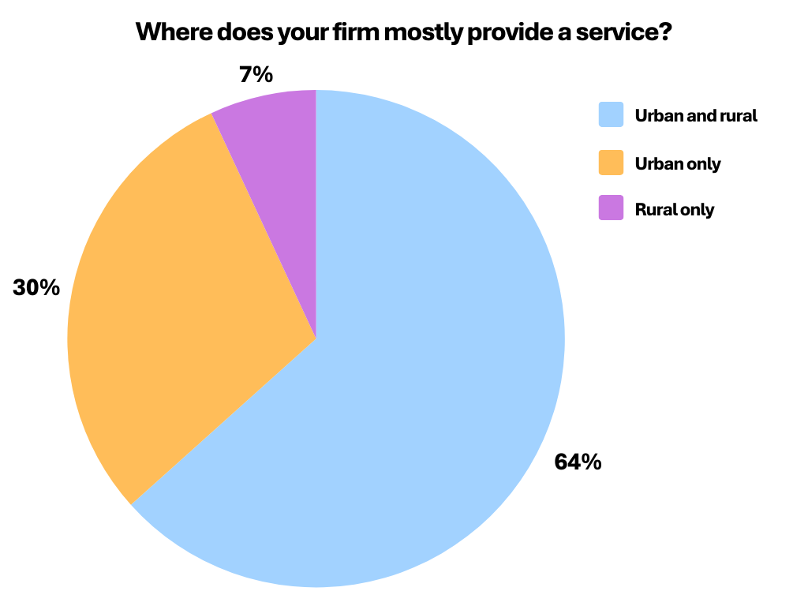
Most firms (64%) provide a service in both urban and rural areas.

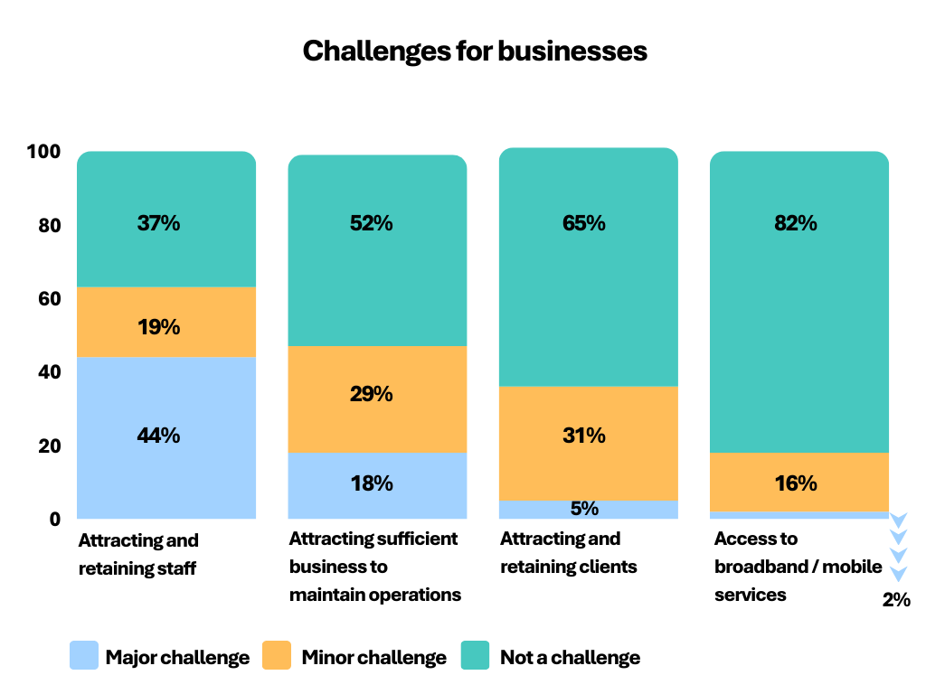
Two thirds of respondents felt that “attracting and retaining staff” is a challenge (63% overall, with 44% saying it was a major challenge).

All three respondents in Grampian, Highland & Islands experienced attracting and retaining staff as a challenge. Those in North Strathclyde were least likely to select this as a challenge (one of seven).

Attracting sufficient client business is a challenge for 48% overall, and a “major challenge” for 18%. Only one of the Grampian, Highlands & Islands respondents felt this to be a challenge.

Almost one in five (18%) found “access to broadband or mobile services” to be challenging. This was not specific to one region although no one in Grampian, Highlands & Islands or North Strathclyde selected this as a challenge.

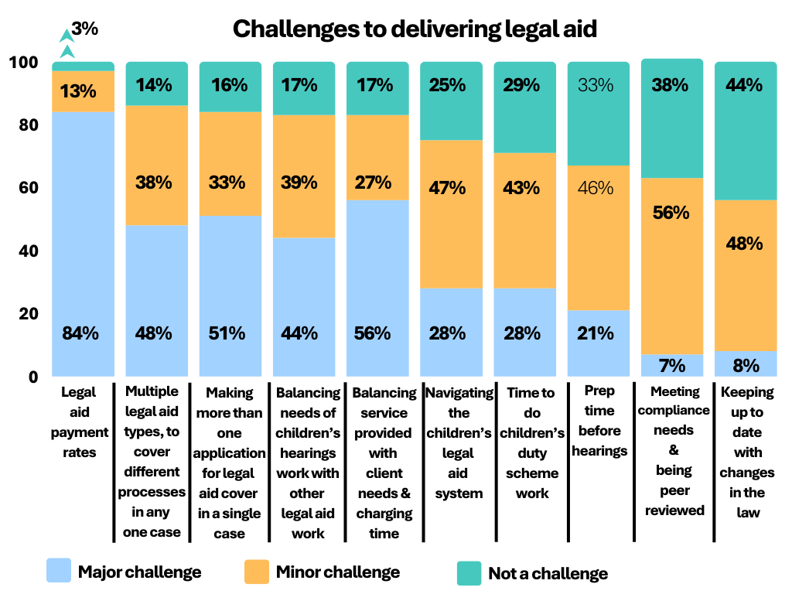
The survey explored challenges for individual solicitors when delivering children’s legal aid, and these questions were answered by partners and non-partners.

Overall, “legal assistance payment rates” was selected as the most challenging aspect solicitors face. Only 3% did not see this as a challenge, with 84% feeling it is a “major challenge”.

“Legal aid processes (the use of multiple types and multiple applications in a single case, and chargeable time)” were each seen as challenging by over 80% of respondents, whilst 75% found “navigating the children’s legal aid system” a challenge.

Least likely to be seen as challenging was “meeting compliance requirements & being peer reviewed”, and “keeping up with changes in the law”. However, over half still found these challenging to some extent.

Views and experiences
The research sought insight into people’s views and experiences with open questions.

Respondents to the survey were asked two open questions:
- “Do you have any suggestions for improving how advice and representation services for children's hearings are delivered? or the legal aid that funds them?”
- “Is there anything else you would like SLAB to know about your experiences of delivering children’s legal assistance?”.

Those interviewed as part of the qualitative research element were asked one question:
- “In the next three years what will be the biggest challenges for Children’s legal aid solicitors?”.

In response to these questions, many survey participants, and most of those taking part in the qualitative research, were worried that there is, or shortly will be, a serious lack of solicitors providing Children’s legal assistance in Scotland. The survey suggested that most firms expect to be doing legal aid for at least the next three years. Individuals noted their personal dedication to the work.
“We’ll continue doing this work because I, obviously, feel so passionate about it and so do my colleagues” (Partner, North Strathclyde).
“The reality is that I don’t think that solicitors in this area – particularly solicitors who persevere in this area – are financially motivated… I know the legal aid fund is under a lot of pressure, but the reality is that someone could go to a commercial firm and make a lot more money and have less demands placed on them” (Partner, Glasgow & Strathkelvin).
“Battering my head against a brick wall, but I’ve been doing legal aid for 30 to 35 years and I don’t intend to stop now” (Partner, Lothian & Borders).
However, these respondents were also concerned about supply of Children’s legal aid services at present and in future.

Supply
Concerns ranged from the possibility of a total lack of provision in the future, to having too few solicitors to provide a consistent service.
“Specialisation in this type of work will cease to exist” (Partner, Tayside Central & Fife).
“There are huge areas of Scotland, especially in the north, where there are no children’s legal aid Lawyers” (Partner, North Strathclyde).
“The number of solicitors practicing legal aid in firms has reduced massively”
(Partner, Glasgow & Strathkelvin).
Solicitors identified the “what” and “why” of their supply concerns.
In terms of “what is happening”, solicitors described circumstances that cause them concern as:
- experienced solicitors leaving the profession for more secure, or better paid, work elsewhere, or due to retirement
- experienced solicitors “downsizing” the amount of legal aid work they undertake
- new entrants to the profession are difficult to attract and are not staying for long
- regional differences in supply.

The following were felt to be the main causes of supply issues:
- Workload and increasing complexity of the work
- Stressful nature of the work
- Pay rates
- Workforce is not being replaced
- Complexity of the legal aid system.

Concerns about supply: the circumstances
It was suggested that experienced practitioners are leaving, and that attracting and retaining new entrants can be difficult. It was felt that people are discouraged from considering a legal aid career at a very early stage, and that there are few sources encouraging them to pursue it. Those who leave are often seen to be attracted to “the big organisations”.
“It is very difficult to attract staff or attract a trainee. We can't pay what the Procurator Fiscal’s office can, and we can't offer the conditions that Government organisations can” (Partner, Glasgow & Strathkelvin).
The Scottish Social Services Council and the Children’s Reporters Office were also specifically mentioned as being employers that solicitors would find it more attractive to work for. One interviewee gave an example to illustrate what they saw as the difference between legal aid solicitors and other publicly funded Children’s Hearings organisations:
“[Organisation], who’ve clearly got plenty of cash thrown at them, because you have meetings with them here, there and everywhere. Rather than meet you in your office they’ll book a room someplace. I’ll say, ‘you can come here for free!’. But that’s the kind of thing that gets done, and it’s just mind-blowing that there’s those two sides of the coin” (Partner, Tayside, Central & Fife).
There are regional differences in supply within Scotland. The research did not ask questions specifically on regional differences, however some people mentioned these spontaneously.
“There are huge areas of Scotland, especially in the North, where there are no children's legal assistance lawyers” (Partner, North Strathclyde).
Several people described how virtual hearings had allowed them to work in areas they had not previously served (or not served so extensively). Out of area firms also assist in giving people access to a solicitor, by attending in person. In both cases, there were some concerns about the quality of assistance provided: communication by virtual methods is not always as effective as in-person, and out of area provision can also be less person centered. It is also potentially more expensive, since travel and accommodation may have to be paid on top of fees.
“Glasgow agents have said ‘stack them up’… they will come up and they will have more than one [case]… [They] come up for one or two days, rushing between court and children’s Hearings… because that's how it makes it more lucrative” (Solicitor, Grampian, Highland & Islands).
It was noted that there are also advantages to clients for using local firms, such as stronger relationships and consistency.

Concerns about supply: the causes
Participants also expanded on the issues that they think (will) contribute to lack of supply. Some of these are also of concern in themselves, even without their relation to supply. For example, “stress and mental health”.

Workload and increasing complexity
The work itself was seen as a factor that might drive people away from this area of law. There are several things that make the work complex, for example the volume of preparatory work. People also contrasted the increased volumes of work currently with those when they began providing Children’s legal aid.
“The preparation for an old Children’s Panel Hearing might involve half an hour of reading. Now it would be two hours of reading, then having to check [a]... report’ and having to clarify matters that come back from the school, and things like that” (Partner, Glasgow & Strathkelvin).
The working environment can also be unpredictable. This includes having long working hours, meeting the varying support needs of clients, and the changeability of some hearings.
“There are confrontations that can flare up and can take up many hours - a whole afternoon” (Partner, Glasgow).
Although they may not be problematic in themselves the conflicting requirements of different areas of the Children’s Hearings System can also cause complications. For example:
- clients don’t always contact a solicitor until the last minute, making it more difficult to get legal aid in place when needed
- more than one hearing may be arranged in a limited time period, making attendance difficult
- other professionals don’t always understand the pressure solicitors are under, including the impacts of being funded by legal aid, rather than being salaried.

Nature of the work
The emotional impact of children’s work on mental health was mentioned in both the survey and the interviews. The was mainly due to the, often distressing, circumstances of their clients.
“On a personal level the subject matter can be quite confronting, it can be quite emotionally draining” (Trainee Solicitor, Glasgow & Strathkelvin).
Added to the circumstances overall is the importance of the work, and related concerns about the impact on children and families if a poor decision is made.
“A plumber would get three times that [hourly rate] probably, and not have the worry about the implications of... getting it wrong, or not helping or whatever” (Partner, Grampian, Highland & Islands).
Other stresses include long hours, and the intensity of their overall workload. One survey respondent commented that the overall impact of stressful work means that “people either burn out or leave the profession”. The vulnerabilities of private practice solicitors, compared with others in the hearings system, were also identified.
“You’ve got solicitors working that shouldn’t be working, because they’re so stressed out and their mental health is so poor. But because they’re a solicitor in private practice they cannot take a day off work. They don’t have the benefits of working for SCRA, or the Crown, or any other big agency. At the end of the day, we’ve got legal aid lawyers who shouldn’t be working because they’re physically and mentally not well enough. I don’t know what else to say” (Solicitor, Tayside, Central & Fife).

Pay rates
Participants reflected on the fee rates in general, as well as the opportunities for better remuneration for other areas of legal work, including in other organisations, and the impact of the reducing value of fee rates, due to inflation.
“There is going to be an increasing gap between the cost of living and the rate of legal aid payments” (Partner, Lothian & Borders).
Fee rates were also noted as a barrier to recruitment. This was seen as putting further pressure on solicitors, in addition to the other stressors mentioned above.
“Fees would have to be the first [change] to allow firms to recruit. We can’t recruit at the moment. So, we’re overworked because we can’t get lawyers in” (Solicitor, Tayside, Central & Fife).
“Paying trainees who undertake aspects of Children’s work was also suggested: they are more than capable of doing the job so pay them” (Solicitor, Lothian & Borders).

Profile of workforce
There were concerns that the workforce is “aging”, leading to near or medium term supply problems, unless there are new entrants.
“There are a lot of solicitors who are now … getting to the age of ‘close to retirement’, and they’re not being replaced” (Partner, Glasgow & Strathkelvin).
Just over half (53%) of survey respondents were aged 45 or over, with 25% aged 55 or over.
This is a similar, but slightly older, age profile to that from the Law Society of Scotland’s overall Profile of the Profession in 2023. 45% of respondents to the profile of the profession were aged 46 or over, with 22% aged 56 or over.

Analysis of registrations for Children’s legal aid since 2013-14 doesn’t show any significant change in the annual numbers of registrations. The most recent Children’s legal aid register contains 651 solicitors from 276 firms.

Legal aid is complex
The complexities of the legal aid system were mentioned more frequently in the survey than at interview. Survey respondents gave examples of how the legal aid process presents them with barriers. These included navigating SLAB’s systems, the deadlines for getting legal aid in place, the amount of information requested, and additional (unpaid) time spent supporting some clients.
“Legal aid is very admin heavy…. having to do financial checks on everyone, get copies, statements, upload them and everything” (Solicitor, Tayside, Central & Fife).
The administration of legal aid work can be seen as a frustration. Doing admin tasks that aren’t directly paid for by legal aid add to this, and some people felt that SLAB is “effectively swapping admin from them onto us” (Partner, Glasgow & Strathkelvin). Respondents also indicated that finding administrative support can be difficult.

Other issues
As well as concerns about supply and factors that contribute to this, the survey and interviews also raised other issues.

Simplifying access for clients
Several solicitors suggested that children should not have to provide financial information to qualify for Children’s legal assistance at their panel (or sometimes in general). The main reason for this suggestion was that this would help remove stress and uncertainty for the child or young person, at an already stressful time.

Solicitors suggested that obtaining financial information from parents, often at short notice, is often difficult. Chaotic lives or disengaged non-resident parents were the most common reasons for difficulty. However, it was suggested that sometimes “bad actor” parents may not want the child’s voice to be amplified. Solicitors also felt that it is unusual for a child not to qualify financially.
“I think the financial side of it needs to be removed altogether when your client is under 16… if a child’s coming in, they need help” (Solicitor, Lothian & Borders).
Some people also suggested removing the means test for adults or increasing financial eligibility levels. The effect of the cost-of-living crisis was sometimes mentioned in relation to this.
There were also suggestions that the process for adult applicants should be simpler. Better information for social workers, to ensure they are aware of solicitor services, allowing them to signpost clients, was also mentioned.

Lack of support
There were some comments about a lack of support, or concern, for Children’s legal assistance generally, including from the Law Society of Scotland. Other areas of law were seen to “get more coverage”.

Future demand
Future demand was discussed by some. There were some expectations that demand will increase, although it was noted that a lack of relevant professionals, in the system generally, may mean that there is a decrease.
“Every school I go to has a big banner saying, ‘we are UNCRC respecting’. So, children are more likely now to be looking for a solicitor and then discovering that they can’t actually get one” (Partner, South Strathclyde, Dumfries & Galloway).
The Hearings Systems Working Group’s findings report (Hearings for Children: Hearings System Working Group's Redesign Report) noted that there are “challenges in social work recruitment”, which Scottish Government is working to address. The findings report suggests some actions which may increase the need for solicitors (and other professionals). It also includes suggestions that should reduce the number of children referred to the Children’s Hearings System.

There has been a 26% decrease in the number of both Children’s legal assistance applications and grants between 2018-19 and 2022-23. This reflects the wider system, where there are fewer hearings taking place.

Using figures from SCRA’s online statistical dashboard suggests this is due to a decrease in the number of children with compulsory supervision orders (CSOs). SCRA’s data shows that the number of children subject to CSOs has fallen continuously since 2009-10, when around 14,000 children had CSOs. The number of children on CSOs in 2022-23 was a little under 7,000.

Further information
If you would like further information about this research, please contact the Research team at research@slab.org.uk.

Only registered solicitors at registered firms can provide Children’s legal aid and demonstrate compliance with related Codes of Practice. SLAB maintains the registers which are on their website. Solicitors on the register will not necessarily undertake legal aid in any one year.
The full question text was “Thinking about numbers of cases, what percentage of your firm’s total legal work is legal aid? Please think about all legal aid work that your firm undertakes, not just children’s legal assistance”.
Due to rounding, figures do not add to 100%.
Not including open questions that expanded on a previous answer.
The response rate for SLAB’s survey was 32%. The Profile of the Profession survey does not provide a response rate; using membership numbers from the Law Society’s website suggests it is below 30%. The 2022-23 Diversity Data report published by the Law Society of Scotland does not address ‘age’ as a standalone characteristic.
For example, “additional offence-based referrals”, “Children and their families must be helped to understand their choices and rights relating to their participation”.
For example, “children and families working in this way alongside the local authority can access the help that they need, in the way that they need it, will help to reduce the number of children referred to the Children’s Hearings System”.
SLAB’s Annual report 2022-23 - Appendix 1 Key Statistics.
Data, including the online statistical dashboard, is within Official Statistics - SCRA.

