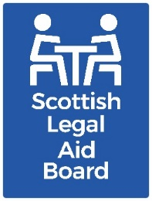 Children’s solicitors’ research: Views on SLAB’s services

Key findings
Most survey respondents were aware that the Scottish Legal Aid Board (SLAB) offers training to solicitors, and other relevant parties. Just under one quarter had had training from SLAB in the past two years.
One third said their firm had been peer reviewed in the past year. We asked this group about their satisfaction on three measures (understanding the results, transparency of scoring and how long the peer review took). Most of those who were peer reviewed were “satisfied” on all three of these. The length of the process was most likely to dissatisfy people, although the majority (58%) were satisfied.
Almost all respondents (90%) had used the guidance on Children’s legal aid published by SLAB. Most of these were satisfied with it. Respondents were most satisfied with how easy it was to understand.

Aims and method
The overall research aim for this work project was to “understand the current and future supply of children’s legal aid services, with reference to practitioner motivations and support needs, as well as the impact of the Age of Criminal Responsibility (Scotland) Act 2019”.
We also asked survey participants for suggestions to improve legal aid.
Some of those who took part in the follow-up interviews also gave views on SLAB’s service.
The research was undertaken with solicitors who had recent experience of providing Children’s legal assistance via:
- a telephone survey.
- semi-structured telephone interviews with 16 private practice solicitors.
- a joint interview with Civil Legal Assistance Office (CLAO) practitioners.

Background
SLAB provides free training to solicitors, as well as others with an interest in legal aid, such as support staff, trainees and students.
Training is provided flexibly; it can be delivered in person or online, and trainees can specify the topics they need. The training, e-learning and Legal Aid Online section of SLAB’s website gives detail on the training available, and how to request training.
SLAB also coordinates a quality assurance peer review scheme, with assistance from the Law Society of Scotland. This is for solicitors and firms who are registered with SLAB to provide children’s legal assistance.

The purpose of a peer review is to assess the quality of the work undertaken for the client, by reviewing a solicitor’s case files. Solicitors are subject to a routine peer review every six years.

Where necessary, reviewing can take place more often, for example if a solicitor only marginally passes their peer review. Peer review criteria includes:
- explaining legal options to the client
- preparation and attendance at hearings and associated court proceedings
- communication of outcomes to the client.
More information is available at Children's quality assurance - Scottish Legal Aid Board.

SLAB provides guidance on all legal assistance matters, including children’s legal assistance.

This includes the steps needed to apply for legal assistance, and guidance on submitting accounts for payment. It also includes the approach to more unusual things, such as the need for prior approval of expenditure or translation requirements. The relevant fees for different types of children’s legal assistance are also covered in SLAB guidance available on our website. The guidance on providing children’s legal assistance is on SLAB’s website at Children’s guidance.

Survey findings
Respondents were asked about their views or experiences in relation to support for legal assistance.
The topics we asked about were:
- SLAB’s training on systems and processes
- Peer review
- Children’s legal aid guidance
- Contact with SLAB.

Training
We asked about use of SLAB’s training during the past two years. Those who had not had training were then asked if they knew that SLAB provides training.
We combined the responses to these two questions. The combined responses show that most respondents (66%) were aware of SLAB’s training. The remainder (34%) were not aware of SLAB’s training. Almost a quarter (24%) of respondents had used SLAB’s training within the previous two years.
Solicitors didn’t offer any comments specifically on the training SLAB delivers.
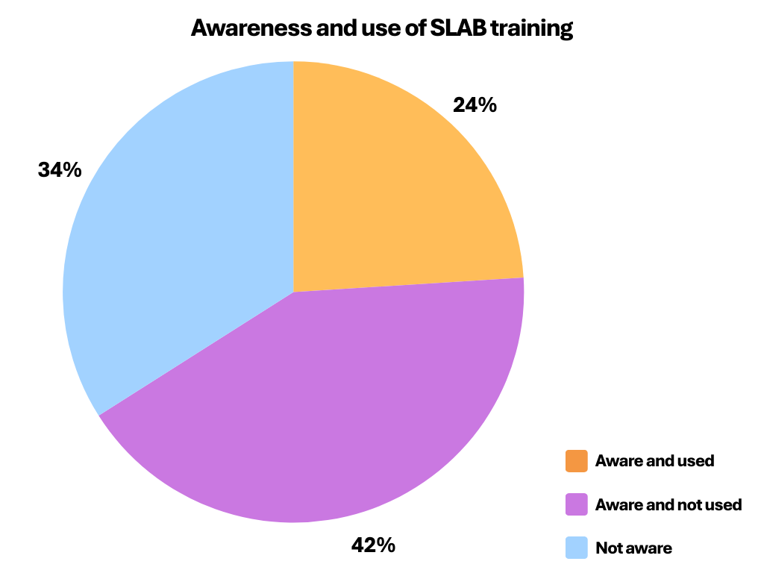

Peer review
We also asked about peer review. Around one third (34%) said that their firm had been peer reviewed in the past year.

Those who had been peer reviewed were asked about their satisfaction with three aspects of the process.

Most respondents were satisfied that the results were easy to understand (79%), although 14% were dissatisfied with this.

The majority, 64%, were satisfied with the transparency of the scoring, however 25% of respondents were “neither satisfied nor dissatisfied” in this, suggesting uncertainty around this aspect. In addition, 11% were dissatisfied.

Respondents were least likely to be satisfied with how long the process took; 19% (almost one in five) were dissatisfied on this aspect.
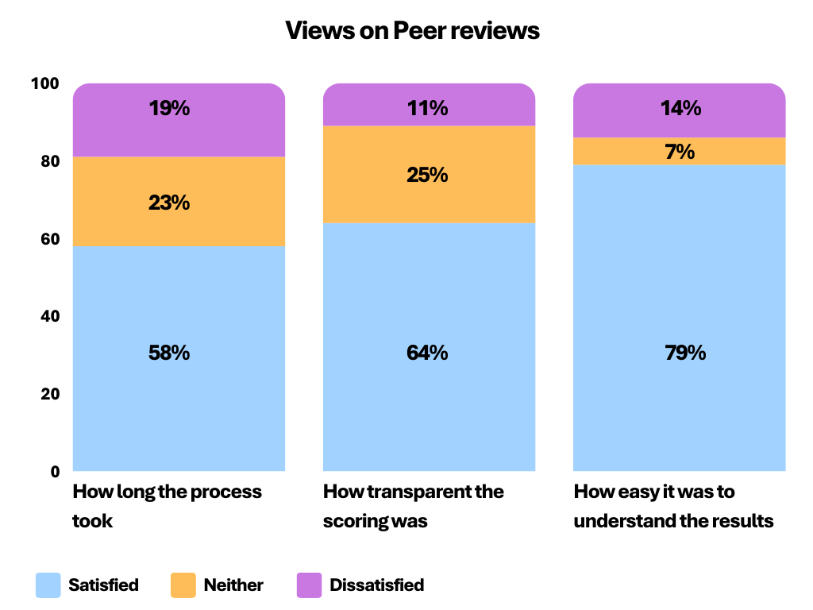
Very few people commented on peer reviews in response to the survey.
Difficulties in providing evidence due to “vulnerable clients [who] don’t provide all the information” were mentioned in relation to peer review, as well as more widely, for example when applying for legal assistance.

SLAB guidance
Most respondents (90%) had used SLAB’s Children’s legal assistance guidance.

The majority were satisfied on each of the three measures that we asked about in the survey.

Satisfaction levels ranged from 72% for “ease of understanding”, to 65% for “ease of finding this guidance on SLAB’s website”

However, around one in five were dissatisfied with the guidance not being able to provide the information they needed, and with the ease of finding the information, and one in six were dissatisfied with how easy the guidance was to understand.

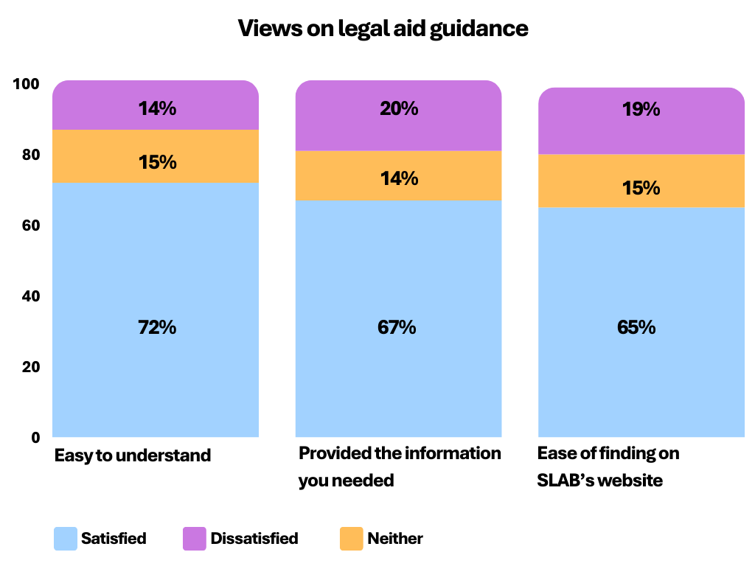

Contacting SLAB
Issues relating to finding or navigating the guidance were mentioned. For example, “[the previous] contents page that was easier to follow” and “it would be helpful if more FAQs’ [Frequently Asked Questions] or examples of common issues with SLAB funding”.
The survey also asked how easy it was for people to contact SLAB when they had a question.
Most respondents (67%) felt it was “easy”, however 20% found it “difficult” (one third of these felt it was “very difficult”).
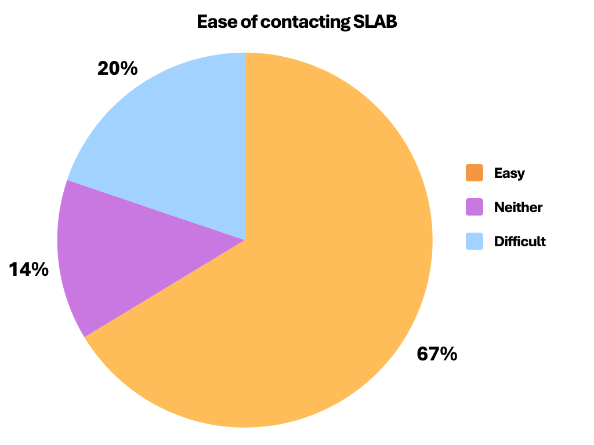
The comments about contacting SLAB were mainly positive, for instance, “The Children's team at SLAB are very good, receptive and quick at coming back with answers”.
However, some people mentioned uncertainty about “out of hours contact” in response to the open questions in the survey.
We were not able to explore why some people felt contacting SLAB was difficult. SLAB also undertakes short customer service surveys with solicitors. These explore satisfaction with our applications and accounts process overall. Contemporary surveys of Children’s solicitors were undertaken in August 2022 and November 2023. They demonstrated high levels of satisfaction. Four comments were provided, none of which mentioned problems contacting SLAB.
Contact details for different SLAB functions are provided on the contact us page of our website. The A&A increases contact details should be used for out of hours Children’s A&A increases.

Other SLAB services
Some respondents raised issues with SLAB in general, or issues around the legal aid system overall.

Multiple applications were mentioned by several respondents. They were felt to make unnecessary work for solicitors, for instance one respondent states, “it is crazy to have two forms for the same clients… You don't have time, when the form could pull in previous information”.
Some people felt Children’s work was time consuming. For instance, preparation for some hearings can be time consuming. Having more detail on why accounts are being abated was also mentioned as something that would be useful.

There were also general comments about changes to the website or problems using it. During 2022 there were several upgrades to SLAB’s Legal Aid Online (LAOL) system, used by solicitors to apply for legal assistance and to submit accounts.

These included routine upgrades (for example, applying new legislation) as well as a significant update in October 2022 (shortly before the survey was undertaken).

Further non-routine changes and fixes were made in the following months, including when the survey was being conducted.

We cannot tell whether solicitors were thinking about the original or the upgraded system in their responses.

SLAB provides information about news, ongoing issues and workarounds for LAOL on their website. Solicitors can also use it to report LAOL issues to the Help Desk via email.

SLAB also offer free customised training on LAOL, allowing solicitors to ask questions while LAOL is demonstrated in real time.

Further information
If you would like further information about this research, please contact the Research team at research@slab.org.uk.

Changes to Legal Aid Online from 1 October 2022 - Scottish Legal Aid Board
Legal Aid Online: Monday 28 November update - Scottish Legal Aid Board

