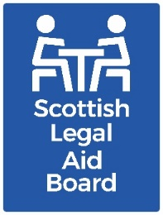 Children’s solicitors’ research: Client communication & promotion

Key findings

The survey findings showed that solicitors use a wide range of methods to contact clients. This corresponds with the findings from SLAB’s 2021-22 surveys of civil legal aid clients.
Informal sources of information, including word of mouth and referrals from others in the justice, or hearings, systems were seen as very important for new clients seeking a solicitor. For firms, their website is important when promoting their service to new clients.

Aims and method
The overall research aim for this work was to “understand the current and future supply of children’s legal assistance services, with reference to practitioner motivations and support needs, as well as the impact of the Age of Criminal Responsibility Act”.
In relation to “communication and promotion methods” the research objectives were to:
- explore the types of communication and promotion methods that firms use
- discover how often specific methods are used.
The research was undertaken with solicitors who had recent experience of providing Children’s legal aid via:
- a telephone survey.
- semi-structured telephone interviews with 16 private practice solicitors.
- a joint interview with Civil Legal Assistance Office (CLAO) practitioners.

Survey findings
Our research explored how children’s legal aid solicitors communicate with adult children’s legal aid clients. We used the survey to ask about the methods they use with adult clients. We asked about six main methods:
- Postal.
- Email.
- Telephone.
- In person (face to face) meetings.
- Text messages, including WhatsApp or similar.
- Video conferencing, such as Zoom or similar.
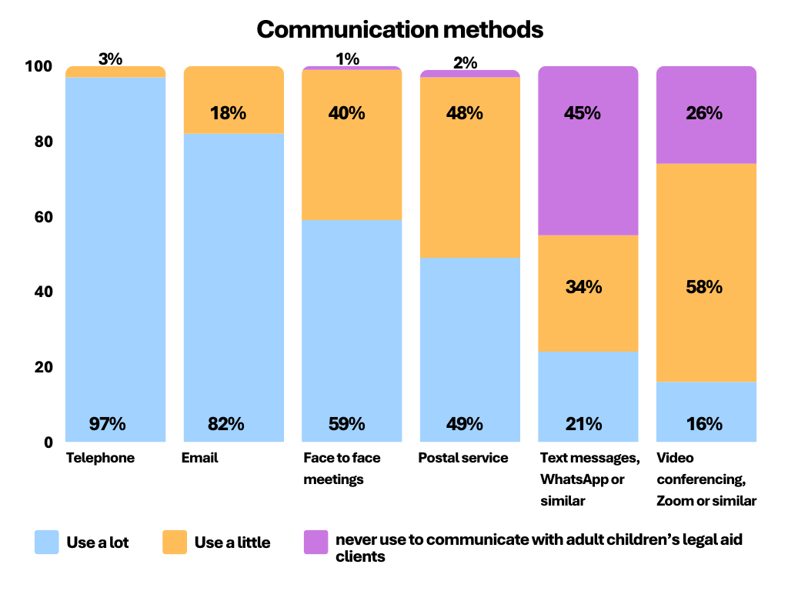Email and phone communication is vital, and all respondents said that they used these, with the majority using them ‘a lot’ (97% for phone and 82% for email).
Text messaging is the least commonly used; but is still used by over half of respondents (55%).
We also explored how firms “advertise that [their] firm undertakes children’s legal work”.
We asked partners of firms which of the following their firm uses to advertise that they undertake children’s legal work.
Previous research with legal aid clients (both civil and criminal) found that word of mouth was important for clients when finding a solicitor.
We therefore interpreted ‘advertising’ widely, as routes that firms rely on, or clients actively use.
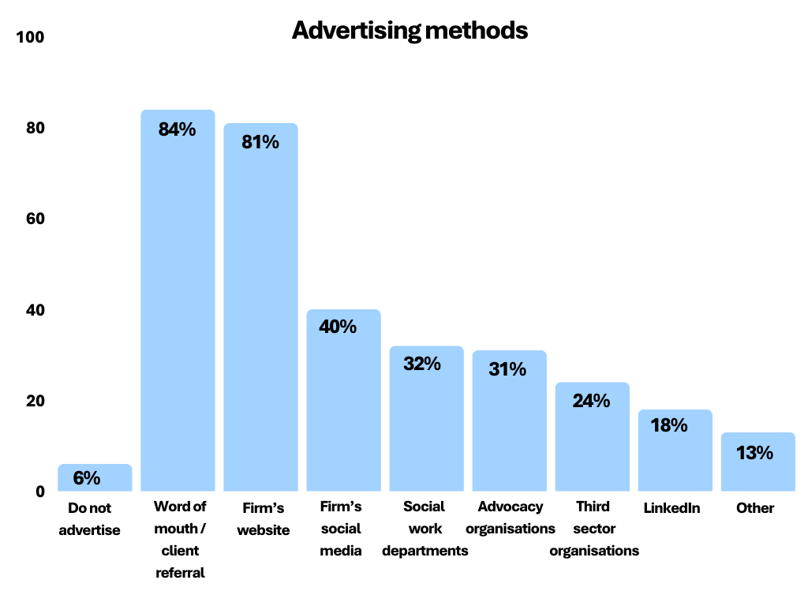Word of mouth was the most common method, used by 84%, the firm’s website was also used a similar amount.
Although a range of other methods were used, they were mentioned considerably less often (used by fewer than 50%).

Interviews
The interviews with solicitors explored communication and promotion in more depth. These confirmed that informal sources of information were seen as very important to people in need of a Children’s legal aid solicitor.
Recommendations from people they trust, (friends, family or community) were felt (by interviewees) to be important for people at a stressful time in their lives.
“Existing clients – they sometimes… have a family member that has a problem, and we’re asked to get involved”
(Partner, Grampian, Highland & Islands).
Contact with other solicitors is another common way of getting new clients. This includes referrals from other firms in the local area, and from other practice areas (such as family law) within a firm.
In some localities, where there are not many firms offering Children’s legal aid, referrals from other nearby firms are routine:
“Within the local area …. the other firm of solicitors acts for Mum so they can’t act for Dad, so they would refer to us. We would refer to them in similar circumstances”
(Partner, Glasgow & Strathkelvin).
Links with others in the Hearings system, or adjacent to it, can also be a route for new clients. The ‘Reporters Office’ and social workers were mentioned, alongside charities, such as Barnardo’s and Scottish Women’s Aid.
The solicitors we interviewed also used more formal ways of promoting their service to potential clients. The firm’s website was commonly mentioned as useful for people seeking a solicitor. One described the change to virtual contact methods that they had seen within their firm:
“Historically a lot of it was word of mouth and footfall…. I think now, new clients routinely use online resources
(Partner, Glasgow & Strathkelvin).
However, the ‘high street’ effect can still be important. The physical presence of their firm or branch was described by some as the way that clients found out about them. There was also a view that little or no formal promotion of their Children’s legal aid services is needed. People who said this sometimes explained that they did not have capacity to take on new clients.
“We don’t need to do any advertising whatsoever. They’re desperate for us. We’ve got a good reputation”
(Solicitor, Tayside, Central & Fife).

Further information
If you would like further information about this research, please contact the Research team at research@slab.org.uk.

SLAB’s 2021 survey of people having civil legal aid says the most common reason for choosing a solicitor were that they were recommended by friends or family (27%) or they were nearby (18%). Advice and assistance survey respondents most commonly chose their solicitor because they had used them in the past (28%), followed by recommended by friends or family (25%) and being nearby (20%)”. The 2021 survey of people having criminal legal aid found when choosing a solicitor previous use at 43% and personal recommendation at 22% were the most important factors”.

