 Children’s solicitors’ research: Supporting child & young person clients

Key findings
The survey findings suggested that most practitioners will take on both child and adult clients.
Solicitors employ a wide range of techniques to engage with, and support, child and young person clients.
Communication is a key concern when supporting children or young people. Solicitors want to make sure that their client understands what a solicitor can do for them. Solicitors also know how important it is that they understand what their client wants, and that this may not always be easy for children or young people to express.
Solicitors recognise that young people may have different support needs from younger children.
The ways they engage with young people are sometimes relevant to adult clients as well.

Aims and method
The overall research aim for this work project was to “understand the current and future supply of children’s legal aid services, with reference to practitioner motivations and support needs, as well as the impact of the Age of Criminal Responsibility Act”.
In relation to supporting children and young people, the research objectives were to explore the strategies used by solicitors to engage with children and young people.
The research was undertaken with solicitors who had recent experience of providing Children’s legal assistance via:
- a telephone interview.
- a semi-structured interview with 16 private practice solicitors.
- a joint interview with Civil Legal Assistance Office (CLAO) practitioners.

Survey findings
Most survey respondents (61%) said they take on both child and adult clients under Children’s legal assistance.

Client type
Most (61%) take on ‘mainly adults’, 31% take on roughly equal proportions of child and adult clients.
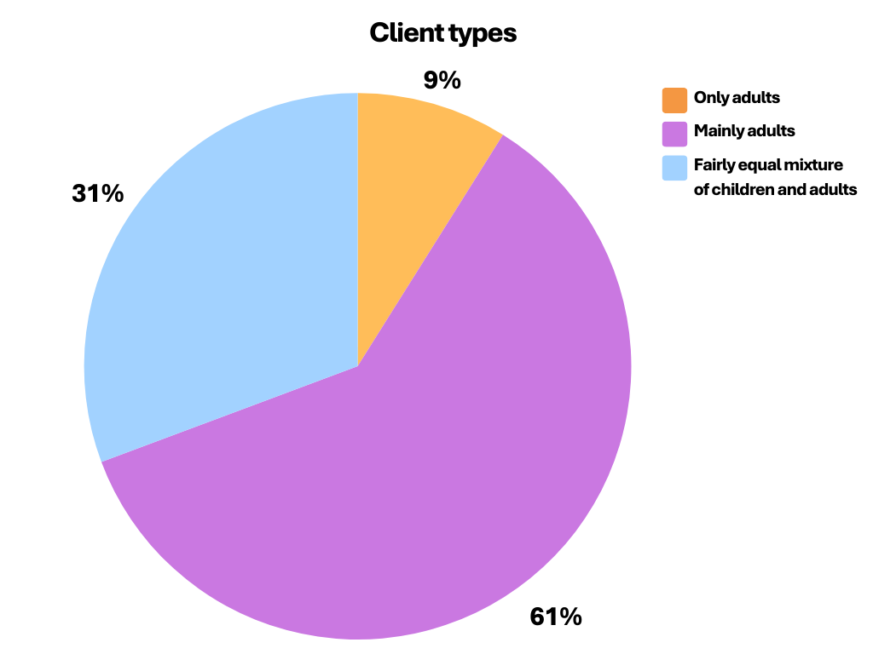
Reasons for only taking on adults included:
- “not been asked to take on children”
- “not cost effective to take on child clients”
- “don’t have the training or skills to communicate with or support children”.

Regional review
Responses by the six Sheriffdoms show that all six have at least one firm who will take on child clients.
The bracketed number in the chart below is the number of responses to this question from each Sheriffdom.
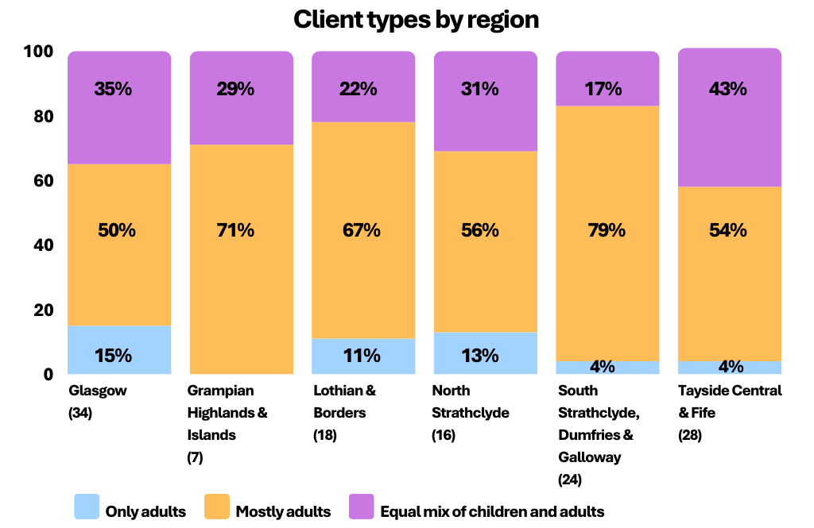
Amongst those who provided a service to children, almost all (99%) adapted their approach when dealing with child clients. Of those that did adapt their approach most had actively developed (by formal or informal training) their approach to child clients in some way.
Respondents were asked about ways in which they had developed their approach to child clients. They were able to select as many ways as applied to them.
Just under half (47%) had used some formal training to develop their approach to child clients. The most used training was “formal training, including online, for professionals involved in children’s hearings” (used by 35% of those taking on child clients). Partners were slightly more likely to have undertaken formal training than non-partners.

Developing approaches
Informal sources of information to develop their approach were widely used.
Almost all of those who used formal training had also used informal sources as well. These were “personal knowledge of children and young people” (76%), common sense approach (72%), informal learning from legal colleagues, or other professionals (64%).
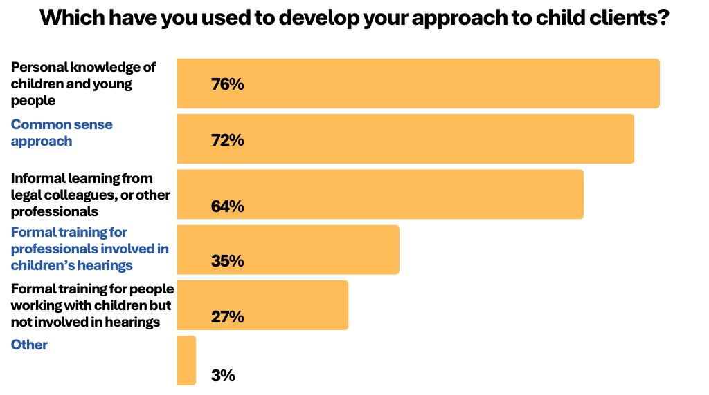

Interviews
The interviews explored the different ways in which solicitors accommodated and supported children and young people. We asked solicitors about whether and how adapted their approach for these groups, and how else they made their services accessible to them.
Those we spoke to confirmed that they adapted their approach to ensure that it supported children and young people. Interviewees identified a variety of ways in which they did this.
Quality of communication was seen as very important. For older children and young people, this included clear written communications. For younger children this is more likely to be direct, face to face, communication. Initially the focus is often about making sure that children and young people know what a solicitor can do to help them before, and at, their hearing.
“You just need to relate to them, in a child focused manner, as opposed to the way you’d deal with an adult client. You might explain the concepts to them in different ways, with a bit more detail, and try and come at it from different angles if they’re not understanding”
(Solicitor, Tayside, Central & Fife).
Interviewees recognised that effective communication was not just about telling things to children and young people. Respondents also described their listening strategies.
“It’s about how you engage with kids, how you get instructions from them… it sounds fairly daft when you talk about it out loud, but if you just draw pictures and stuff with them, they’ll sit and tell you things. Just by general chatting, so you’re not ‘questioning’ them about things”
(Partner, Tayside, Central & Fife).
Interviewees noted that good communication included making sure that the child feels confident and supported to express their views. Solicitors routinely check with child clients to make sure that they are communicating well. Sometimes this will be to make sure the child or young people understands what their solicitor is telling them. Solicitors also want to be certain that they have a full understanding of what their client wants from them.
“Sometimes children want to please those they’re speaking to, and they’ll try to work out what it is you want them to say. So, you always have to be watchful for that, that they’re saying what they actually want. And I would always confirm back – maybe multiple times in different ways ‘this is what you’re saying?’, ‘Is that what you think’?”
(Partner, South Strathclyde, Dumfries & Galloway).
The importance of not rushing children or young people, when asking them for information, was also mentioned. Solicitors adjusted, for example allowing extra time for meetings or having more (but shorter) meetings. They also ensure that child clients feel relaxed and comfortable with them, before starting to discuss the hearing.
“They don’t come in, sometimes, ready to speak and you have to give them a bit of general chat. We have on office that looks out onto the sea, so there’s something to talk about”
(Partner, South Strathclyde, Dumfries & Galloway).
Solicitors also described their approach to ongoing communications. They sometimes use different forms of communication in order to make it easier for individuals (mainly young people) to continue to engage with them. Generally, this means offering a range of communication methods, such as email, WhatsApp or telephone, to allow the client to identify what works best for them.
Solicitors consider the individual child’s circumstances when arranging a meeting. The location is seen as very important, it needs to be ‘somewhere where the child feels safe and happy’ which might need to be “away from the conflict of children’s parents”.
Often the best place is somewhere the child already feels comfortable, such as a school or grandparents’ home. Interviewees also mentioned making the office as “child friendly a place as possible”. For example, by having toys there.
Solicitors also consider their own appearance, and whether this might appear formal or intimidating, with some mentioning that they avoid wearing a suit. Respondents noted that the needs of teenagers and young people are often different from those of younger children. Young people may prefer to be treated in a more adult way, to acknowledge their maturity when compared with younger children. Solicitors will generally vary their approach to suit what they feel will help the individual client.
Sometimes the approach to children informs that for adult clients with Children’s legal assistance. The survey responses and interviews both highlighted that a proportion of adult Children’s legal assistance clients will have significant vulnerabilities. These are different to the inherent vulnerabilities of children and young people; however, solicitors may use similar support strategies when providing a service.
“Some of my clients may have learning difficulties or addictions or mental health problems, so it takes a little longer to sit down and give them advice due to their difficulties”
(Solicitor).
Some people mentioned having other Hearings system roles, or training, that had helped them when considering their approach to supporting children and young people. These included:
- child welfare reporter
- Safeguarder
- curator ad litem
- previously working as a play assistant
- involvement with school mooting / court projects
- involvement with a Child Law Centre.

Further information
If you would like further information about this research, please contact the Research team at research@slab.org.uk.

Response options were: a) “Formal training, including online, for professionals involved in children’s hearings”, b) “Formal training, including online, for people working with children unrelated to children’s hearings (for example general training for youth workers or teaching assistants)”, c) “Informal learning from legal colleagues, or other professionals”, d) “Personal knowledge of children and young people”, e) “Common sense approach”, and f) “Something else, please specify”.
a) “Formal training, including online, for professionals involved in children’s hearings” had been undertaken by 37% of partners compared with 25% of non-partners; b) “Formal training, including online, for people working with children unrelated to children’s hearings” had been undertaken by 31% of partners compared with 18% of non-partners.

