 Board report
AGENDA ITEM: 09
REPORT NUMBER: SLAB / 2025 / 04
Report details
Report to: The Board
Meeting date: 17 March 2025
Report title: Draft Budget Approval 2025-26
Report category: For decision
Issue status: Business as usual
Written by: Audrey Crawford
Director responsible: Linda Ross
Presented by: Linda Ross
Contact details: crawfordau@slab.org.uk
Delivery of Strategic Objectives
Select our relevant Strategic Objective(s).
1 – Administration: Our timely, clear, and consistent decisions on legal aid applications and accounts deliver a positive customer experience.
Link to Board or Committee remit:
This is linked to the Board’s role in oversight of key organisational activity.
Link to Risk Management:
Our work to monitor administrative expenditure enables us to mitigate corporate risk 6, with awareness of pressures and ensuring planned changes are reflected.
Risk 6: If we fail to appropriately respond/plan to unplanned reductions in SLAB's administration funding then we may be unable to meet the needs of customers and/or prioritise our resources to ensure effective decision making.
Publication of the paper:
It has previously been agreed that this paper should be published.
Executive Summary:
The paper gives details of proposed 2025-26 budgets for SLAB Administration costs and the non-judicare parts of the Legal Aid Fund, like Client Legal Services and Quality Assurance.
2025-26 Admin budget requests amount to £16.2m, this includes a 4% pay award assumption.
Total in year Admin funding for 2025-26 is expected to be £16.2m. This includes estimated pension pressure but does not include any additional funding for the increased cost of employers NI.
Previous Consideration
Meeting: N/A.
Details: N/A.

Report
The Board are asked to discuss and comment on this paper, with a view to approving the budget, noting the employers NI position is included in the budget, but not yet reflected in Scottish Government allocation.

SLAB’s Budget Setting and Review Process
SLAB sets annual budgets using the zero based approach. Each year budget holders assess their objectives and build their resource requirements around them.
Managers also provide a high level view of the following financial year with some of the larger operational budgets (like Digital Services and Facilities) providing a five year plan of expenditure which, alongside the staffing establishment, are used for medium to long term financial planning.
Throughout the year we review budgets quarterly and adopt a rolling, continuous budget approach whereby budgets are amended based on the outcome of the most recent review to provide a more realistic estimate based on the most up to date information. Scottish Government provide an annual allocation, there is a review process to amend for exceptional pressures, such as additional pension or legal aid expenditure, but the core administration allocation will not change.

Admin

Funding Available
The core funding we expect to receive from Scottish Government (SG) is detailed in the table below.
Core funding includes £100k for capital which cannot be transferred to staff or running costs.
Funding | 2024-25  Budget | 2025-26  Budget
 | £k | £k
Core SG Funding (Actual/draft SG budget) | 15,150 | 22,450
Non cash funding for Depreciation | (550) | -
Non cash funding (movement on pension liability and Depreciation) | - | (6,500)
Sub-Total Core and non-cash | 14,600 | 15,950
Retained superannuation receipts | 250 | 250
Additional funding for Grant Funding/ SWRC | 20¹ | 20¹
Pension Pressure (additional funding from SG) | 590² | -
Total available in year funding | 15,460 | 16,220
1 Admin fee £20k from Justice for SWRC
2.Pension pressure increased from £590k to £675k, as part of the 2024-25 Q3 budget review however there are small underspends elsewhere which will cover

Summary Admin Budget Requests for 2025-26
Executive Team have considered all budget requests and present the proposed budget for approval. The consolidated budget request, including income from Thistle House sub-let, is £16,234k which is a small over-commitment of £14k.
Scottish Government funding: We will receive increased core funding of £1,350k, our understanding is that this should include £760k to cover operational costs and should also cover any pension pressure (currently £590k) up to and including anticipated £2,200k pension spend. This removes forecast in-year pension pressure; however, this is a change in approach to have no forecast in year pressures and SG remain liable for full pension pressures.

Admin - Movements across spend types between 2024-25 and 2025-26
 | Staff £k | Running £k | Capital £k | Pension £k | Income £k | Total £k
2024-25 Q3 Budget | 11,136 | 2,766 | 100 | 2,285 | (1,121) | 15,166
2025-26 Budget (Proposed) | 12,191 | 2,869 | 100 | 2,200 | (1,126) | 16,234
Movement (Q3 to 25/26) | 1,055 | 103 | - | (85) | (5) | 1,068

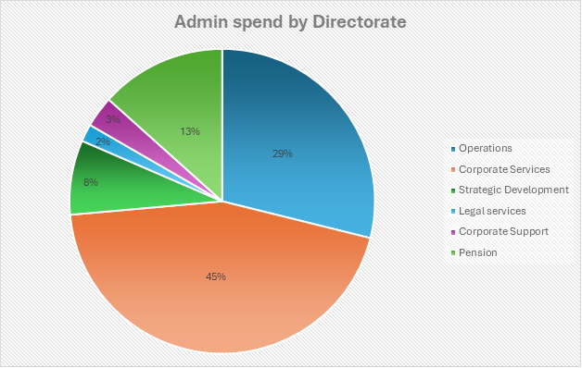

Staff
SG published a revised pay policy in December 2024 with the key metric setting a 9% pay envelope over a three year period.
The budget figures included in this paper assume a 4% award in 2025-26. Each additional 1% rise would cost £120k in Admin (and £70k in Fund).
The staffing establishment has been fully reviewed, and several vacant posts have been removed. Budget holders identified approximately £250k staff savings, which has supported the affordability of the budget proposed.
We await confirmation from Scottish Government on how the increased Employer National Insurance Contributions (ERNIC) costs will be dealt with. Our budget requirement of £16,234k includes a £260k increase due to this change. However, the SG allocation reflects no increase.
Our understanding is that discussions are ongoing between SG and UKG, and that while there has been no formal confirmation, we are anticipating that funding of up to 60% of the additional cost may be made available. This could therefore mean a further funding increase of up to £155k, which would place us in a surplus position going into the year. This could enable us to reprofile some spend that would otherwise have to fall in future years, making later periods more affordable.

Running
All departments have considered the request to consider savings whilst building their budgets. For now, several savings have been realised immediately (and are included in the proposed budget) with little or no impact on service. The significant change is an £80k reduction across Digital Services contracts and a £35k reduction in Professional Legal Fees.

Income from sub-let
For now, Thistle House is at capacity with no plan to alter the billing structure, so income remains steady at a similar level to the previous year. Any increase in utilities will be passed along to tenants so the income could see a small rise although this would be offset by increased utility costs in the Facilities budget.

Capital
Our capital budget is £100k per annum and this is ring-fenced by SG (it cannot be transferred to other budget areas like staff or running). The most significant requests for 2025-26 are:
- upgrading the fire alarm in Thistle House
- replacing the hardware which runs 90% of our infrastructure (UCS) – this has slipped from previous years and is becoming more urgent each year
- web filtering and firewall replacement
- replacing staff laptops.
We continue to work with the main capital spending areas (Digital Services and Facilities) using the five year expenditure plan to try and smooth out any competing priorities for this budget across the coming years.

Pension Costs
Pensions are shown above at £2,200k. As ever this is a difficult figure to forecast, it largely depends on when/if staff chose to retire. If several staff members of long service and high grade choose to retire the pension budget would see significant pressure (largely in relation to lump sums).
The columns below show year on year comparisons of spend between 2024-25 (as at quarter three) and budget requests for 2025-26. The spend is broken down into directorate and type of spend.
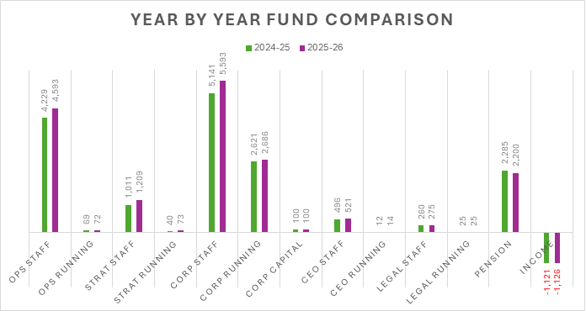

Admin Future Years
 | Current Year | 2025-26 | 2026-27
Staff | 11,135 | 12,191 | 12,784
Running | 2,767 | 2,869 | 2,856
Capital | 100 | 100 | 100
Income | (1,121) | (1,126) | (1,126)
Pension | 2,285¹ | 2,200 | 2,200
Funding Required | 15,166 | 16,234 | 16,814
1 Pension pressure for current year was increased by 85k as part of the Q3 budget review
Staff costs are increased in 2026-27 to reflect current SG pay policy. Negotiations have not yet commenced for the possible three year deal. We have presumed a 4% increase in 2025-26, and a 3% increase in 2026-27 for the purpose of this paper. Please note that any changes to the 2025-26 pay award would mean adjustment to the starting point for 2026-27.
Running costs reduce in 2026-27 as we intend to commence the user licence recharge to Fund. It should also be noted that the Oracle licences (which we had previously paid upfront for four years) will become due again in late 2025-26/early 2026-27, and the budget assumption now is that we will only renew a year at a time.
Income levels and pension costs are forecast at the same level.

Funding Pressures
Given the well published pressures on public sector finance, we continue to plan on the basis that funding will not meet all inflationary pressures.
For context, our Admin budget has just under 90% on staffing costs. Approx 61% of running costs are spent on IT infrastructure and essential property costs, leaving just under 7% of total budget for discretionary spend, such as training, research, and employment law advice.
Budget holders have been asked to identify a range of potential savings to support this longer term planning. The savings will be progressed and monitored by the Executive Team.
The Executive Team have recently agreed the principles for SLAB’s future workforce planning and discussed some of the tools that may be required to enable benefits to be fully realised. Simplification is a key driver for legal aid reforms and any impact on SLAB resource will be planned for as part of the roll out using the principles identified in our workforce plan.

Fund Non-Judicare

Summary Fund Budget Requests for 2025-26
As with Admin, all Client Legal Services departments, Quality Assurance and other non-judicare Fund areas have submitted budget requests for 2025-26.

£k | Staff | Running | Capital | Case Related | Total Budget
PDSO | 3,776 | 826 | 32 | 425 | 5,059
CLAO | 2,048 | 257 | 19 | 168 | 2,492
SCL | 1,143 | 33 | 1 | 18 | 1,195
Central CLS | 330 | 150 | - | - | 480
Vacancy Gap CLS | (160) | - | - | - | (160)
Total CLS | 7,137 | 1,266 | 52 | 611 | 9,066
Glasgow Courts | 69 | - | - | - | 69
SNSIAPS | 117 | 43 | - | - | 160
Quality Assurance | - | 176 | - | - | 176
Grant Funding | - | 2,476 | - | - | 2,476
Total | 7,323 | 3,961 | 52 | 611 | 11,947

Fund – Movements across spend types between 2024-25 and 2025-26

You can see from the chart above that whilst most areas remain largely static, there are increases for PDSO and CLAO. The main driver for these increases is in Staff costs.
An explanation of the major variances between the 2024-25 revised Q3 forecast and the proposed 2025-26 budget for Client Legal Services (CLS) areas is given below.

CLS Staff
As for Admin, the budget build assumes pay increases for all grades of 4% in April.
In 2024-25 it was agreed that several over-established posts would be created in CLS. These posts are fixed term, and most will end during the 2025-26 budget year. At this point, the service will resort back to the established posts only. Due to timing of recruitment, the posts did not all start at the same time so the end of their fixed terms will occur across the 2025-26 year and not all on the same date.
For the first time we have built in a negative allowance for the effect of vacancy gaps, the percentage of paybill used to calculate the allowance is 2.2% of total paybill, which is the same percentage used in Admin. The allowance has been set at £(160k).

CLS Running
Inflationary increases haven affected most cost areas, largely utility/facilities costs to run the multiple office locations across CLS.
Costs for the relocations of PDSO offices in Falkirk and Glasgow have been factored into the budget.

CLS Case Related
We have seen increases in case related costs during 2024-25, specifically down to the cost of experts. The budget assumption is that this is an area that we will continue to see increases in. We will however keep this area under review as the year progresses.

Grant Funding
Currently, we have no clear view from Scottish Government as to the overall budget available for 2025-26, so the budget assumption is flat year on year funding of £2,476k.

Future Year Costs for Client Legal Services
The table below shows current and future costs for the Client Legal Services directorate only.
 | Current Year | 2025-26 | 2026-27
Staff | 6,146 | 7,137 | 7,438
Running | 1,442 | 1,266 | 1,251
Capital | 31 | 52 | 48
Case Related | 556 | 611 | 633
Funding Required | 8,175 | 9,066 | 9,370
Staff costs have increased by over £800k between 2024-25 and 2025-26 due to 2025-26 assuming a full quota of staff and 2024-25 holding a significant number of vacancies which took some time to fill.
The staff cost increase between 2025-26 and 2026-27 due to pay remit (like Admin, presumed at 4%), is partially offset by the removal of the over-established posts from 2024-25 and 2025-26 as they reached the end of their fixed terms. Both 2025-26 and 2026-27 contain a vacancy gap of £(160k).
The main fluctuations in running costs are caused by office relocations in the year. 2024-25 contained PDSO Falkirk and 2025-26 will see the move of PDSO Glasgow and the dilapidations payment for Falkirk. Running costs are reduced in 2026-27 as there are no planned office relocations currently.
Case related costs are increasing year on year, the largest cause of increase is the cost of expert’s fees, specifically medical experts.
Governance links
- Finance and resources
Paper details Funding for Admin GIA and budget requests for Admin and Fund (non-judicare) expenditure.
- Risk
Our work to monitor administrative expenditure enables us to mitigate corporate risk 6 with awareness of pressures and ensuring planned changes are reflected.
- Legal and compliance
N/A.
- Performance
N/A.
- Equalities impact
N/A.
- Privacy impact and data protection
N/A.
- Communications and engagement
It has previously been agreed that this paper be published.

Conclusion and next steps
The proposed budget is presented with a small, £14k, overcommitment, Scottish Government have yet to confirm the position with the new Employers NI costs.

Appendix and/or further reading links
N/A.

The approved number of posts required for the normal and regular activity of the organisation.

