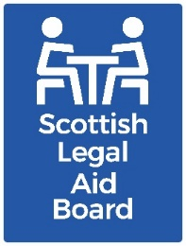 Board Report
AGENDA ITEM: 11
REPORT NUMBER: SLAB /2025 /40
Report details
Report to: The Board
Meeting date: 3 November 2025
Report title: Business Plan Update
Report category: For discussion
Issue status: Business as usual
Written by: Andrew McIntosh, Corporate Support Manager
Director responsible: Colin Lancaster
Presented by: Andrew McIntosh
Contact details: ceo@slab.org.uk
Delivery of Strategic Objectives
Select our relevant Strategic Objective(s).
1 – Administration: Our timely, clear, and consistent decisions on legal aid applications and accounts deliver a positive customer experience.
2 – Delivery: Our client legal services and targeted funding deliver high quality and accessible information, advice, and representation.
3 – Investing: We support our people to develop the skills and ways of working needed to deliver our mission, both now and in the future.
4 – Shaping: Our insightful, evidence-based and outcome-focused advice to Ministers supports their decision-making on the future of legal aid and SLAB.
Link to Board or Committee remit:
The Board has reserved authority to approve SLAB’s annual business plan. The Board considered and approved the 2025-26 business plan in March 2025.
The Board is subsequently responsible for overseeing and scrutinising progress against its delivery.
Link to Risk Management:
The corporate business plan is a key vehicle for us to deliver our Corporate Plan. Our corporate risk register details how we are trying to mitigate against a range of risks that may divert our resources away from delivering this plan of work.
Publication of the paper:
We consider this paper is suitable for publication.
Previous Consideration
Meeting: August 2025.
It was noted that it was early in the business year and there were no serious concerns around the ability to deliver the scheduled programme of work at this stage.
The Board agreed that when a project or workstream was not on target that additional information in relation to implications and a revised target date should be given.

Project status
The status of each project is given a traffic light score by the project sponsor. This is based on the risk to the overall delivery of the project and concerns around high level issues. For this reason, the status may differ to that which is reported at a project board level which may be dealing with more granular or short terms issues. Each score is categorised as follows:


Green: The project overall is on track in terms of project end date and deliverables. Green may also mean that the project has been fully delivered.
This is represented by the symbols and .

Amber: Issues or delays exist which may affect the overall success of the project, but these are being dealt with by the project manager and sponsor. Any deviation from the plan remains within tolerance levels and risks to overall delivery are not serious.
This is represented by the symbol .

Red: There are significant risks to the overall success of the project which require corrective action to meet the project’s objectives. The issues cannot be handled solely by the project manager or sponsor. One or more aspects of the project exceed tolerances.
This is represented by the symbol .
This report covers the period up to the end of September 2025.

Progress summary and future reporting
The updates below focus on the projects that are currently amber.
As the Executive progress with discussions on the Corporate Plan we have also been reflecting on the business planning process in general. The latter has also been subject to scrutiny by managers as part of their leadership and development group work. This has highlighted several improvements that could be made to the way in which key business activity is decided upon, monitored, and aligned with our new Corporate Planning and Delivery Team.
This work is also considering how best to report progress to the Board to ensure they get the right level of information, for example on milestone activity and delivery of benefits, to enable Board to scrutinise our key activities. This will include lessons we can take from previous iterations of this report and feedback we have previously had from members.
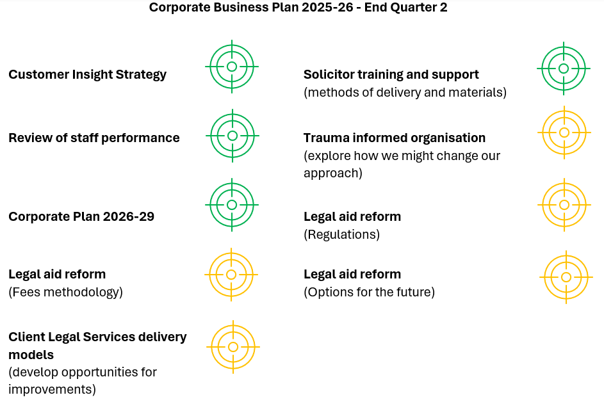

Journey to become a trauma informed organisation
This project has moved from green to amber.
Our discussions have highlighted that there already appears to be a range of good practice across the organisation that is already cognisant of trauma with a strong employee wellbeing offer. The Executive Team has considered a suggested corporate approach to become trauma informed. However, has agreed at this stage not to progress with a corporate approach. Instead, we plan to pilot the approach in one area of the teams, and this will inform our future roll out.

Legal Aid Reform – implementation of regulations

Legal aid reform – payment review mechanism

Legal aid reform – future legal aid
We have debated internally the status that these projects should have on the business plan.
We are progressing our work well, for example in terms of what is being asked of us from Scottish Government. On the regulations we have provided a range of advice and are assisting with the consultation, we have submitted detailed advice on the payment review mechanism, and we are in a good place to speak to stakeholders by the end of the year on future legal aid reform.
However, the project updates reported separately to this meeting point towards current issues that have the potential to impact the overall success of the projects, and it therefore seems more appropriate to give these projects an amber status.

Client Legal Services delivery models
The aspects of this work are a review of the Solicitor Contact Line and the testing of new approaches with the aim of informing longer term reform. This work has always been intended to run into 2026-27.
This was assessed as amber at the latest review due to elements of the work dependent on further clarity being required around legal aid reform and the need to develop current management capacity in the network. This remains the case for CLAO and PDSO. However, the Executive Team has agreed parameters for the first phase of the SCL redesign work, with an initial update scheduled for discussion on 4 December 2025.
Governance links
- Finance and resources
Delivery of the business plan will be done within available funding. Availability of resources has the potential to impact on the delivery plans of individual projects. Future restrictions on public funding may impact on the degree of change we can contemplate whilst maintaining good financial management.
- Risk
At a local level, each project within the corporate plan will have its own assessment of risk, with risks escalated as appropriate. This may result in a risk being escalated to the corporate risk register which will be considered by the Audit Committee and the Board.
- Legal and compliance
We are required by our framework agreement with Scottish Government to have a business plan in place and published on our website. Progress against the plan is monitored by the Board and Scottish Government.
- Performance
Performance against the plan will be measured through the established business planning update process. Performance on our administration of the legal aid schemes will be monitored through our performance benchmarks. A revised set of benchmarks has been agreed.
- Equalities impact
Equalities issues are a key driver for much of the activity within the business plan. All activity that results in changes to policies or procedures will be subject to equalities impact assessment.
- Privacy impact and data protection
N/A.
- Communications and engagement
We publish the plan itself, and we also publish the board papers that deal with progress.

Conclusion and next steps
The Board is asked to consider progress made on the 2025-26 plan and comment as necessary.

Appendix and/or further reading links
N/A.

