

Business Plan 2026-27
April 2026

Contacts
To access this report in an alternative format please contact our Communications office:
Telephone: 0131 226 7061.
Email: Communications@slab.org.uk.
Information about the Scottish Legal Aid Board is available on our website: Corporate information - Scottish Legal Aid Board.
Contents
Our Organisation 3
Our contribution to Scottish Government outcomes 4
What is legal aid? 4
Our financial settlement 4
Our priority activity 2026-27 5
Business Plan Activity 6
Activity Description 6
Deliverables in 2026-27 6
Delivery of Corporate objective(s) 6
How will we deliver 12
Monitoring performance 13
Corporate Performance 13
Operational Performance 13

Introduction
This report sets out our Business Plan for 2026-27, marking the first year of delivery under our 2026-29 Corporate Plan.
The Corporate Plan establishes nine ambitious objectives across three themes – Service, People and The Future – which will guide our priorities and decision-making over the next three years. These objectives are grounded in our purpose: to fund, provide and advise on services that secure access to justice, and in our vision of transforming lives through modern, responsive and accessible legal aid services.
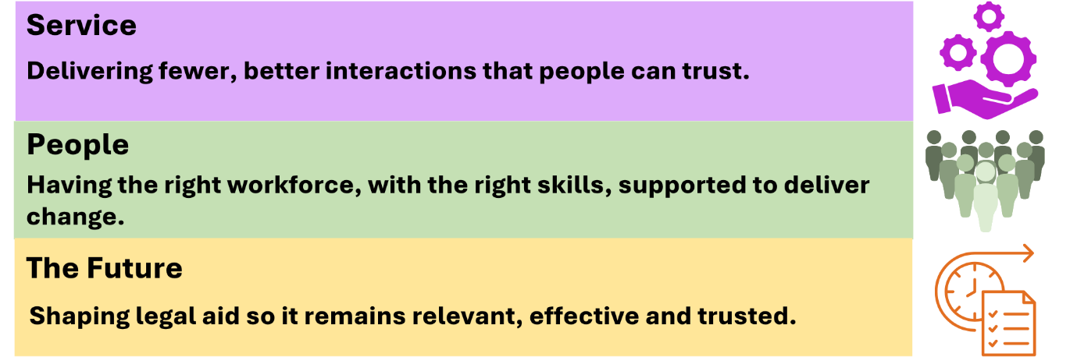
This Business Plan outlines the key activities we will deliver in 2026-27 to progress these objectives.
It does not attempt to capture all our work; business-as-usual activity remains essential to our overall performance and will continue to be managed at team level and reported to our Board.

Our Organisation
The Scottish Legal Aid Board (SLAB) was set up in 1987 to manage legal aid in Scotland. As a non-departmental public body, SLAB operates independently but is accountable to Scottish Government.
Our main purpose is to manage and deliver funding for legal assistance, and to advise Scottish Ministers on its strategic development. We are governed by a non-Executive Board with a mixture of legal and non-legal professionals. The Scottish Government is responsible for the overall direction of legal aid policy.
We employ around 370 staff and are structured around four Directorates with around half of our employees involved in the assessment of legal aid applications and the payment of solicitor and advocate accounts.
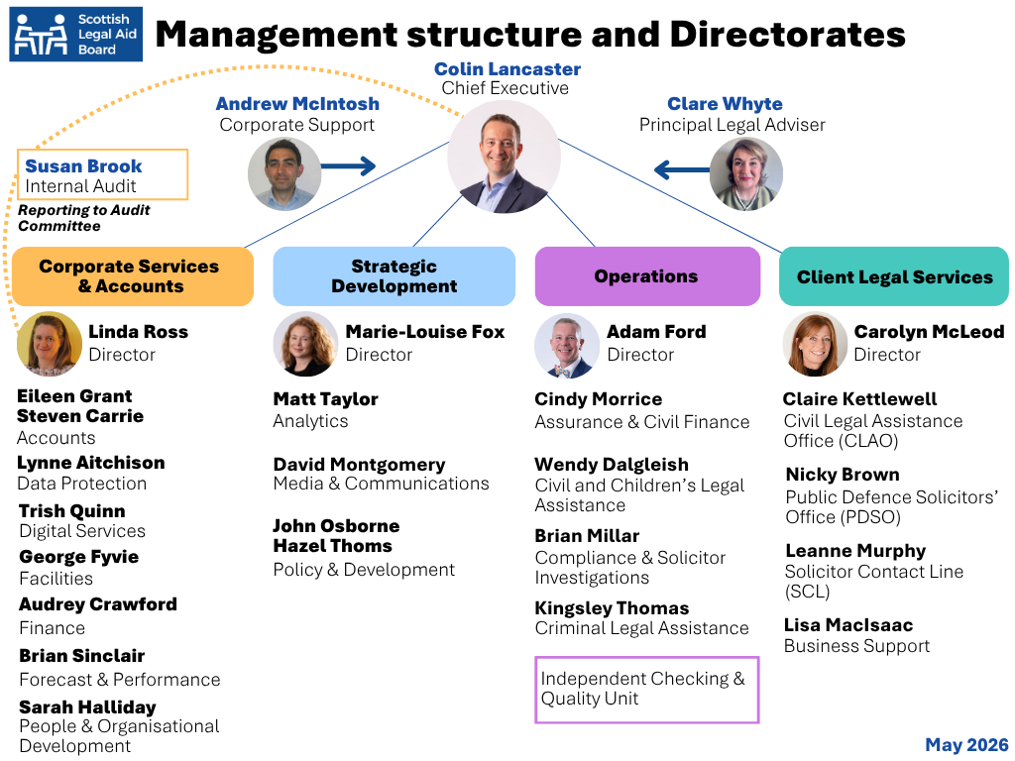

What is legal aid?

Further information is available on our website:
- New to legal aid - Scottish Legal Aid Board
- Videos on legal aid - Scottish Legal Aid Board.

Our contribution to Scottish Government outcomes
Legal aid provides a vital service, enabling people to pursue or defend their rights, often at the most challenging times in their lives, with life-changing outcomes. It also delivers wider societal benefits – supporting human rights, enabling challenges to discrimination and public bodies, ensuring representation for children, and sustaining legal services across Scotland.
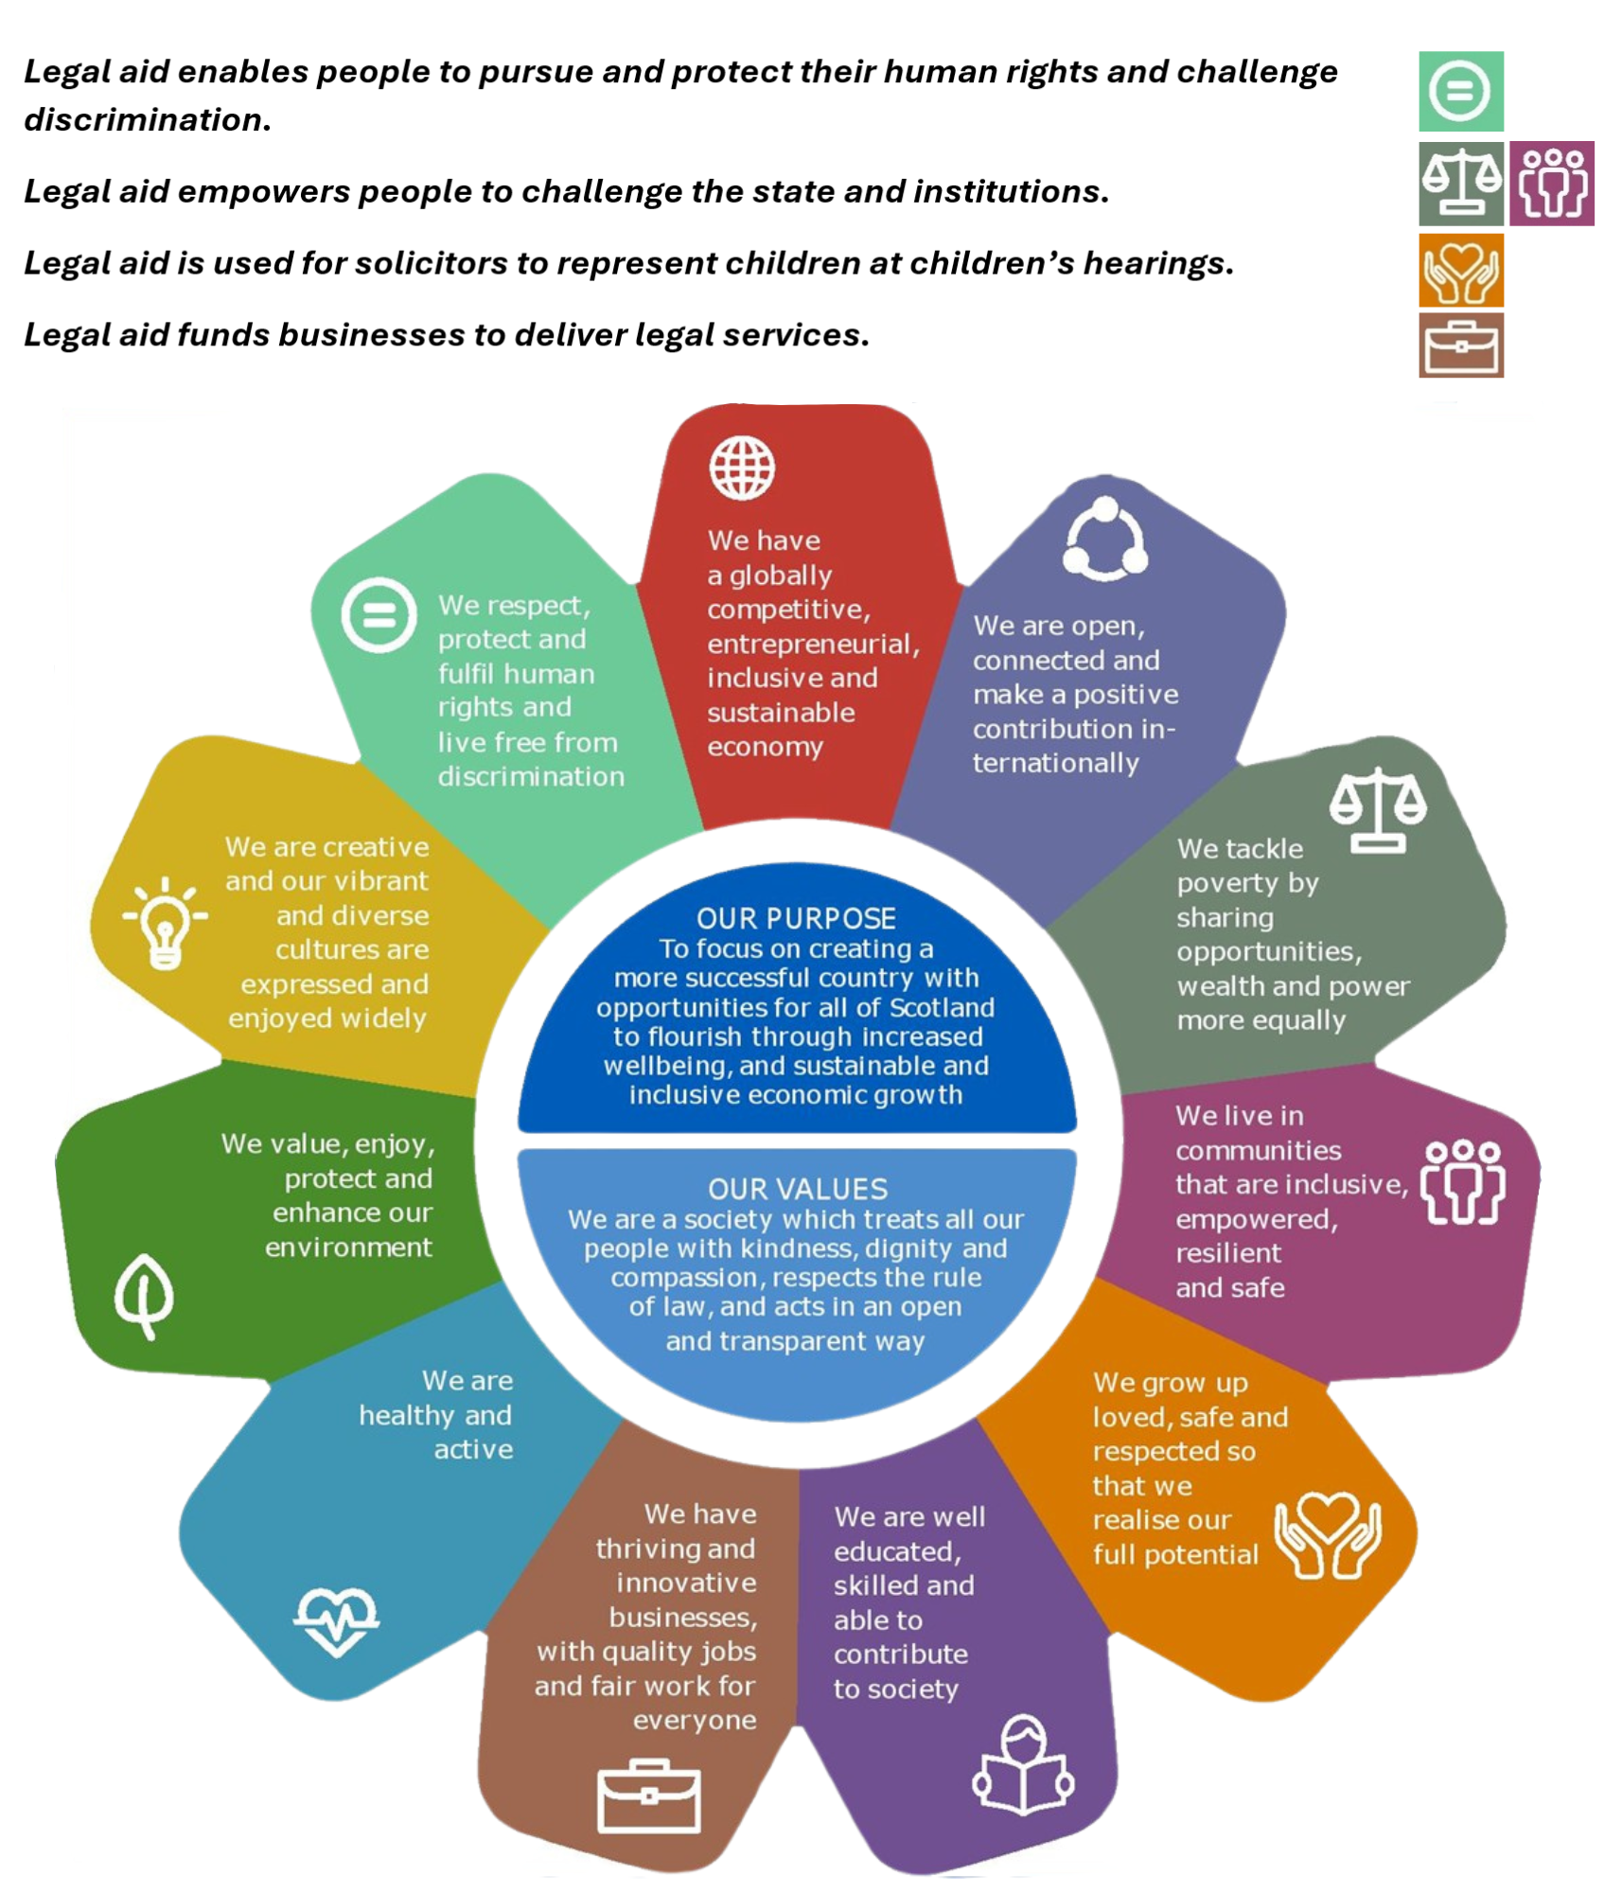

Our financial settlement
Legal aid funding is split, in line with direction from Scottish Ministers, into two distinct elements:
- Legal Aid Fund costs
- Legal Aid Administration costs.
Unlike most public sector expenditure, the Legal Aid Fund is uncapped, ensuring that any cases that meet the statutory tests will be funded by Scottish Government. However, the primary purpose of this uncapped expenditure is to ensure that applicants for legal aid are not prevented from accessing assistance due to a lack of funds. Scottish Government sets a budget provision each year, with any shortfall met at year end.
The Legal Aid Fund – by far the larger element – meets the direct costs of legal assistance, including payments to solicitors and advocates, and the delivery of services through SLAB’s Client Legal Services Directorate. This funding supports both the delivery of legal aid across Scotland and SLAB’s network of employed solicitors.
Administration costs cover the staff and systems needed to assess applications, manage grants, pay legal providers, and ensure compliance.
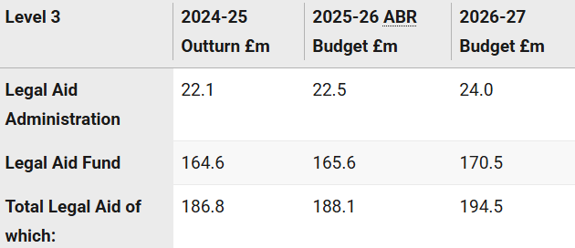
Scottish Budget 2026 to 2027 - Chapter 7 Justice & Home Affairs | Scottish Government.

Our priority activity for 2026-27
Our objectives are delivered through our themes:
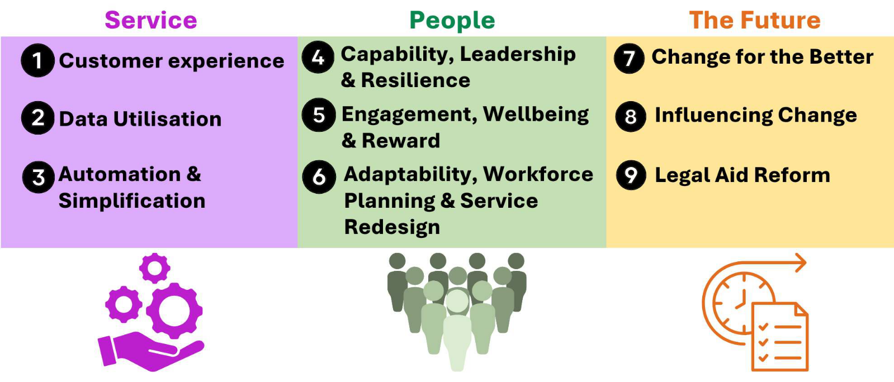
2026-27 Business Plan Activity | Activity Description | Deliverables in 2026-27 | Delivery of Corporate Objectives
- Police Station Advice service redesign | We will redesign the way in which our police station advice service is delivered via the Solicitor Contact Line | - Options appraisal  - Business case for recommended operating model  - Implementation plan. | - 1. Customer Experience  - 6. Adaptability, Workforce Planning & Service re-design  - 8. Influence change
- Review of service delivery models in Client Legal Services (CLS) | We will consider how we might remodel our current direct client legal services in response to a request from SG to consider this as part of legal aid reform. | - Options appraisal.  - Pilot initiatives agreed by Board and Ministers.  - Pilot delivery plan. | - 1. Customer Experience  - 4. Capability, Leadership and resilience  - 6. Adaptability, Workforce Planning & Service re-design  - 7. Change for the better  - 8. Influence change  - 9. Legal Aid reform
- Legal Aid Reform regulations | We will implement the necessary changes in preparation for the regulations approved by the Scottish Parliament in February 2026. This will include system updates, guidance, communications and training. | - Solemn fee changes in April.  - Children’s regulation changes in June.  - Summary/ABWOR Regulation changes in December.  - Fee uplift in September.  - Production of decision makers’ guidance.  - Training to staff and the profession. | - 1. Customer Experience  - 3. Automation & Simplification  - 4. Capability, Leadership and resilience  - 7. Change for the better  - 8. Influence change
- Continuous improvement framework | We will establish and embed an organisation wide framework for identifying, prioritising, monitoring and delivering continuous improvement opportunities | - Agreed framework.  - Agreed programme of work.  - Agreed methodology for measurement of benefits. | - 1. Customer Experience  - 3. Automation & Simplification  - 7. Change for the better
- REACT system upgrade | We will procure a digital delivery partner to review the civil legal aid process and commence early implementation to support transition to the REACT platform. | - Procure delivery partner.  - Scope civil legal aid development. requirements.  - Limited implementation of development. | - 1. Customer Experience  - 3. Automation & Simplification  - 7. Change for the better
- Pilot of trauma informed approach | We will pilot and evaluate a trauma informed approach to delivery within the civil and children’s legal aid teams to inform recommendations for future organisational rollout. | - Pilot scope agreed.  - Run pilot.  - Pilot evaluation report.  - Agreed approach to organisational roll out. | - 1. Customer Experience  - 2. Data Utilisation  - 4. Capability, Leadership and resilience  - 7. Change for the better
- Workforce planning | We are rolling out workforce planning through the completion of team or departmental level workforce plans. The People and OD team will provide targeted support to managers.  By 2029 all teams will have their own workforce plan. | - Agree prioritised list of workforce  - Provision of support through tools and guidance  - Completion of agreed priority workforce plans  - Review of learning and refreshing of tools. | - 1. Customer Experience  - 2. Data Utilisation  - 4. Capability, Leadership and resilience  - 6. Adaptability, Workforce Planning & Service re-design  - 7. Change for the better
- Implementing a change methodology | We will strengthen our ability to manage change by developing and rolling out the ADKAR change model, supported by guidance and tools. | - Development of guidance on ADKAR.  - Development of governance structure to monitor and support change.  - Launch of change model. | - 1. Customer Experience  - 2. Data Utilisation  - 4. Capability, Leadership and resilience  - 6. Adaptability, Workforce Planning & Service re-design  - 7. Change for the better  - 9. Legal Aid reform
- Piloting the use of Artificial Intelligence | We will pilot the use of Microsoft Copilot and related AI tools across selected business areas. | - Completion of selected pilot activity.  - Evaluation report summarising outcomes and lessons learned.  - Recommendations for wider deployment. | - 1. Customer Experience  - 2. Data Utilisation  - 3. Automation & Simplification  - 4. Capability, Leadership and resilience  - 7. Change for the better
- Customer Insight Strategy | We will implement the 2026-27 action plan for the Customer Insight Strategy that was finalised in January 2026. | - Establishment of Customer Insight Steering Group  - Commissioning research work  - Implementation of action plan  - Monitoring and reviewing of Insights and agree any changes and improvements to be made. | - 1. Customer Experience  - 2. Data Utilisation  - 3. Automation & Simplification  - 7. Change for the better
- Solicitor and applicant training and support hub | We will improve the consistency and quality of solicitor training delivery and general support information. | - Launch new hub area on website  - Deliver six training sessions with the LSS between May and July with recordings linked to from the hub  - Review of website content and information booklets for applicants and opponents  - Desk research to highlight ‘pain points’ in the application and account process  - Review all current training materials for content and consistency | - 1. Customer Experience  - 6. Adaptability, Workforce Planning & Service re-design  - 7. Change for the better
- Data strategy | We will develop and agree a SLAB Data Strategy and action plan. The strategy will guide us towards better data utilisation. | - Agreed strategy for 27-29.  - Agreed strategy action plan. | - 7. Change for the better  - 9. Legal Aid reform
- Legal aid reform | We will deliver a programme of legal aid reform work as agreed with the Scottish Government and monitored separately through a joint SG/SLAB Legal Aid Reform Programme Board. | - Deliverables as per legal aid reform regulations project  - Deliverables as per review of service delivery models in CLS project  - Develop opportunities for test and learn using existing funding tools  - Produce advice on further regulation changes  - Work with stakeholders to build consensus on what can be delivered by a Bill  - Contribute to meetings of the Payment Review Mechanism  - Delivery of engagement strategy activity  - Implement changes to financial assessment & contributions in civil legal aid. | - 2. Data Utilisation  - 4. Capability, Leadership and resilience  - 9. Legal Aid reform

How will we deliver
The framework of how we deliver the Corporate and Business Plans also include four supporting strategies covering People, Finance, Digital and Communications, alongside detailed Directorate Business Plans.
Progress against the Business Plan will be reported to the SLAB Board, who are responsible for overseeing delivery and managing risk.
Throughout 2026-27, we aim to strengthen our approach to business planning, monitoring and reporting, improving how we track progress and outcomes across the organisation. This will include enhanced reporting to the Executive Team, Corporate Planning and Delivery Team, and Board, supported by an outcomes-focused monitoring framework.

Monitoring performance

Corporate Performance
Quarterly reports and data are analysed by our Executive Team, Corporate Planning and Delivery Team, and Board to oversee delivery of the plan and the risks we are facing to delivery.

Operational Performance
The SLAB Board approved our operational performance benchmarks for 2026-27 in March 2026. The benchmarks reflect our customers’ experience of the legal aid journey from start to finish.
SLAB’s Operational Performance Overview Reports (SOPOR) are available here, including guidance on the application and account information in the reports, as well as our Guide to the SLAB Operational Performance Overview Report (SOPOR).
We will publish papers considered by the Board on corporate and operational performance on our website: Board and committee papers - Scottish Legal Aid Board.

