Report No: SLAB/2021/11
Agenda Item: 15

Report to: | The Board
Meeting Date: | 15 March 2021
Report Title | Benchmark Proposals for 2021-22
Report Category | For Decision
Issue status: | Business from a project

Written by: | Graeme Hill, Marie-Louise Fox and Matt Taylor
Director responsible: | Graeme Hill
Presented by: | Matt Taylor
Contact details: | taylorma@slab.org.uk

Delivery of Strategic Objectives
Select the Strategic Objective(s) relevant to the issues | 1. to deliver improvements to legal aid processes that increase efficiency and improve the experience of system users and customers.  3. to ensure that our organisation has the culture and capability to be responsive to our customers, the justice system and developments in legal and advice sectors.

Link to Board or Committee Remit
To monitor the performance of the Operational departments.

Publication of the Paper
We consider that this paper is suitable for publication. However, once agreed by the Board, a plan to communicate our approach to performance reporting with staff and the profession will be developed. We are therefore recommending that publication of this paper happens after that communication takes place.

Executive Summary
This paper proposes the benchmarks for performance reporting for financial year 21-22. Benchmarks have been proposed that balance the aim of being challenging but achievable but also the need to manage the risks and uncertainty around the coming year. They are based on performance during the pandemic in 2020/21 and also pre the pandemic in 19/20.

Previous Consideration
Meeting | Detail
Board – September 2019 | Paper reviewing more detailed information regarding performance against benchmarks during 2019-20.
Board – March 2019 | Paper proposing benchmarks for 2019-20.
Board – February 2018 | Slide presentation of thinking behind introducing static benchmarks into operational performance reporting.

Report

Introduction

- The Board paper SLAB-2019-11 (March 2019) proposed benchmarks for performance reporting for financial year 19-20. The benchmarks were designed to be challenging but achievable. They were based on performance at the time with some adjustment according to management input.
- The benchmarks were set originally with an emphasis slightly more on being achievable as the approach was a new one for us. The aim was that for each KPI most months (~ nince out of 12) would show a Met performance with around one or two months possibly exceeding (Better Than) and possibly one or two months being Worse Than performance.
- This translated into benchmarks that were set to produce mostly met (green) results, approx. nine in 12 months, with one or two worse than (yellow) and one or two better than (blue). This was done whilst attempting to find a balance between being overly sensitive and insufficiently sensitive – through setting both the benchmark and the met zone.
- Performance during 2019-20 was reported against these benchmarks. This showed that most areas had either maintained or improved their performance.
- Proposals were drawn up for 2020-21 where we proposed some changes to maintain the sensitivity of the benchmarks and/or be more challenging where it was deemed appropriate. The need to allocate resource to work on priority projects was balanced against continuous improvement.
- However, with the developing pandemic situation it was decided to only alter a single benchmark.
- Because of the hiatus in applying new benchmarks and because of the ongoing uncertainties over volumes we have presented more information than in previous papers.
- During 20-21 we saw a number of different factors affecting performance both positively and negatively. It has been a very dynamic situation and it is difficult to judge what the normal position is that we can try to improve from.
- Benchmarks have been proposed that balance the aim of being challenging but achievable, but also the need to manage the risks and uncertainty around the coming year with the resource management issues relevant to specific operational areas. They are based on performance during the pandemic in 2020/21 and also before the pandemic in 19/20. As with previous years, we aim to achieve a ‘Met’ performance in the majority of the benchmarks.

Review of Benchmarks Proposed for 2021/22

- The benchmark proposals are presented in two ways below. Firstly, there are tables summarising the proposals in numeric form.
- Secondly, the benchmarks are illustrated graphically. Each KPI is considered on a separate row. There are three columns of graphs. The first column presents the volumes of applications decided or accounts registered over the past two years. 2020 figures are shown as the black line, with 2019 figures as the red line. The volumes provide a context for considering performance. As the KPIs can relate to the same applications or accounts not each row requires a new volumes graph.
- The second column shows the KPI performance in 2020 and 2019 – again with the black line for 2020 and red for 2019, set against the current benchmarks.
- The third and fourth columns then propose changes to the benchmarks given the previous performance and volumes and the context described above.

Civil Applications

 |  | Benchmark | Zone | Benchmark | Zone
Id | Measure | 19-20 & 20/21 | 19-20 & 20/21 | 21-22 | 21-22
1 | First Decision Average Duration (AWI) | 23.0 | 10% | 17.0 | 10%
2 | First Decision % Granted (AWI)* | 96.0% | 1% | Keep same
3 | First Decision Average Duration (Other) | 70.0 | 5% | 68.0 | 5%
4 | First Decision % Granted (Other) | 63.0% | 4% | 70.0% | 4%
5 | % First Decision with FW (Other) | 18.0% | 10% | 14.0% | 10%

Criminal Applications
 |  | Benchmark | Zone | Benchmark | Zone
Id | Measure | 19-20 & 20/21 | 19-20 & 20/21 | 21-22 | 21-22
6 | First Decision Average Duration (Solemn) | 5.1 | 5% | Same | 10%
7 | First Decision % Granted (Solemn) | 85.0% | 2% | Keep same
8 | % First Decision with FW Solemn | 9.0% | 10% | Keep same
9 | First Decision Average Duration (Summary) | 10.0 | 10% | 9 | 10%
10 | First Decision % Granted (Summary) | 79.5% > 78% | 1% | 79.0% | 2%
11 | % First Decision with FW Summary | 16% | 5% | 15% | 10%
Children’s Applications
 |  | Benchmark | Zone | Benchmark | Zone
Id | Measure | 19-20 & 20/21 | 19-20 & 20/21 | 21-22 | 21-22
12 | First Decision Average Duration (Sheriff Court) | 8.0 | 5% | 7.5 | 10%
13 | First Decision % Granted (Sheriff Court) | 80.0% | 4% | 81.0% | 4%
14 | % First Decision with FW (Sheriff Court) | 10.0% | 10% | Keep same

Civil Accounts

 |  | Benchmark | Zone | Benchmark | Zone
Id | Measure | 19-20 & 20/21 | 19-20 & 20/21 | 21-22 | 21-22
1 | Duration Civil A&A & ABWOR initial assessment | 22.1 | 10% | 19.0 | 10%
2 | Duration Civil legal aid initial assessment | 24.2 | 10% | 23.0 | 10%
3 | Duration Negotiations | 50.6 | 5% | 42.0 | 10%
4 | Initial Assessments % paid in full | 63.2% | 5% | 67.5% | 5%
5 | Ratio of Negotiations to Initial Assessments | 14.1% | 10% | Keep same

Criminal Accounts
 |  | Benchmark | Zone | Benchmark | Zone
Id | Measure | 19-20 & 20/21 | 19-20 & 20/21 | 21-22 | 21-22
6 | Duration Criminal A&A | 9.6 | 10% | 9.0 | 10%
7 | Duration Criminal ABWOR Auto | 6.4 | 5% | 6.2
8 | Duration Criminal ABWOR Non-auto | 12.3 | 10% | Keep same
9 | Duration Criminal Auto | 6.4 | 5% | Keep same
10 | Duration Criminal Non-auto | 12.7 | 10% | Keep same
11 | Duration Solemn | 18.1 | 10% | Keep same
12 | Duration Negotiations | 39.9 | 10% | 32.5 | 10%
13 | Initial Assessments % paid in full | 93.0% | 5% | Keep same
14 | Ratio of Negotiations to Initial Assessments | 4.5% | 10% | Keep same
Children’s Accounts
 |  | Benchmark | Zone | Benchmark | Zone
Id | Measure | 19-20 & 20/21 | 19-20 & 20/21 | 21-22 | 21-22
15 | Duration Children’s A&A & ABWOR | 23.0 | 10% | 17.0 | 10%
16 | Duration Children’s legal aid | 23.0 | 10% | 20.0 | 10%
17 | Duration Negotiations | 31.4 | 5% | 29.0 | 7.5%
18 | Initial Assessments % paid in full | 35.3% | 5% | 41% | 5%
19 | Ratio of Negotiations to Initial Assessments | 19.3% > 35% | 10% | Keep same at 35% & 10%

Appendix 1: Graphical Illustration of Benchmarks Proposed for 21-22

CIVIL APPLICATIONS
Id | Jan20–Dec20 & Jan19-Dec19 Volumes  (not 3 mth avg) | Jan20–Dec20 & Jan19-Dec19 Performance | Option for 21-22 | Jan20–Dec20 Performance vs proposed benchmark
1 | 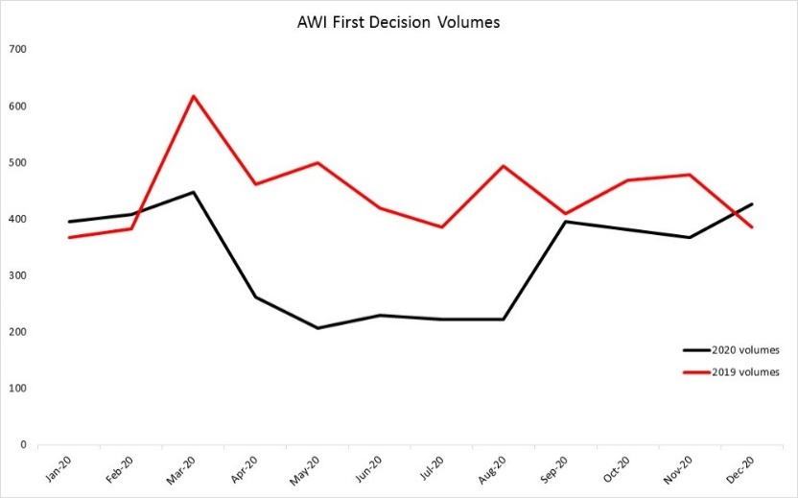 | 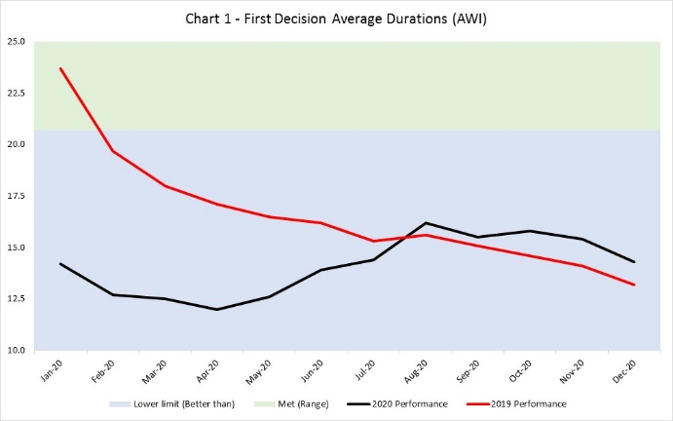 | AWI 1st Decision - Avg Duration  Go with 20/21 proposal to move from 23 to 17. | 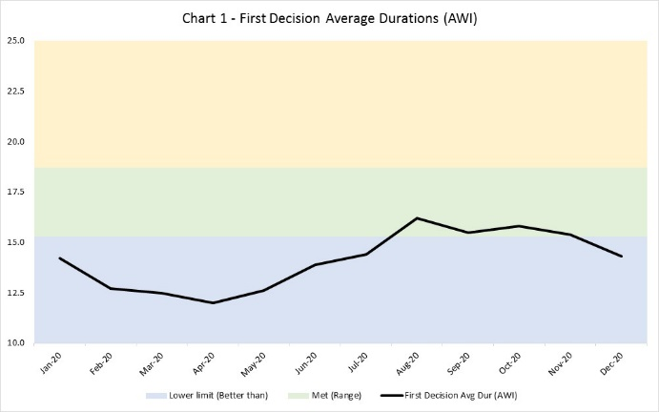
2 | AWI - As above | 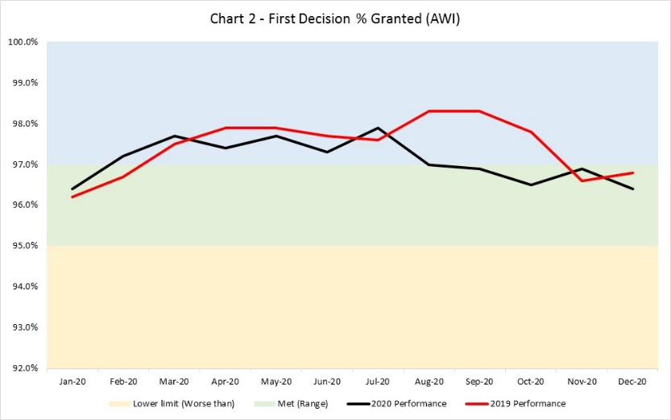 | AWI 1st Decision - % Granted  Keep same at 96%. | No change
3 | 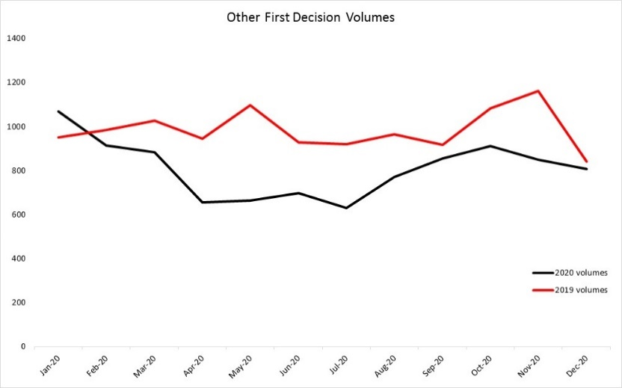 | 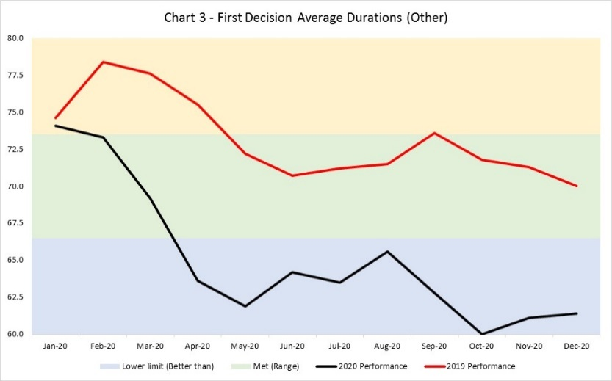 | Other 1st Decision - Avg Duration  Avg duration has actually remained low. Maybe due to fewer Form 2s ?  Could consider moving from 70 to 68. | 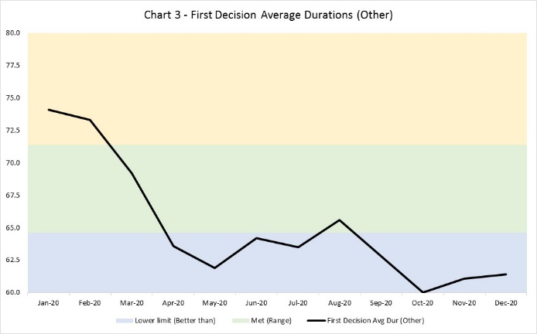
4 |  | 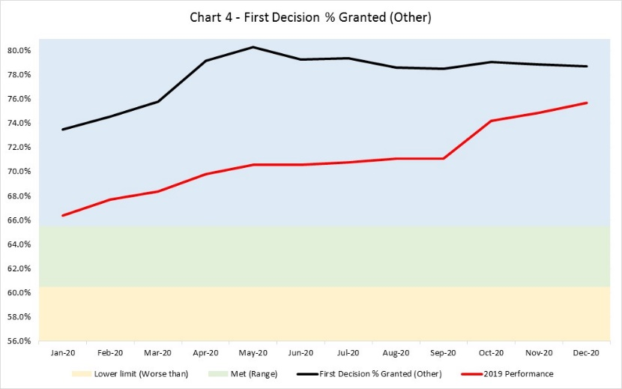 | Other 1st Decision  - % Granted  Go with 20/21 proposal to move from 63% to 70%. | 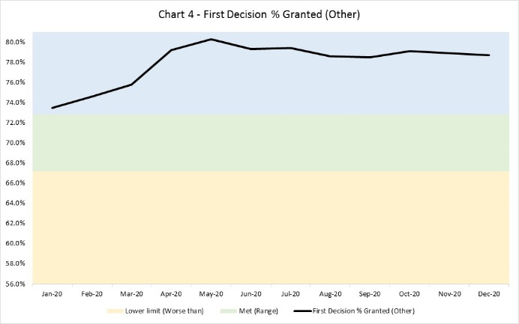
5 |  | 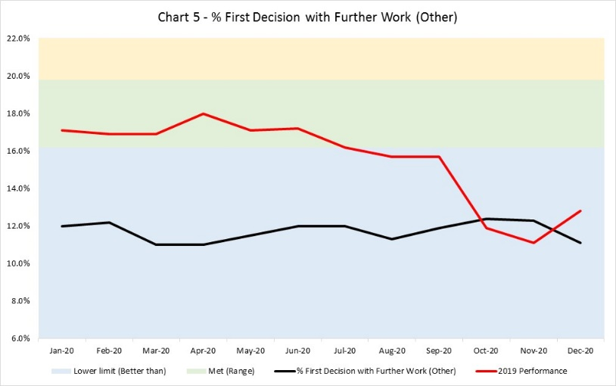 | Other 1st Decision  - % Further Work  Go with 20/21 proposal to move from 18% to 14%. | 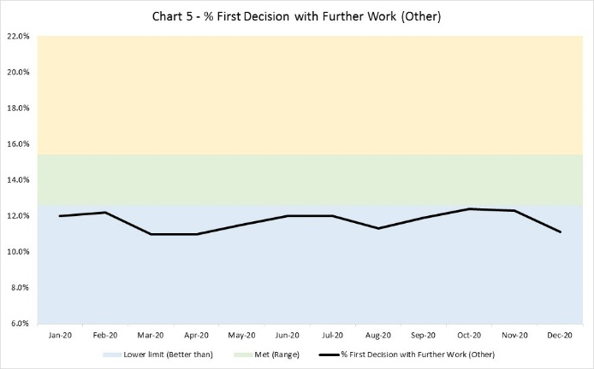
CRIMINAL APPLICATIONS
Id | Jan20–Dec20 & Jan19-Dec19 Volumes  (not 3 mth avg) | Jan20–Dec20 & Jan19-Dec19 Performance | Option for 21-22 | Jan20–Dec20 Performance vs proposed benchmark
6 | 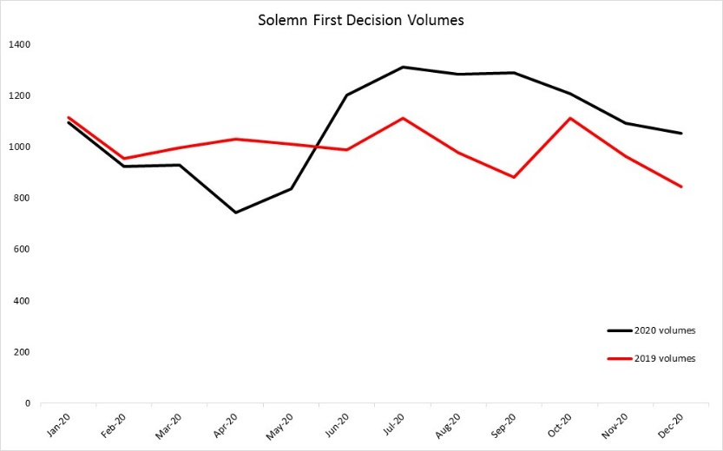 | 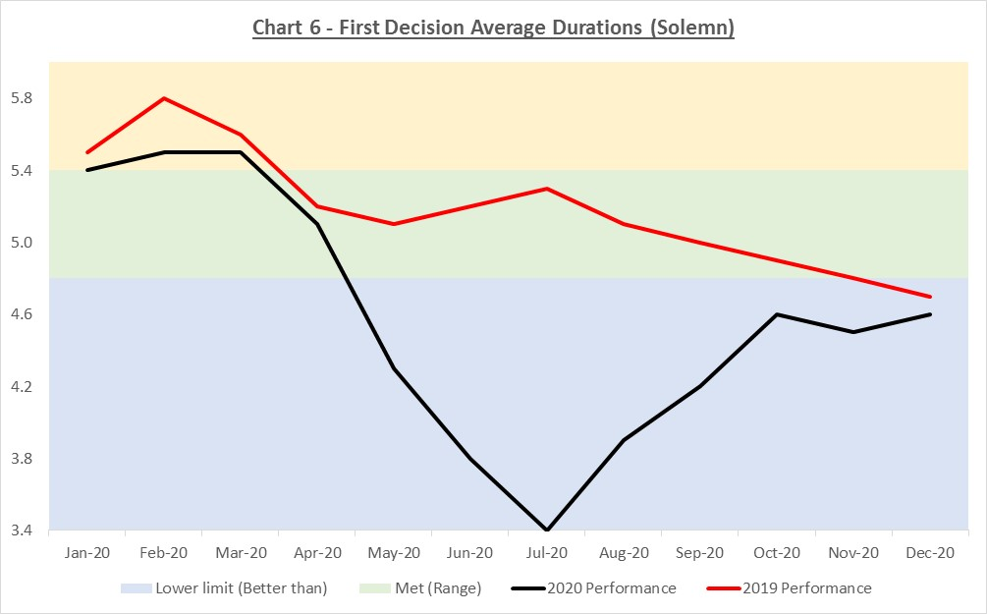 | Solemn 1st Decision - Avg Duration  Performance improved & remains just better than pre-lockdown.  Widening the met (green) zone to 10% would meet objectives. | 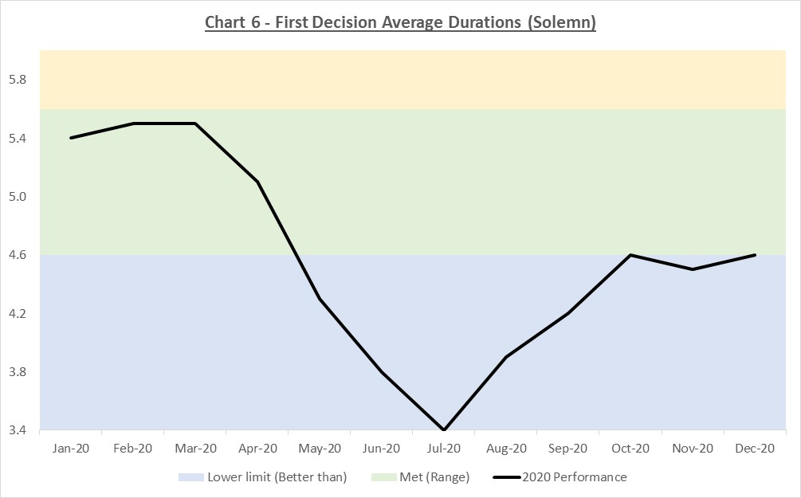
7 | Solemn as above | 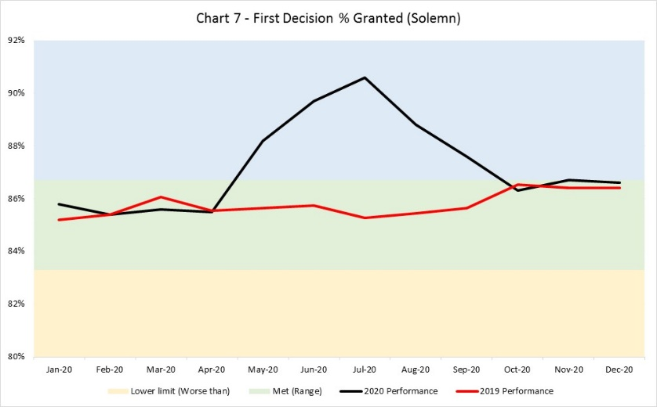 | Solemn 1st Decision - % Granted  Remain at 85%. | No change
8 | Solemn as above | 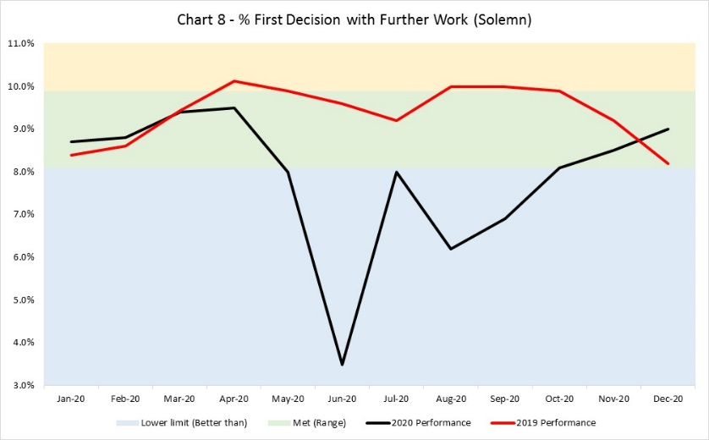 | Solemn 1st Decision - % with Further Work  Remain at 9% | No change
9 | 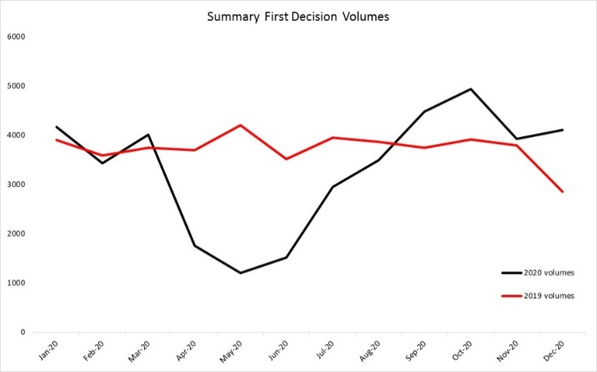 | 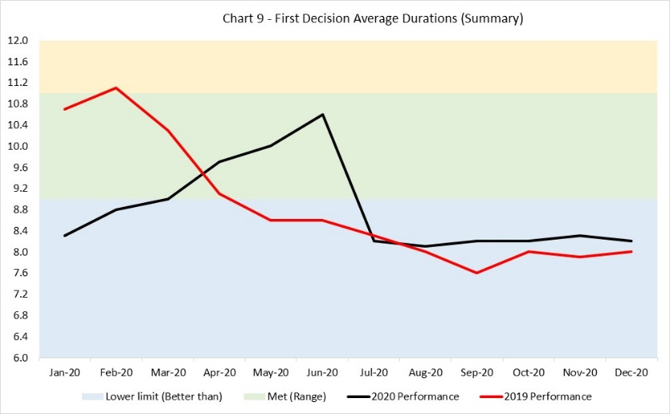 | Summary 1st Decision - Avg Duration  Perf dipped with lockdown but since recovered. Has been Better Than since July.  A move from 10 to 9 is proposed. | 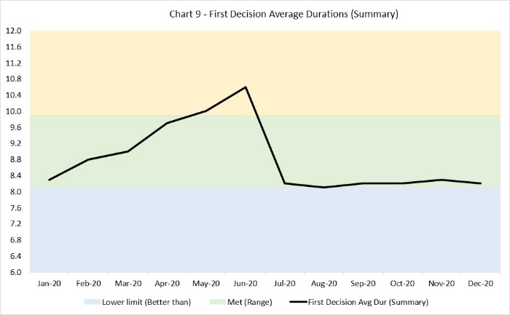
10 | Summary as above | BM changed from 79.5% to 78% Apr 2020.  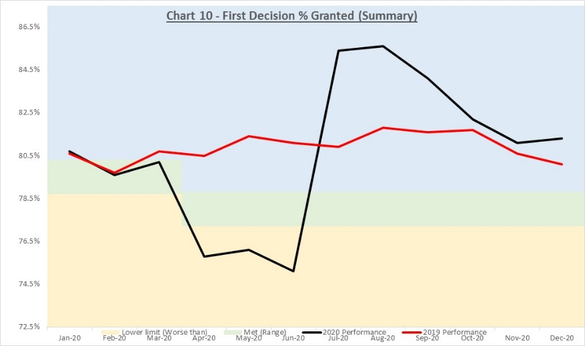 | Summary 1st Decision - % Granted  Perf dipped with lockdown but recovered. Been Better Than since July. Remains better than pre-lockdown.  Expand met zone to 2% as previously suggested and move BM to 79%. | 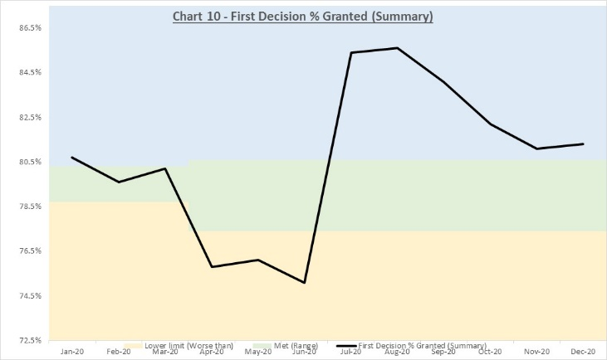
11 | Summary as above | 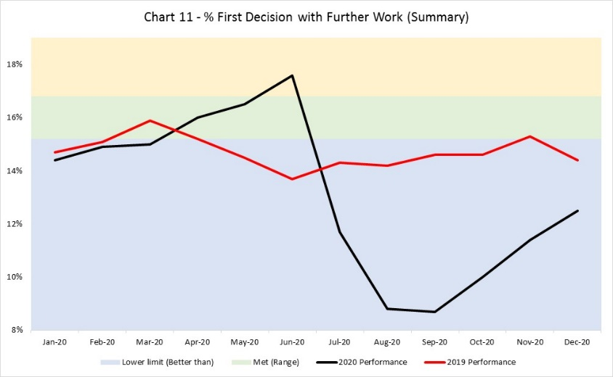 | Summary 1st Decision - % with Further Work  Dipped w lockdown but recovered. Been Better Than since July. Remains better than pre-lockdown.  Move BM to 15 and expand met zone. | 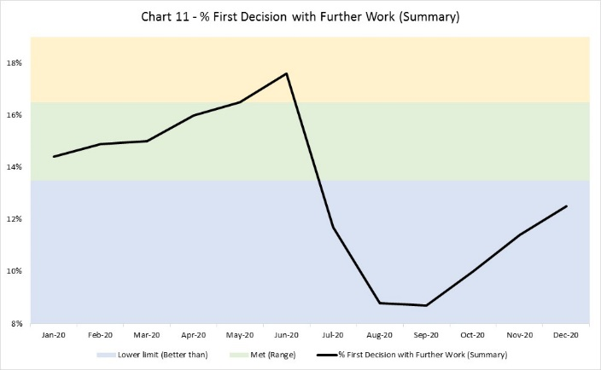

CHILDRENS APPLICATIONS
Id | Jan20–Dec20 & Jan19-Dec19 Volumes  (not 3 mth avg) | Jan20–Dec20 & Jan19-Dec19 Performance | Option for 21-22 | Jan20–Dec20 Performance vs proposed benchmark
12 | 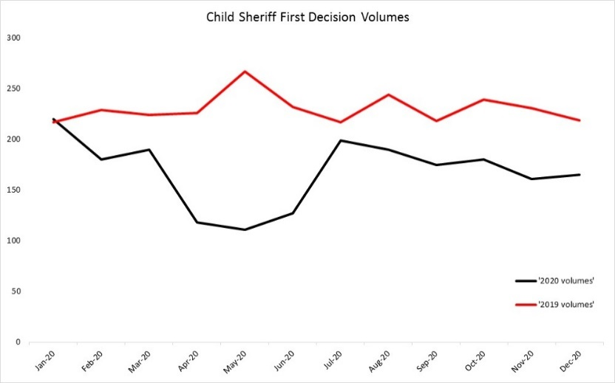 | 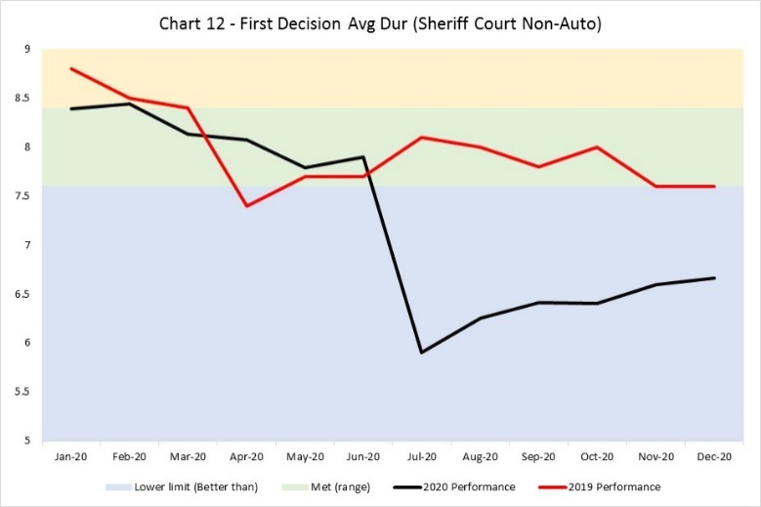 | Sheriff Court 1st Decision - Avg Duration  Perf improved considerably & sustained in lockdown.  Propose - Move BM 0.5 to 7.5 and expand zone. | 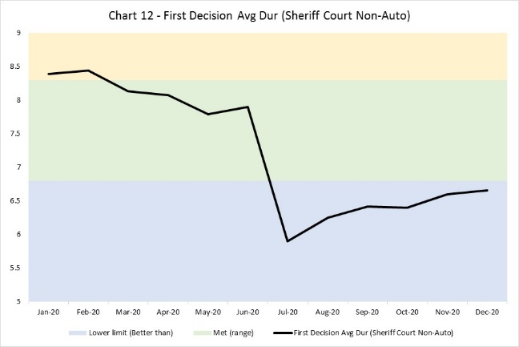
13 | Childrens Sheriff Court as above | 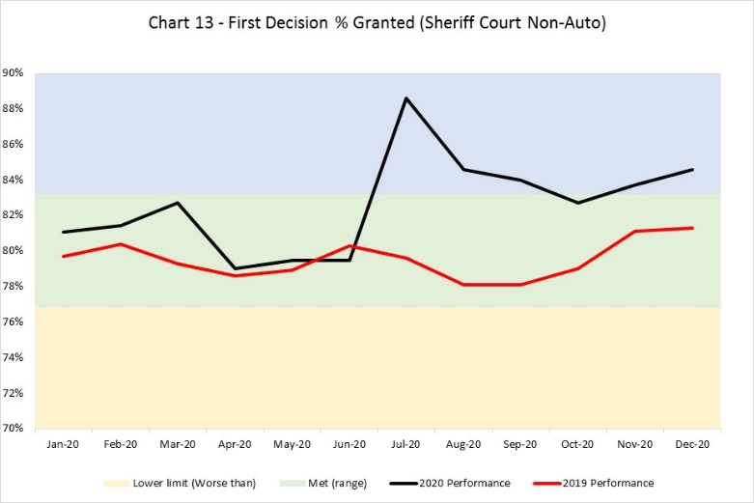 | Sheriff Court 1st Decision - % Granted  Perf slightly improved.  Increase BM 1 point to 81%? | 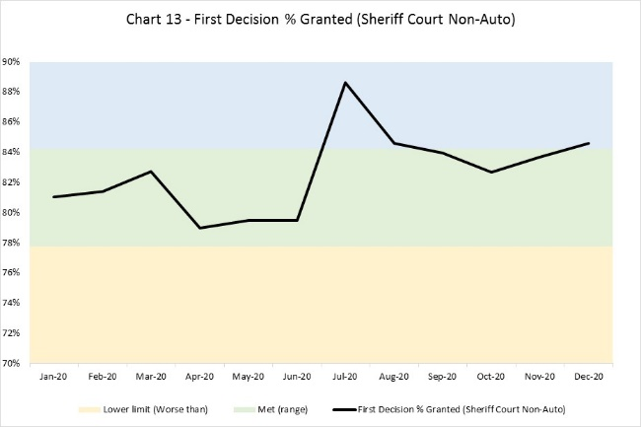
14 | Childrens Sheriff Court as above | 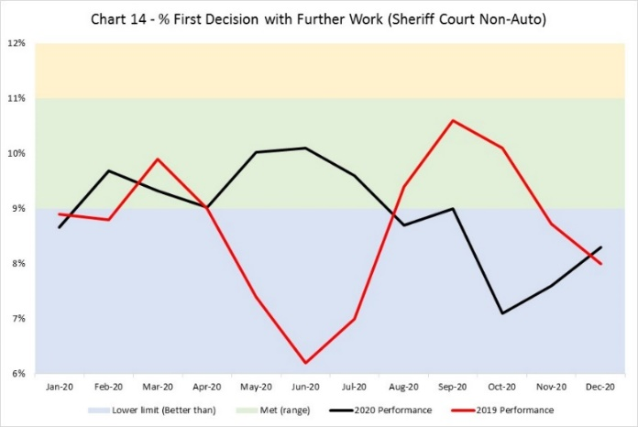 | Sheriff Court 1st Decision - % w Further Work  Slight improvement recently.  Prob leave unchanged as quite variable. | No change
CIVIL ACCOUNTS

Id | Jan20–Dec20 & Jan19-Dec19 Volumes  (not 3 mth avg) | Jan20–Dec20 & Jan19-Dec19 Performance | Option for 21-22 | Jan20–Dec20 Performance vs proposed benchmark
1 | 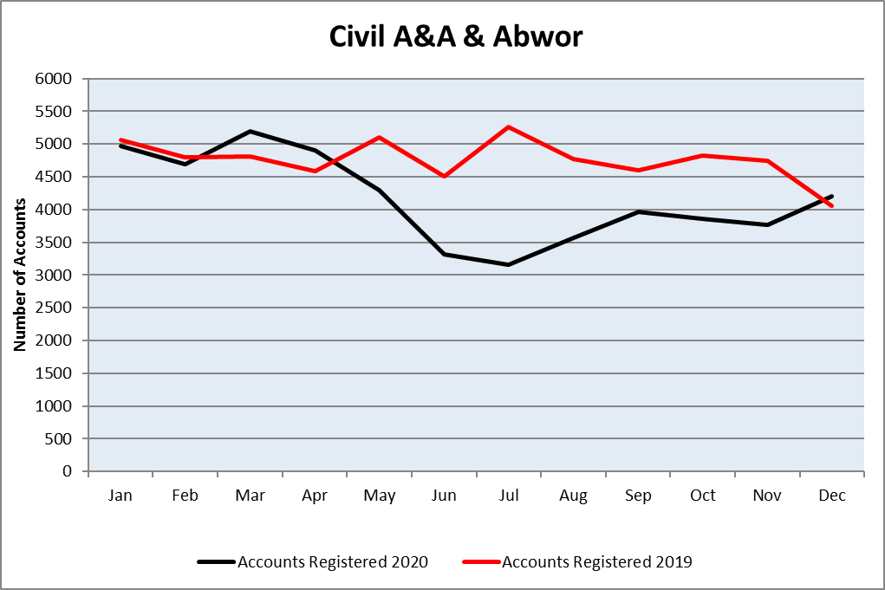 | 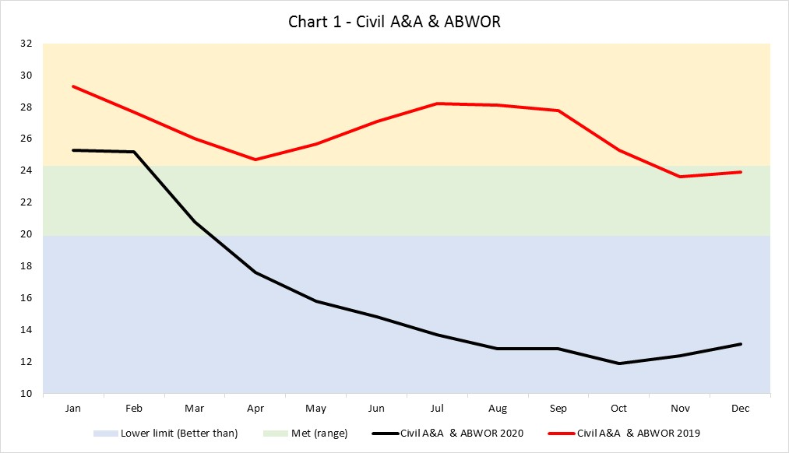 | Civil A&A & ABWOR  Performance improved considerably.  Propose change BM from 22.1 to 19.0. | 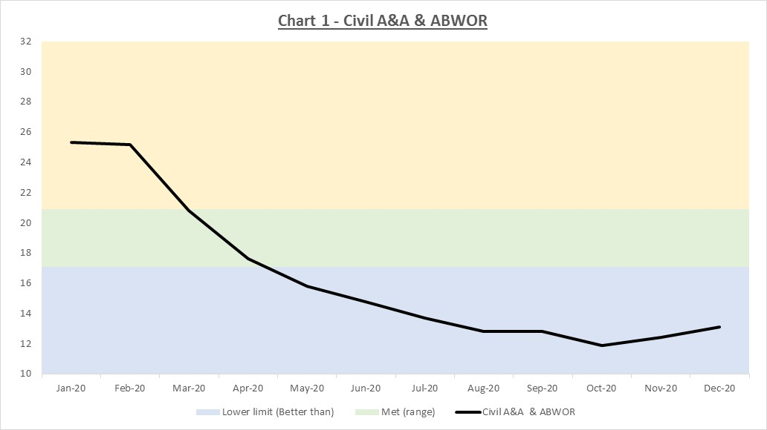
2 | 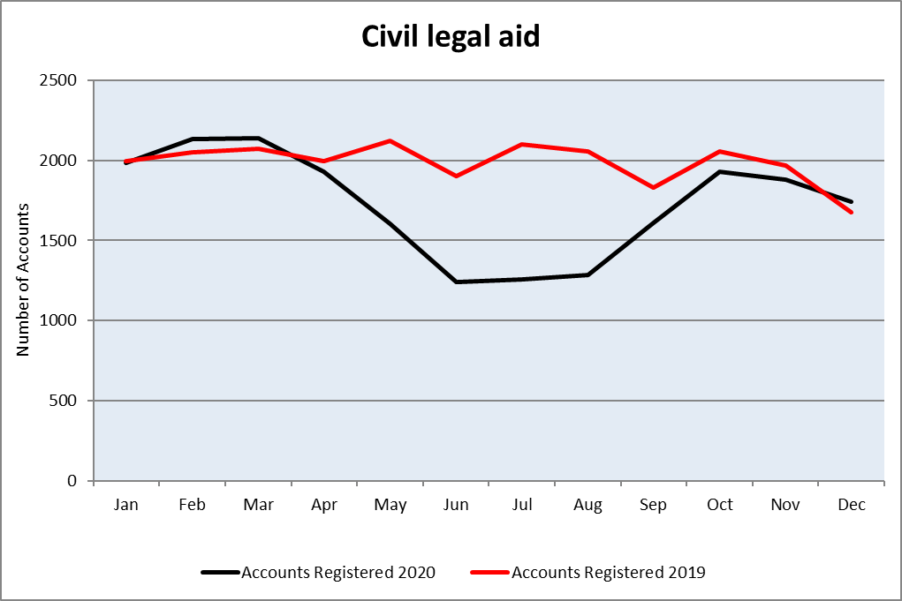 | 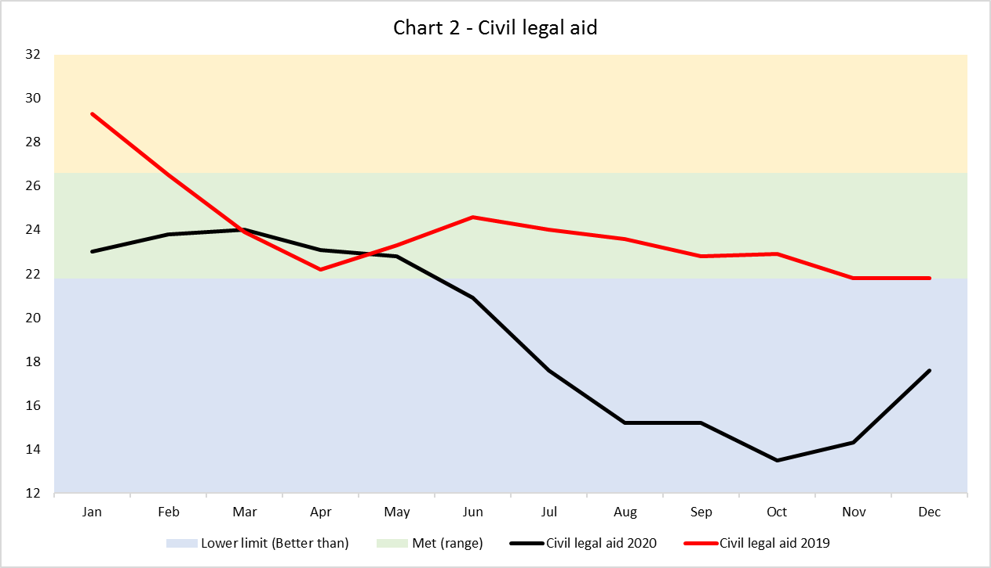 | Civil Legal aid  Propose change BM from 24.2 to 23.0. | 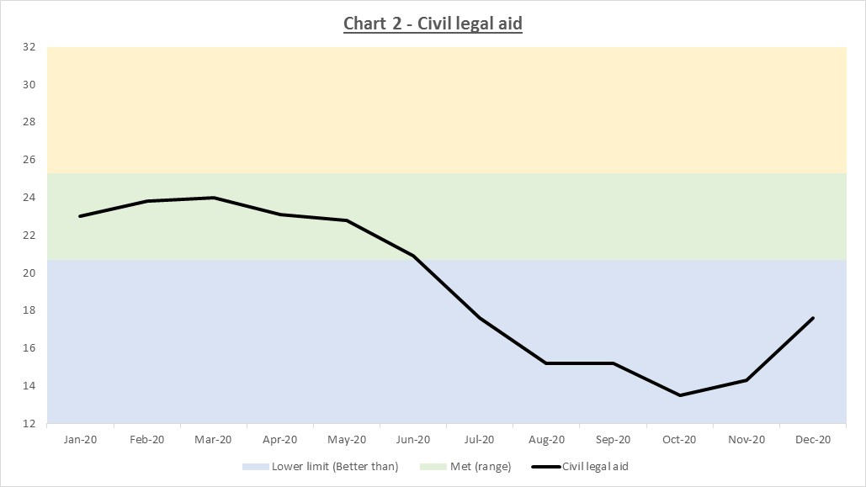
3 | 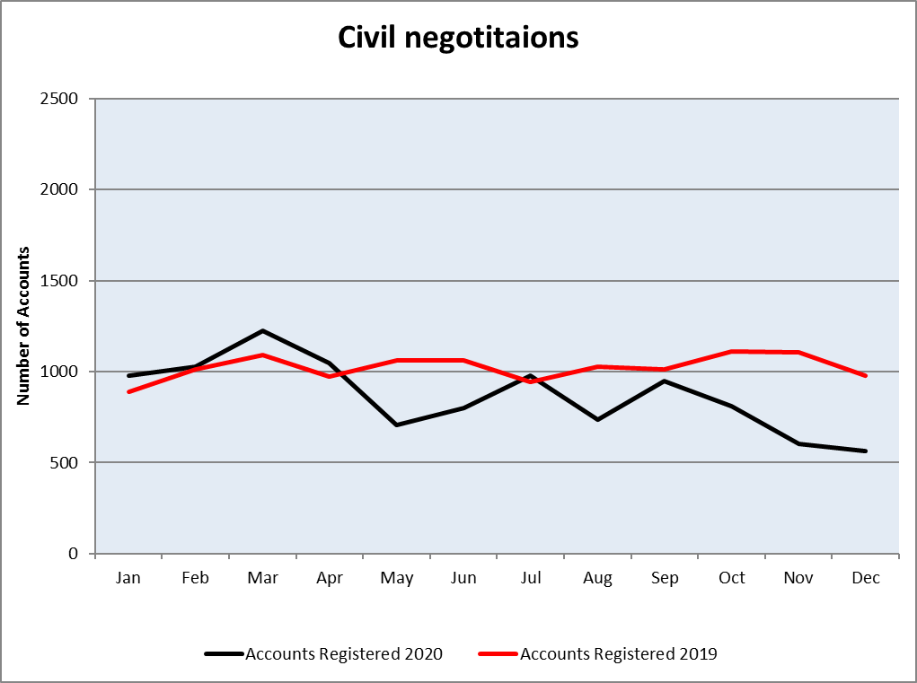 | 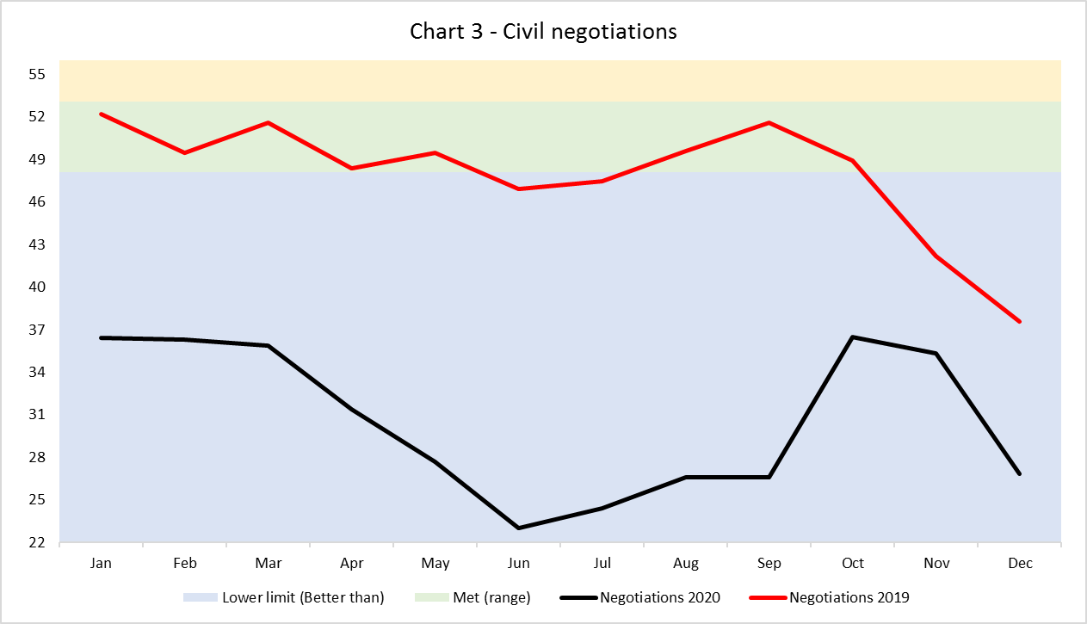 | Civil Negotiations  Propose change BM from 50.6 to 42.0. | 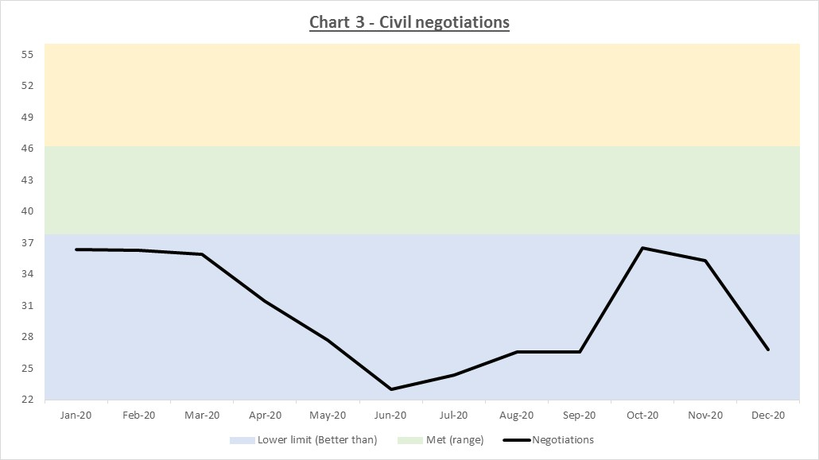
4 | As above (1&2) | 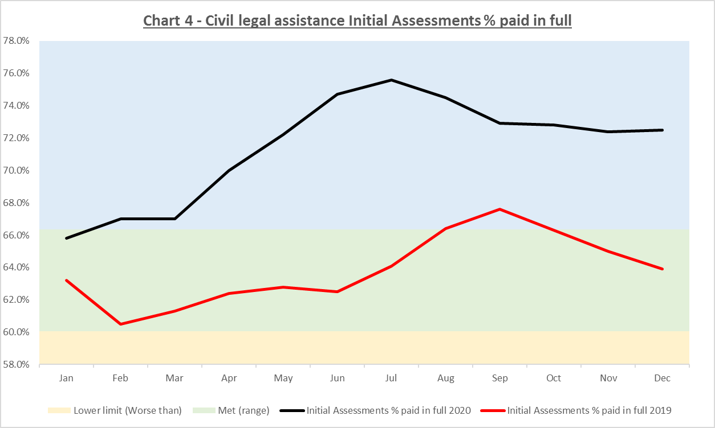 | Civil % Paid in Full  Propose change BM from 63.2% to 67.5%. | 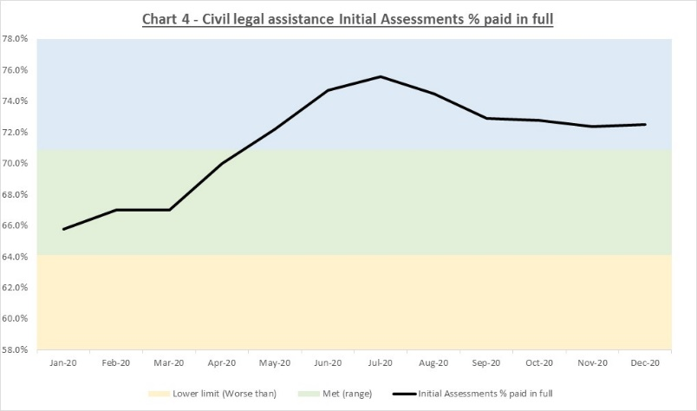
5 |  | 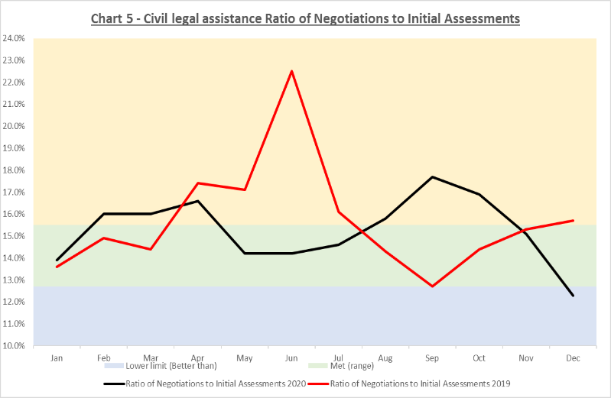 | Civil Negotiations Ratio  Keep BM same. | No change

CRIMINAL ACCOUNTS

Id | Jan20–Dec20 & Jan19-Dec19 Volumes  (not 3 mth avg) | Jan20–Dec20 & Jan19-Dec19 Performance | Option for 21-22 | Jan20–Dec20 Performance vs proposed benchmark
6 | 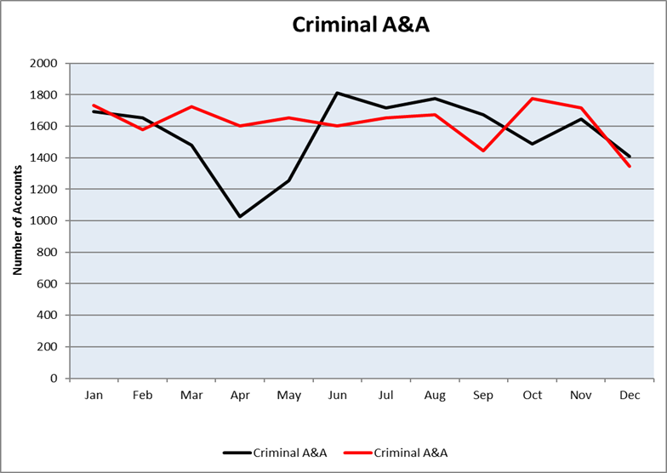 | 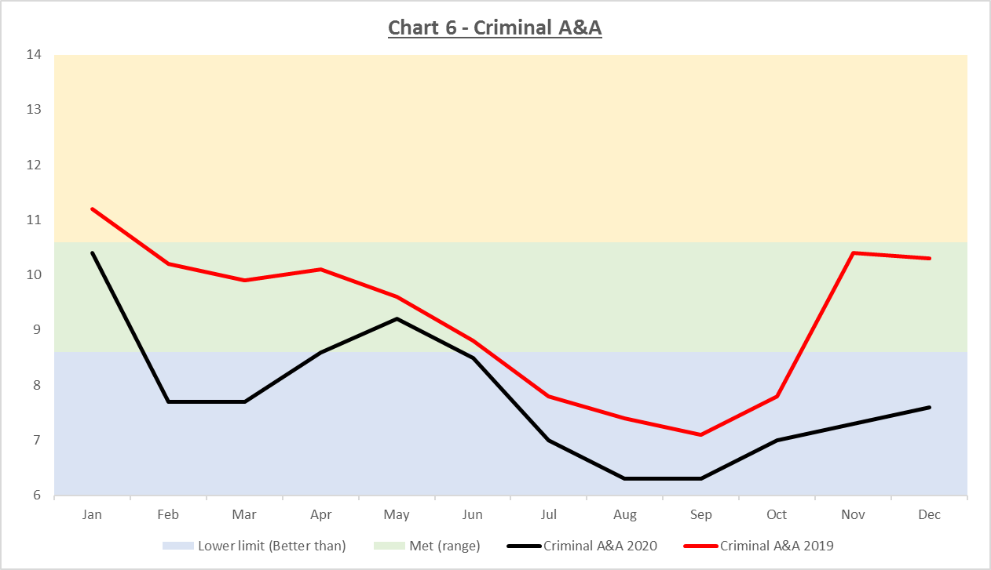 | BM set at 9.6. Performance Met or Better Than since Feb 19.  Realign from 9.6 to 9.0 | 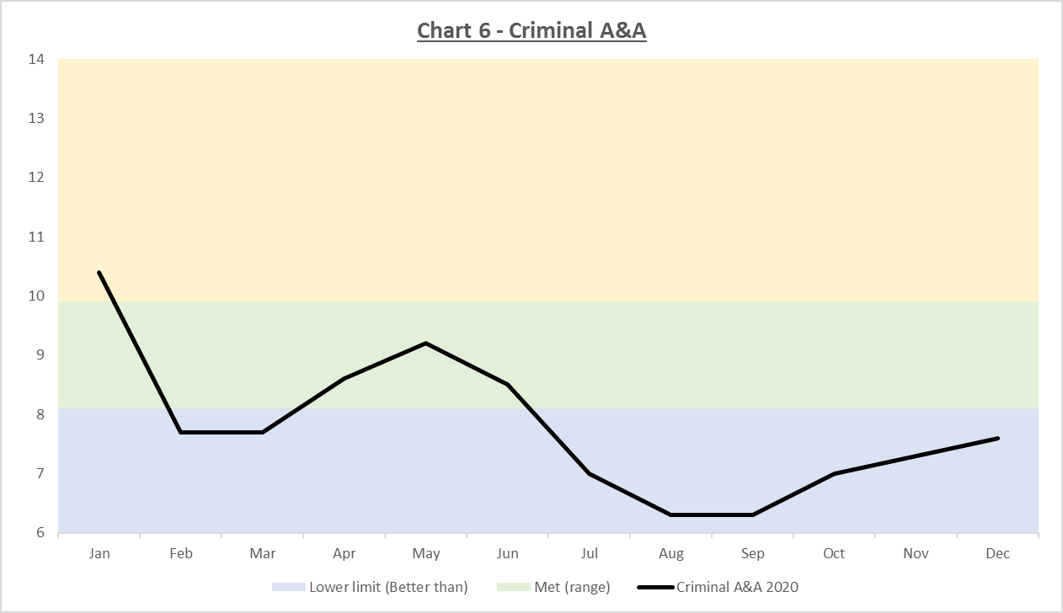
7 | 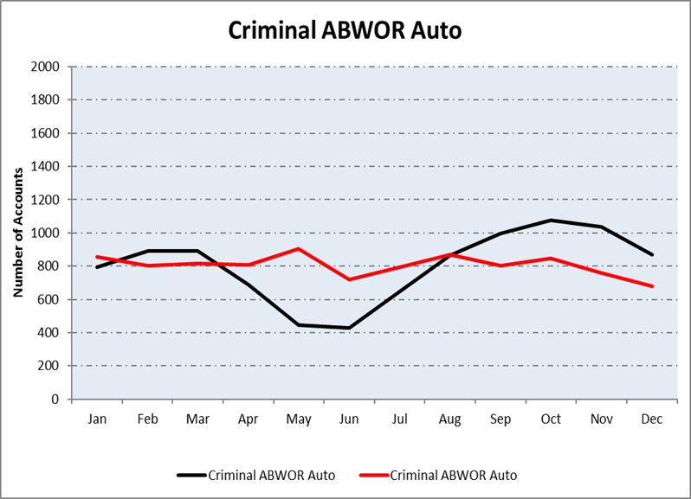 | 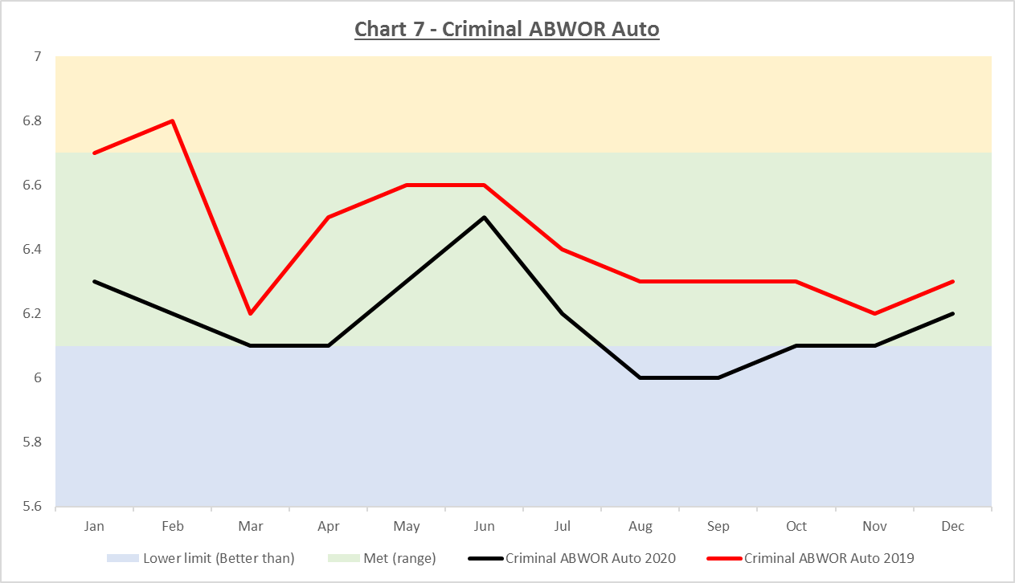 | Performance mostly within BM (6.4) zone.  Propose amend BM from 6.4 to 6.2 | 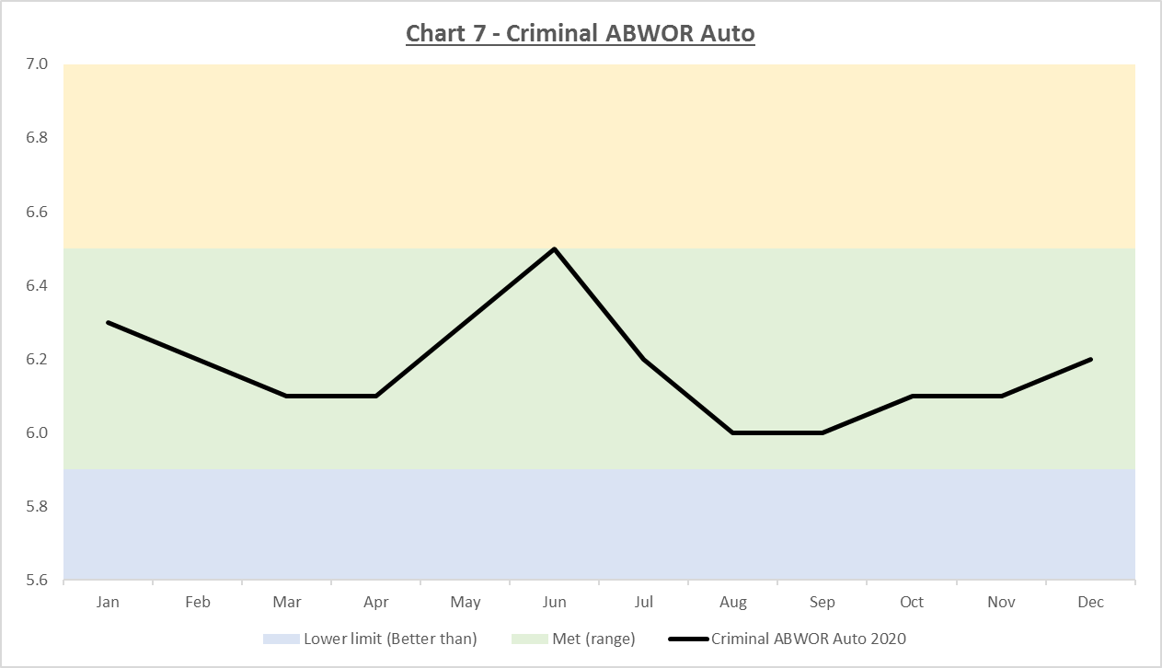
8 | 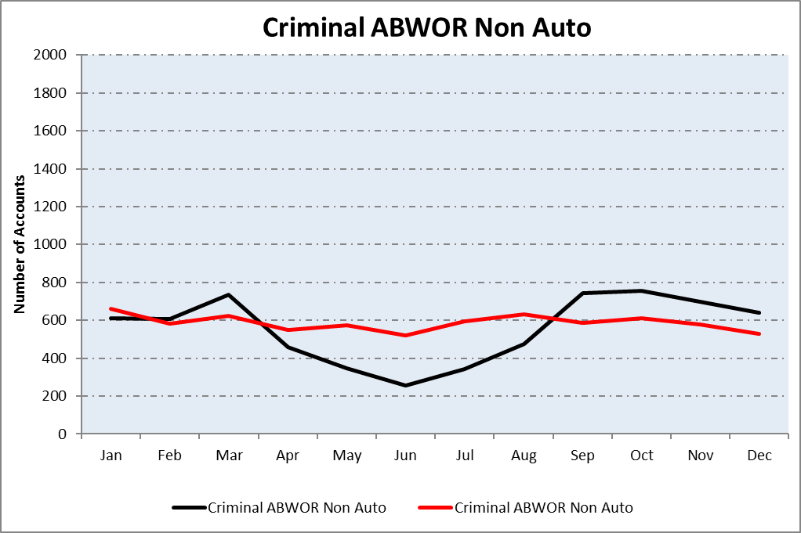 | 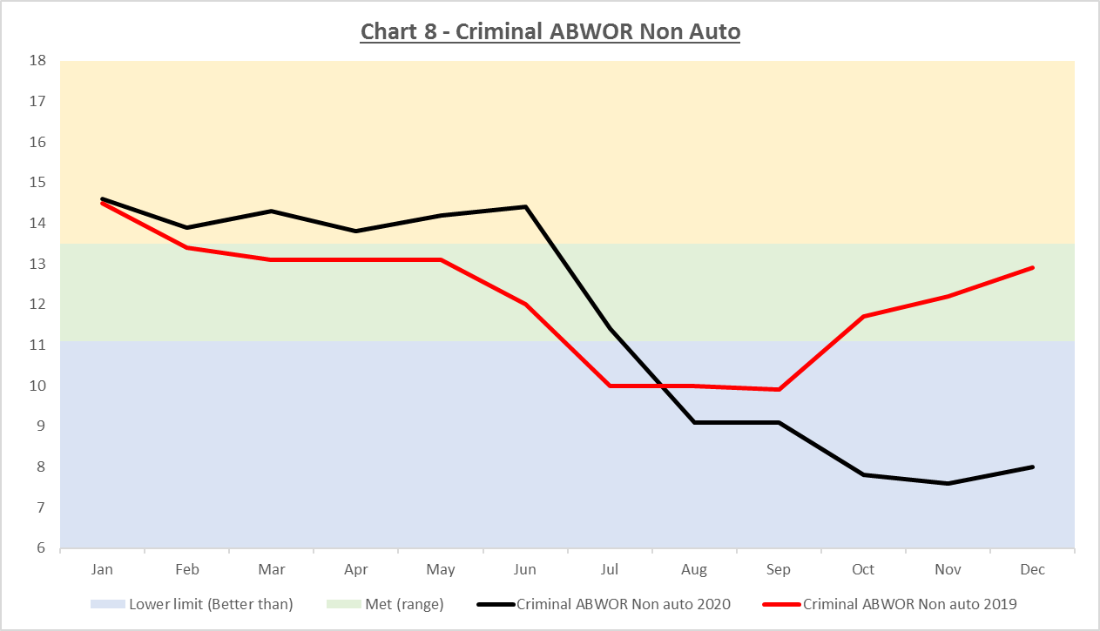 | Performance improved since Dec18.  BM set at 12.3 to be achievable which it has been. | Keep same at 12.3 days.
9 | 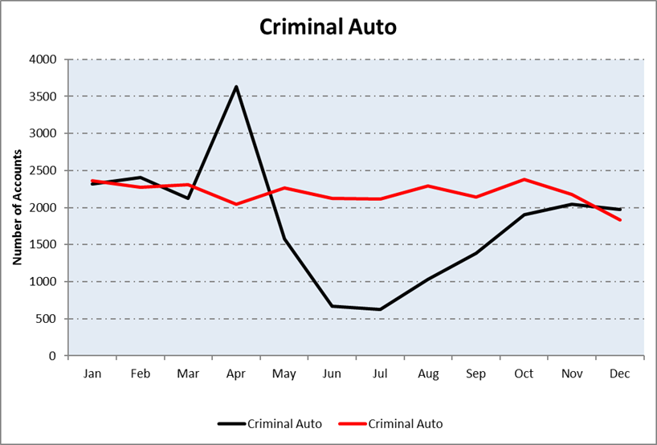 | 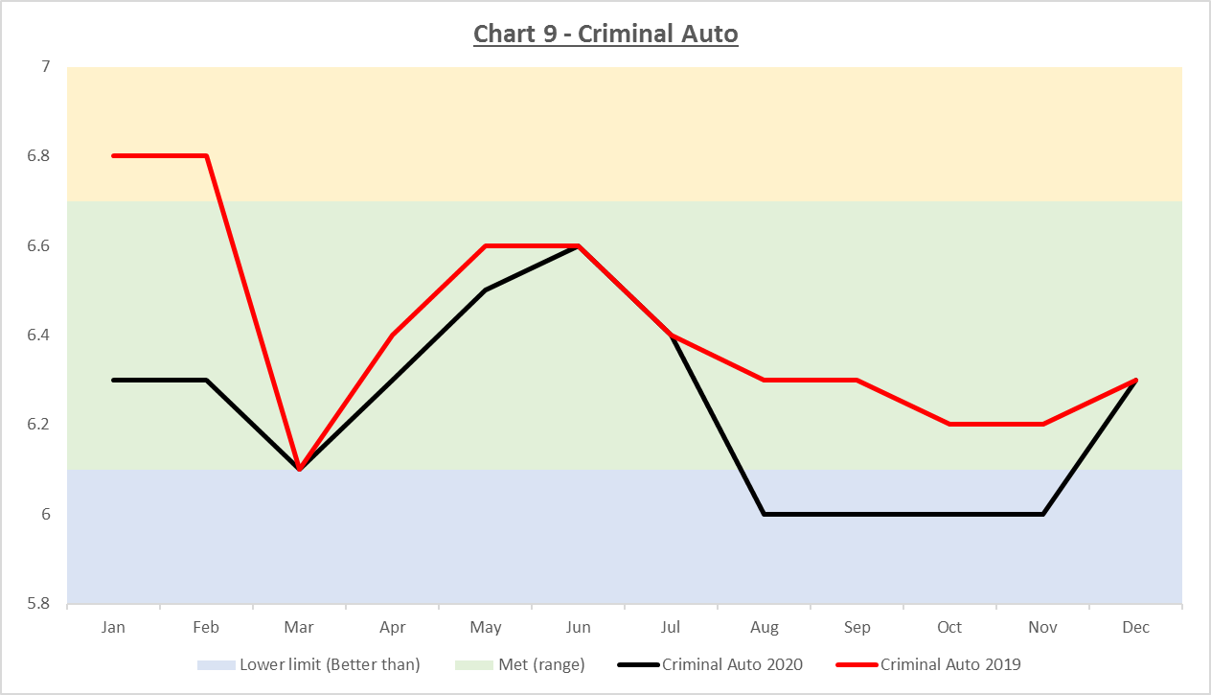 | Performance mostly within BM (6.4) zone. | Keep same at 6.4 days.
10 | 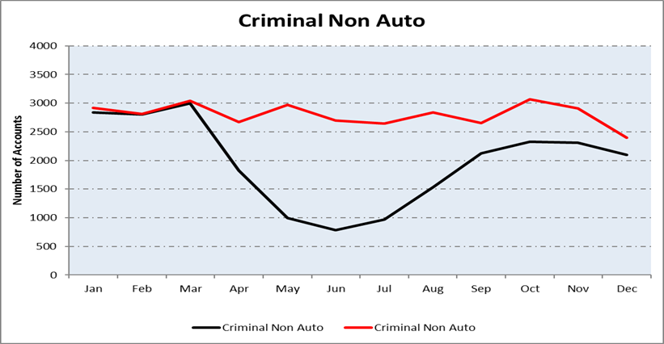 | 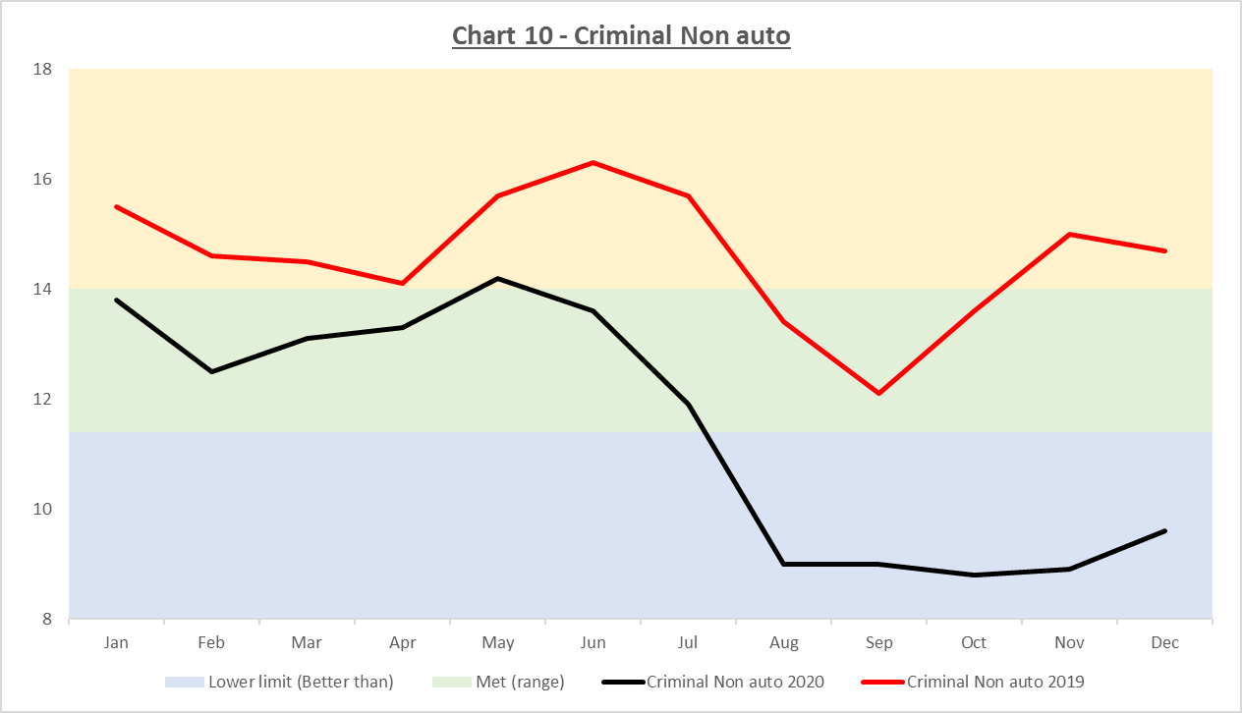 | BM set at 12.7. This has been challenging but achievable. | Keep same at 12.7 days.
11 | 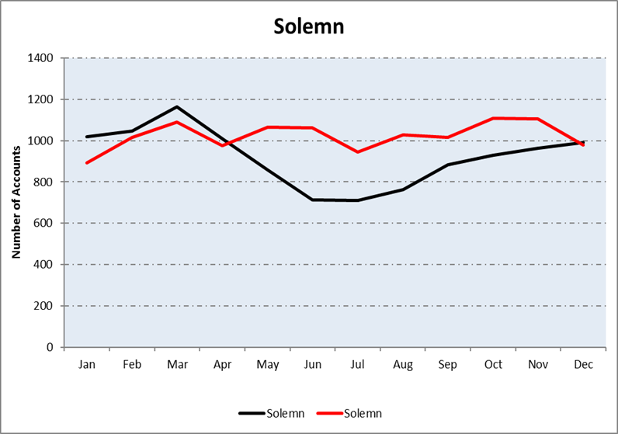 | 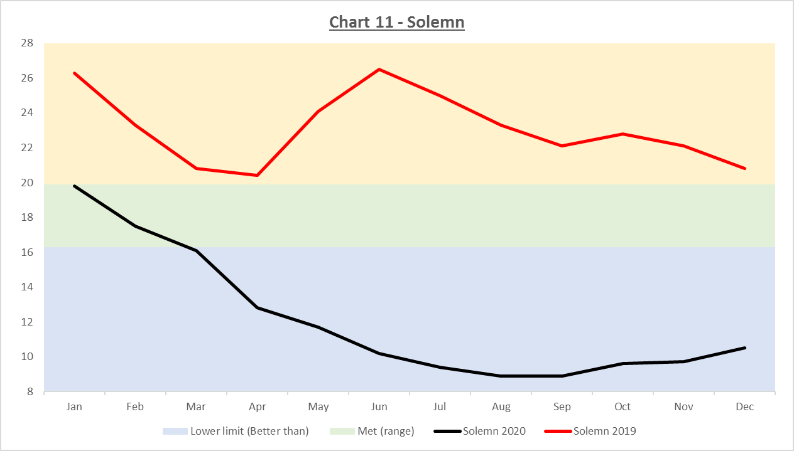 | Recent improvement but may not be sustained. | Keep same at 18.1 days.
12 | 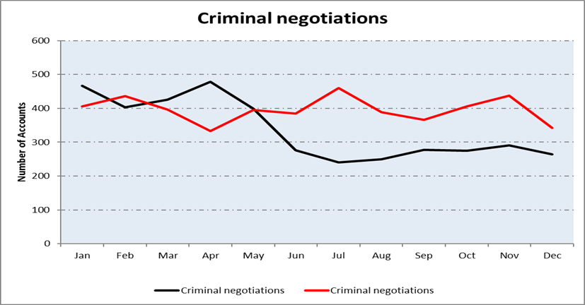 | 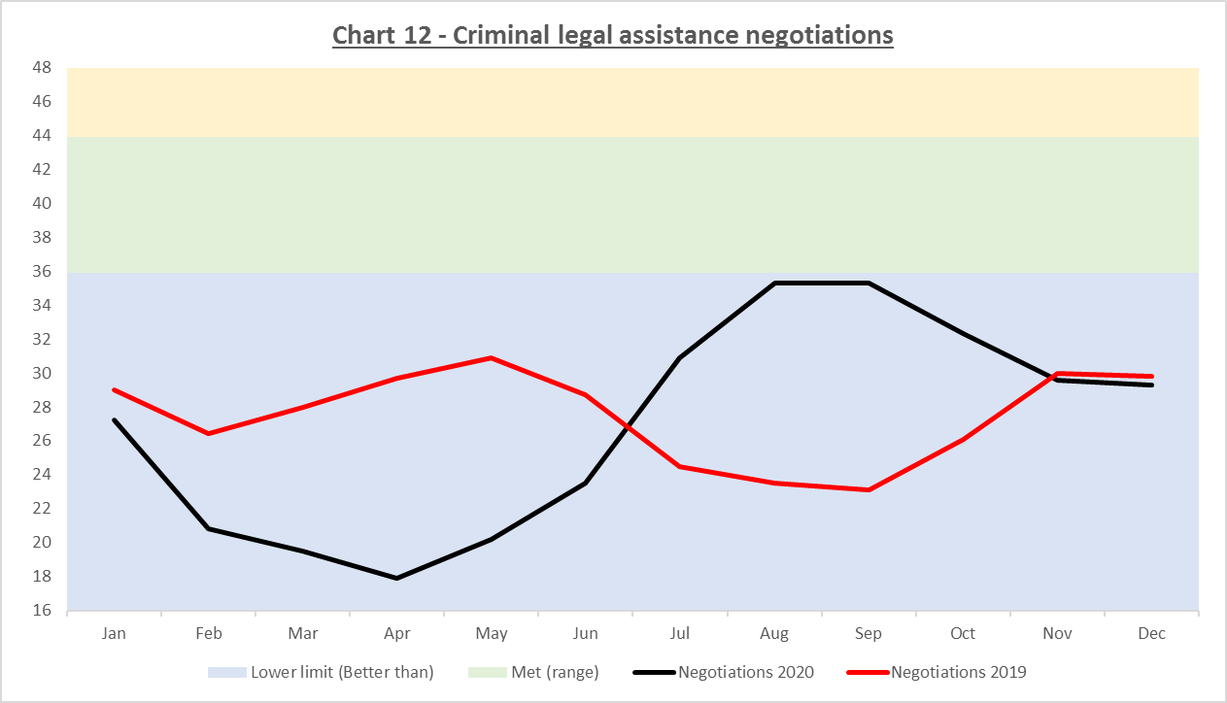 | BM set at 39.9. Performance consistently been Better Than this averaging around the 28 mark.  Readjust BM to 32.5. | 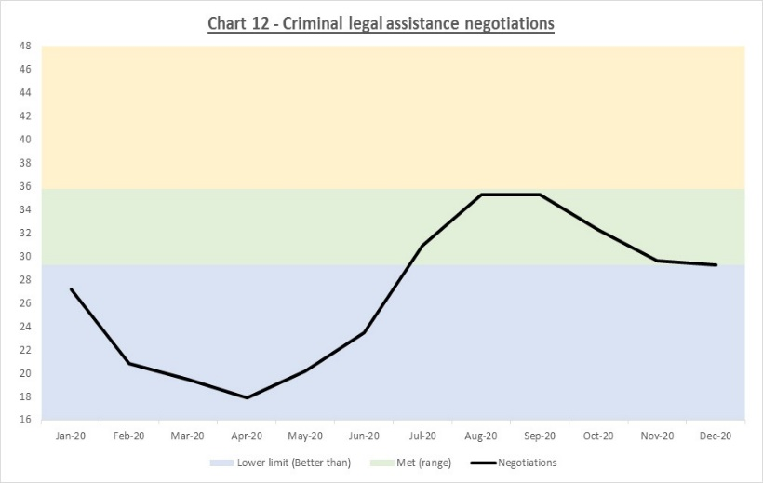
13 |  | 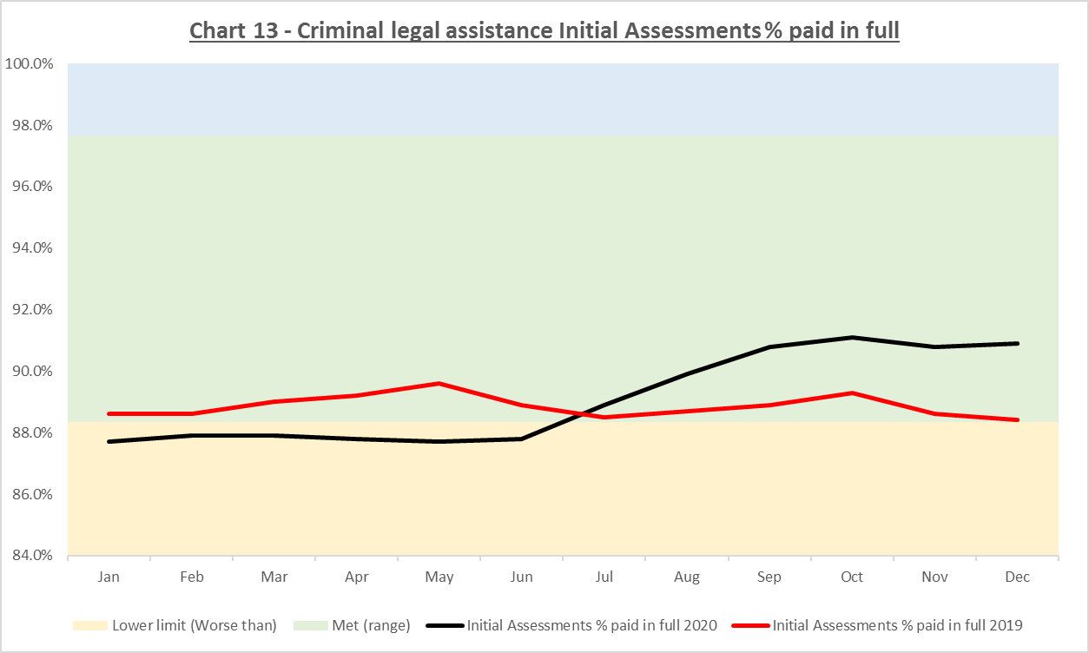 | BM set at 93% but quite a wide zone.  Performance is consistently meeting the BM zone but is at the bottom of it. | No change.
14 |  | 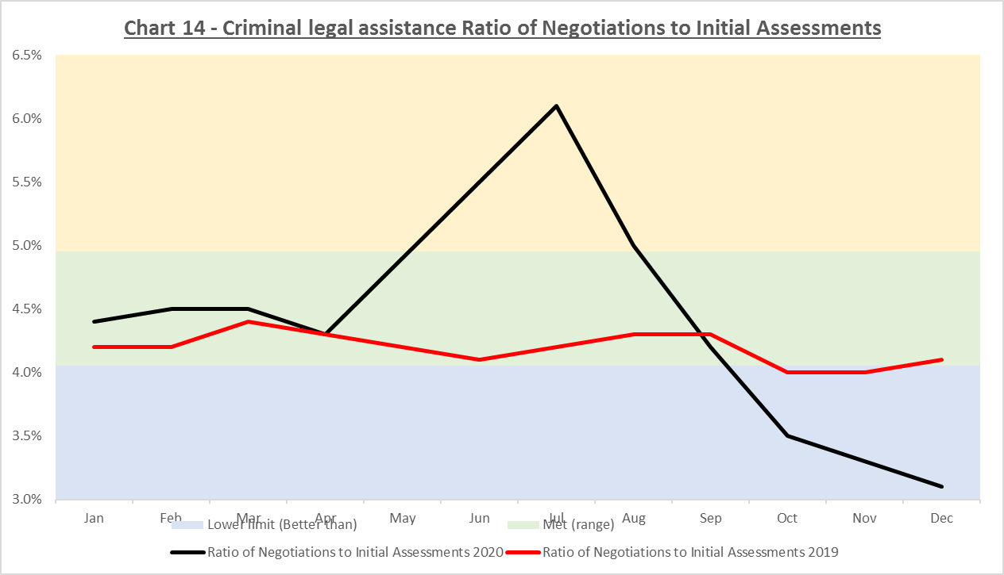 | BM set at 4.5%. Performance has been stable in this zone. | Keep same at 4.5%.

CHILDRENS ACCOUNTS
Id | Jan20–Dec20 & Jan19-Dec19 Volumes  (not 3 mth avg) | Jan20–Dec20 & Jan19-Dec19 Performance | Option for 21-22 | Jan20–Dec20 Performance vs proposed benchmark
15 | 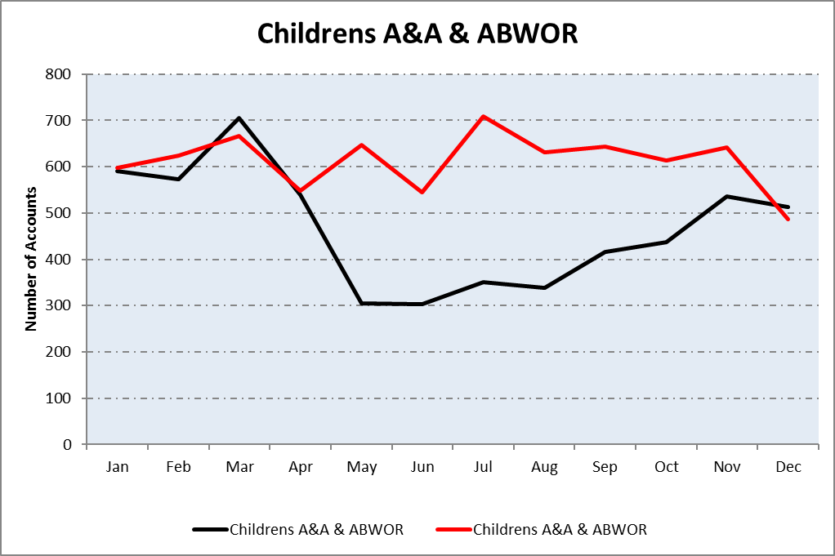 | 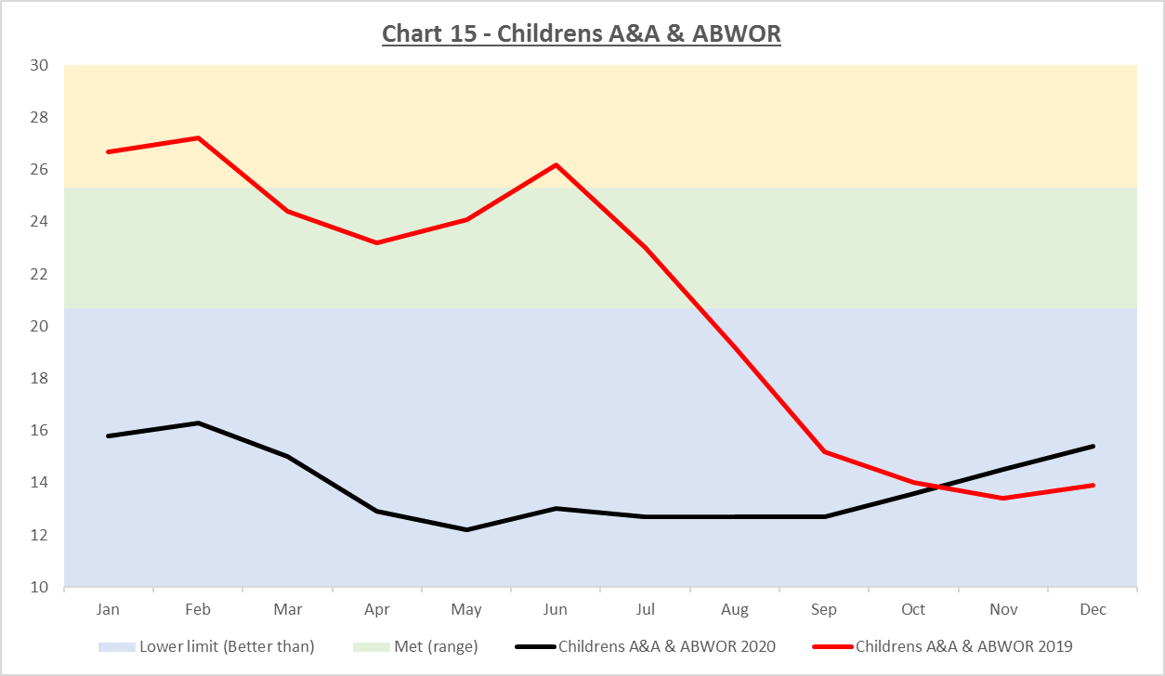 | BM set at 23. Since Jul 19 performance has met or surpassed this level.  Adjust to 17. | 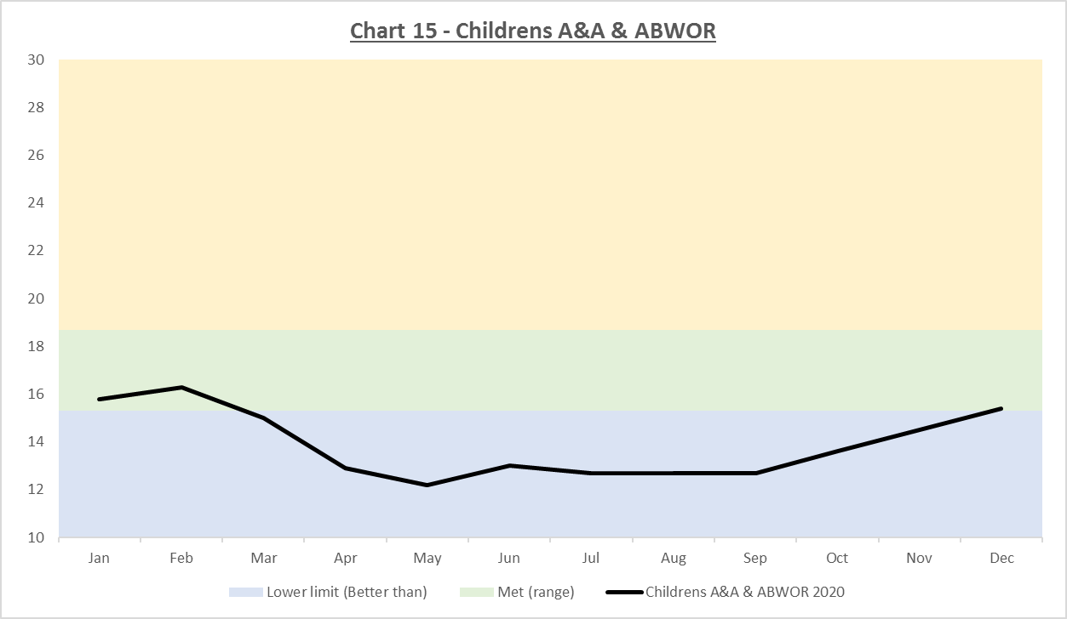
16 | 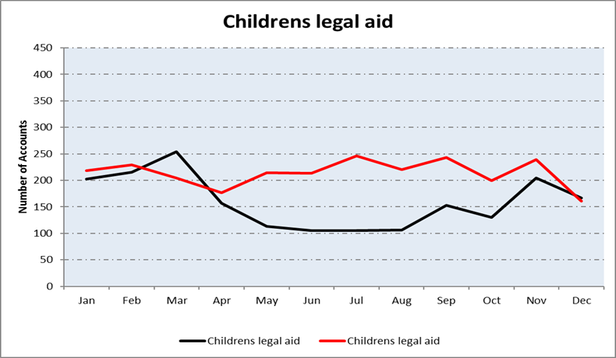 | 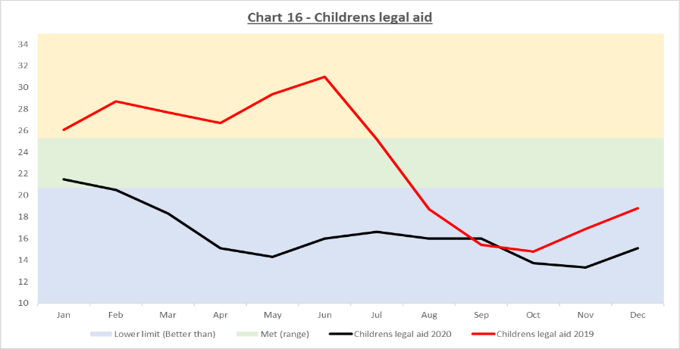 | BM also set at 23, and also met or surpassed BM level since Jul 19.  Adjust to 20. | 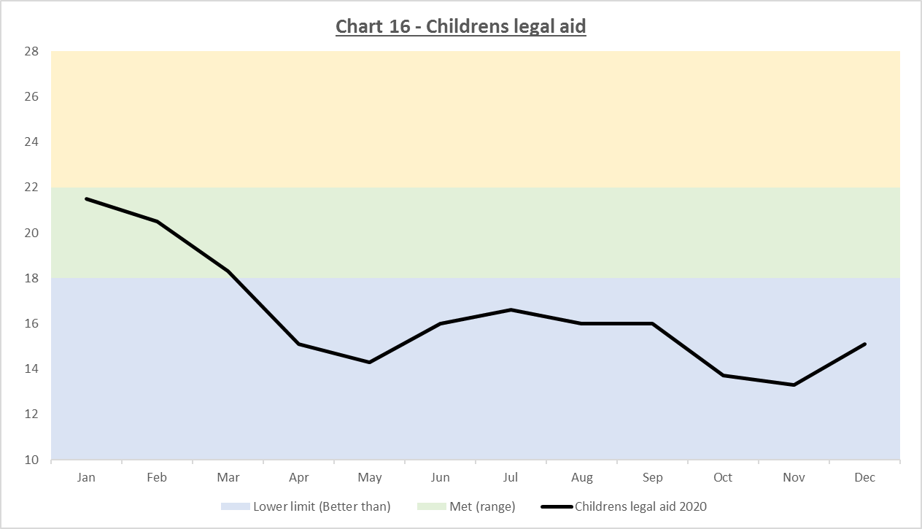
17 | 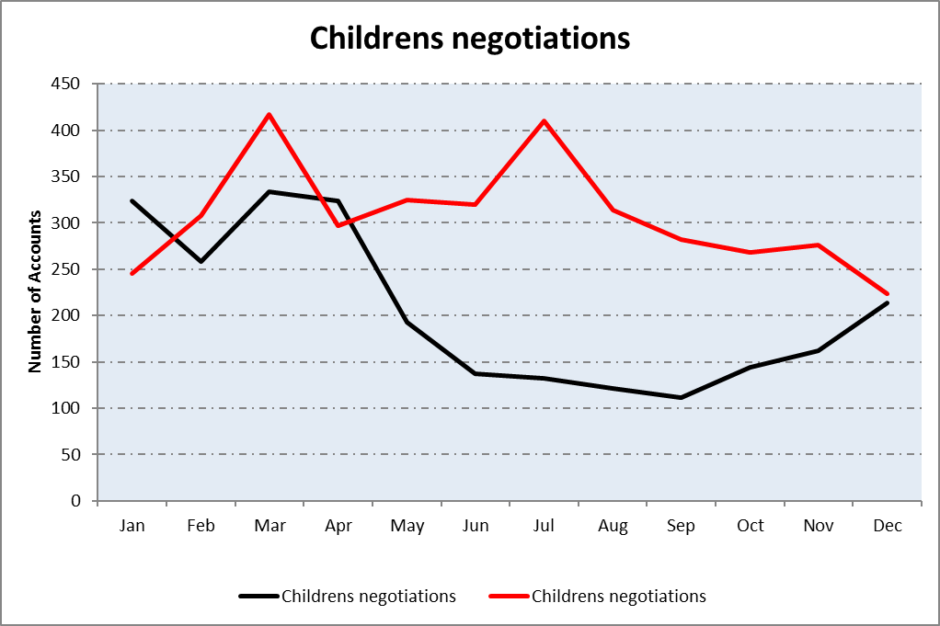 | 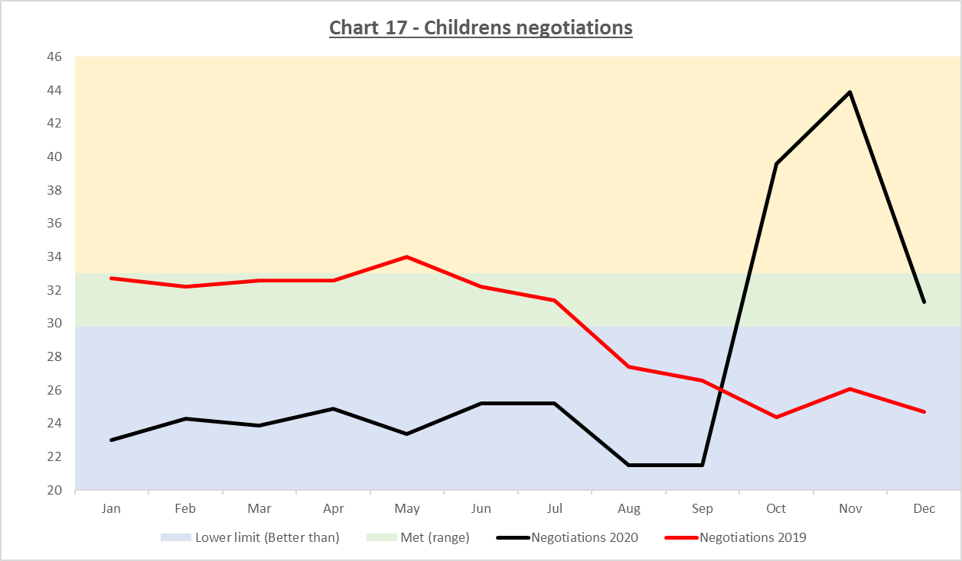 | BM set at 31.4.  Performance mostly Met or Better Than.  Realign to 29.0 & 7.5%. | 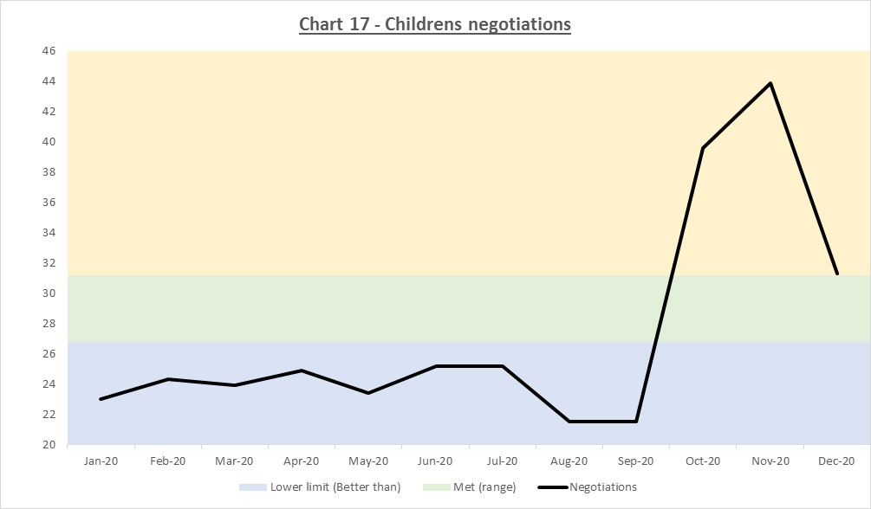
18 |  | 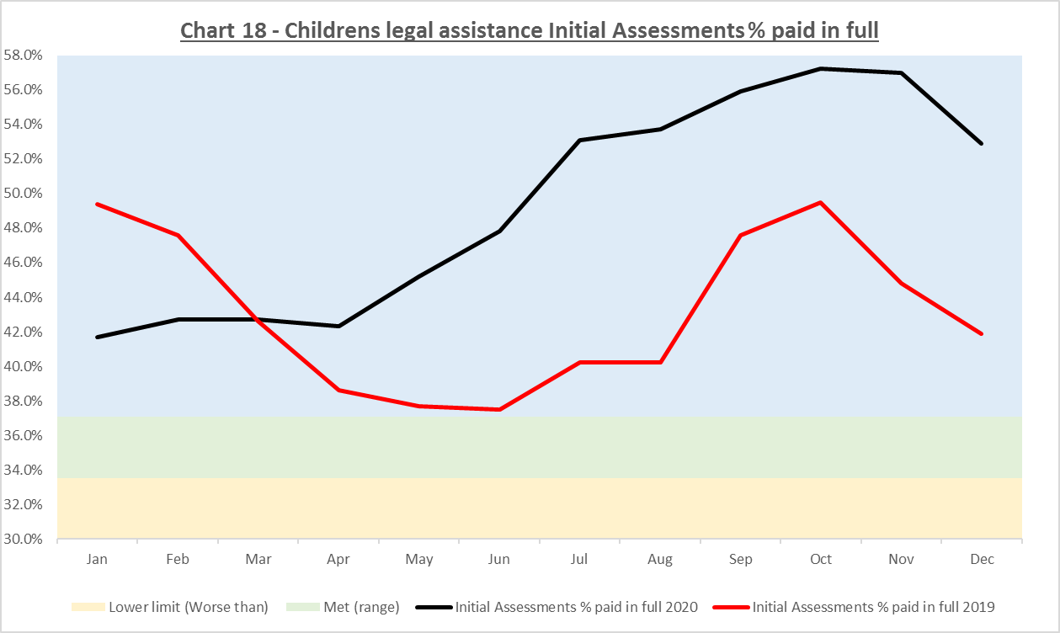 | BM set at 35.3% anticipating an un-materialised negative impact.  Perf remained Better Than.  Adjust to 41%. | 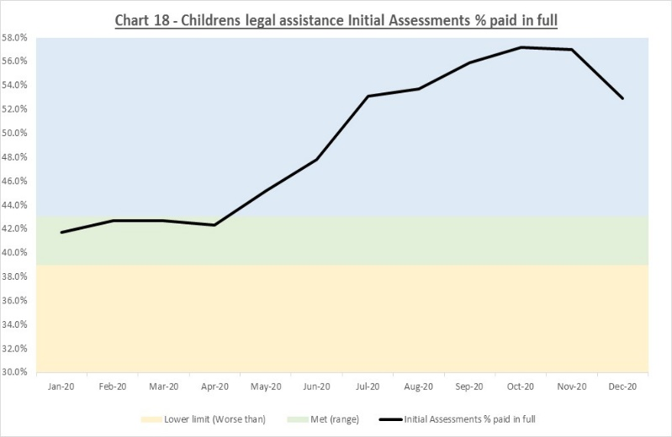
19 |  | 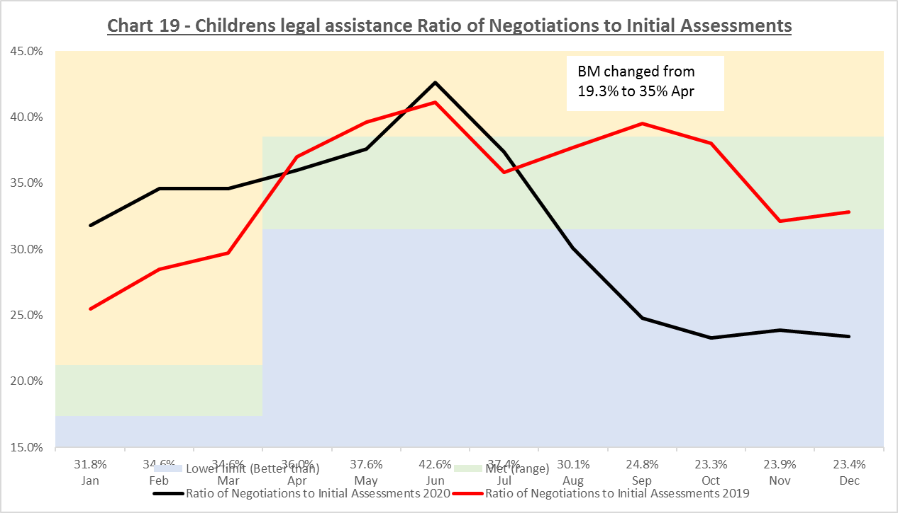 | Process change – realignment required.  BM set at 35% in Apr-20  Keep at 35%. | 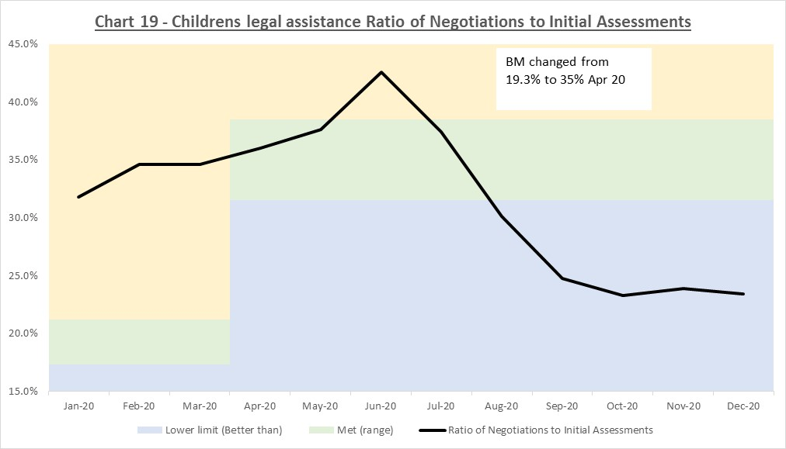

Appendix 2: Technical Description of Performance Calculations

- A rolling 3-month average (i.e. a mean) is the basis for calculating performance. This is compared against static benchmarks. A rolling 3-month average produces a smoothed set of results for a performance measure, i.e. it lessens swings up and down.
- The mean is the default statistic for reporting performance. The advantages to this are:
  - It is understood most widely
  - It is consistent with what we have been reporting in previous years
  - It is the common statistic we use for reporting on percent metrics.
- Supporting statistics continue to be generated and monitored by management to provide a more in-depth picture. For example individual monthly figures will be reported to allow early flagging of potential adverse shifts in performance.
- In some areas, such as negotiation accounts, outliers (older than two years) are removed before calculating the mean. The volume of cases removed by this process is reported separately.
- The benchmarks have been set based on the average of the past two years’ figures but they have been customised to the specific measure depending on a number of factors including the degree of sensitivity required, known process changes and other management objectives.
- The benchmark is calculated as a specific figure but performance will be reported against it in terms of three zones:
- Met
- Worse than (the benchmark)
- Better than (the benchmark).
- The Met zone is defined initially as the benchmark plus or minus 5%. The ‘Better than’ and ‘Worse than’ zones are above or below the Met zone – depending on the type of measure. For example with the First Decision % Granted measure in general higher figures are better. So the ‘Better than’ zone is above the Met zone, i.e. above 105% of benchmark. But we aren’t necessarily aiming to be as high as possible – we may find issues with accuracy and quality if we get too high or we may need to expend a disproportionate amount of effort.
- With the Duration and Further Work ratio measures the ‘Better than’ zones are below the benchmark (less than 95% of benchmark).
- The starting point for defining the width of the Met zone is plus or minus 5%. In some cases it has been necessary to adjust it. This adjustment is because of the differences in application and account types and processes which which produce different distributions for the different measures – some are more variable than others. This is especially so in relation to the size of the measure value. For example plus or minus 5% covers a wider range of values at 90% than it does at 20%.
- The benchmark approach has facilitated the re-inclusion of AWI within civil and a more detailed breakdown of accounts to be presented.

Full Year Reporting

- It is proposed that we only report on month to month performance, i.e. that there is no figure for the year as a whole other than that of the picture of 12 monthly reports. It is intended that this will prevent the disproportionate shifting of resources to influence a single year-end statistic.

- If there are one or two months with poorer performance then these will be reported as such. But they won’t unduly influence the overall full year picture as that picture will be created from 12 monthly reports. The intention is that this will encourage more consistent management of performance.

Colour Highlighting

- To reinforce the message that these are guideline benchmarks a green-yellow-blue colour scheme is proposed. Green indicates a benchmark is being met. Yellow highlights the ‘Worse than’ zone and Blue highlights the ‘Better than’ zone.

 | Governance Links
1 | Finance and Resources  N/A
2 | Risk  Applications  This paper proposes an approach to increase assurance that we are managing the functional risks identified in relation to: (i) Failure to accurately assess applications and increases in accordance with SLAB's policies and procedures; and (ii) Failure to take operational decisions within agreed service standards.  Accounts  This paper proposes an approach to increase assurance that we are managing the functional risks identified in relation to: (i) Failure to pay solicitors within a timeframe that is acceptable to the profession and enables management of the Legal Aid Fund; and (ii) Inconsistent approach to assessment of accounts.
3 | Legal and Compliance  No legal or compliance issues identified.
4 | Performance  The paper proposes a specific approach within which performance information for 21/22 can be assessed.
5 | Equalities Impact  A full EQIA is to be written as decisions of the performance project board could have a discriminatory effect.
6 | Privacy Impact and Data Protection  No privacy or data protection issues identified.
7 | Communications and Engagement  Once the Board has agreed the approach to reporting in 2021-22, a communication will be made to staff and externally.
Conclusion and next steps
Board members are asked to agree to the benchmarks proposed.

Appendices/Further Reading
Appendix 1: Graphical Illustration of Benchmarks Proposed
Appendix 2: Technical Description of Performance Calculations

