Report No: SLAB/2019/54
Agenda Item: 09

Report to: | The Board
Meeting Date: | 25th November 2019
Report Title | Trends Analysis
Report Category | For Information
Issue status: | Business as usual
Written by: | Matt Taylor
Director responsible: | Anne Dickson
Presented by: | Matt Taylor
Contact details: | taylorma@slab.org.uk

Delivery of Strategic Objectives
Select the Strategic Objective(s) relevant to the issues | 1. to deliver improvements to legal aid processes that increase efficiency and improve the experience of system users and customers.  2. to advise Scottish Ministers on strategic development pf legal assistance and its contribution to Scotland in which rights are supported and disputes are resolved fairly and swiftly  3. to ensure that our organisation has the culture and capability to be responsive to our customers, the justice system and developments in legal and advice sectors.

Link to Board or Committee Remit
This information enables the Board to understand the environment that the organisation is operating in. It influences strategic direction and is a key element of oversight

Publication of the Paper
The Board has previously agreed that this paper should be published as a matter of course. It will be published on our website in due course.

Executive Summary
Total gross expenditure has increased 1.6% to £127 million in the 12 months to Sep’19. Applications in civil legal aid and summary and solemn legal aid are increasing.

Previous Consideration
Meeting | Detail
Board – June 2019 | Total gross expenditure has decreased 1.7% to £126 million in the 12 months to May’19. Applications are mostly level or decreasing however civil and solemn legal aid have seen increases.
Board – February 2019 | Total gross expenditure had fallen 3% to £126 million in the 12 months to Dec’18. Applications were mostly level or decreasing.

Report

SUMMARY OF KEY TRENDS
Total gross expenditure has increased 1.6% to £127 million in the 12 months to Sep’19.
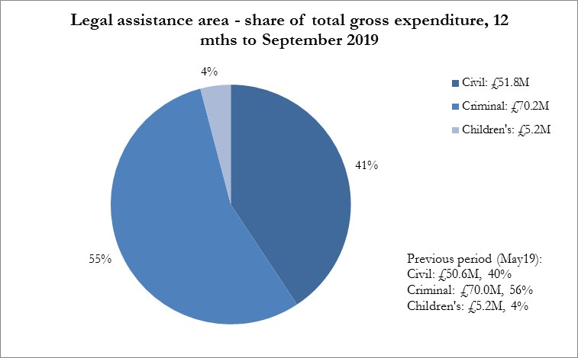

Civil legal assistance
- The total gross spend on civil legal assistance increased 5% - to £51.8 million.
- Intimations of civil advice and assistance (inc ABWOR) have decreased 4% to 59,800.
- The total spent on civil A&A, including ABWOR, increased 4% to £20.2m.
- Civil legal aid applications received were 18,500 – a 4.3% increase on the previous 12 months.
- Gross expenditure on civil legal aid in the 12 months increased 6% to £31.5 million.

Criminal legal assistance
- Criminal A&A (inc CJA) shows an increase of 12% to 27,000.
- The number of grants of criminal ABWOR has decreased 1.9% to 25,900.
- The number of summary criminal cases granted decreased 3.2% to 39,850.
- The number of grants of solemn criminal legal aid is up 10% to 10,760.
- Overall expenditure on criminal assistance decreased 1% to £70.2 million. This included:
  - A 14% increase in the expenditure on criminal A&A (inc CJA) & duty to £2.7 million;
  - expenditure on criminal ABWOR rose 1.6% to £11.0 million;
  - expenditure on summary criminal legal aid fell 10% to £23.8 million;
  - the amount spent on solemn proceedings rose 3.8% to £30.9 million;
  - the expenditure on criminal appeals rose 23% to £1.3 million.

Children’s legal assistance
- The number of children’s A&A intimations decreased 4% to 3800.
- Intimations of children’s ABWOR, increased 5% to 4750.
- Receipts of children’s legal aid cases decreased 1.5% to 2660.
- The total gross spend on children’s legal assistance declined 1.3% to £5.2 million:
  - there has been a 5% decrease in children’s A&A expenditure, to £200,000;
  - the amount spent on children’s ABWOR was level at £2.4m;
  - the amount spent on children’s sheriff court legal aid was also level at £2.4m.

TREND ANALYSIS BY AID TYPE

Civil legal assistance - Civil advice and assistance (A&A) and ABWOR

- Over the 12 months to Sep’19 the total number of civil A&A & ABWOR intimations received has decreased 4.4% to 59,800. The largest volume year-on-year decreases were in cases with subject matters of:
- Immigration = down 715 (9%) to 6900 cases;
- Benefit-appeals = down 680 (19%) to 2900 cases;
- Contact = down 570 (5%) to 10,100 cases;
- Wills = down 360 (32%) to 780 cases.

- The fall in immigration cases has been more than matched by a rise in asylum cases. There we saw an 815 (18%) increase to 5400 cases. Combined immigration and asylum have seen a 1% increase to 12,300. Within the area some firms see quite large changes but these are often linked to the movement of practitioners who intimate large volumes of cases. In the previous 12 months there were 15 practitioners who intimated over 200 cases. In the recent 12 months there were 19.

- The decline in benefit-appeals has been noted for some time as has the decline in contact.

- The decline in the volume of wills is because of the introduction of a new power of attorney template as it includes funding for a will, and the trend is towards getting a power of attorney at the same time as getting a will. So instead of two separate intimations of A&A there is now just one. Power of attorney volumes have not changed much (+4%) as there were more to start with and there should not be the need for a new grant.

- Apart from asylum the subject areas with the most sizeable rises in volume have been:
- Mental health up 290 (9%) to 3500;
- Residence up 210 (9%) to 2500;
- Adults w incapax up 170 (7%) to 2500.

- In civil ABWOR the key areas are immigration and asylum and mental health. In mental health the combined figure for A&A and ABWOR started to show a decline in annual volumes in Feb’17. Since Oct’18 the 12 month average line has been increasing. We have now seen a 9% annual increase to Sep’19 to 3500 intimations – its highest level since Apr’17. Figure 1 below.

Figure 1: Mental health - monthly receipts of A&A and ABWOR combined
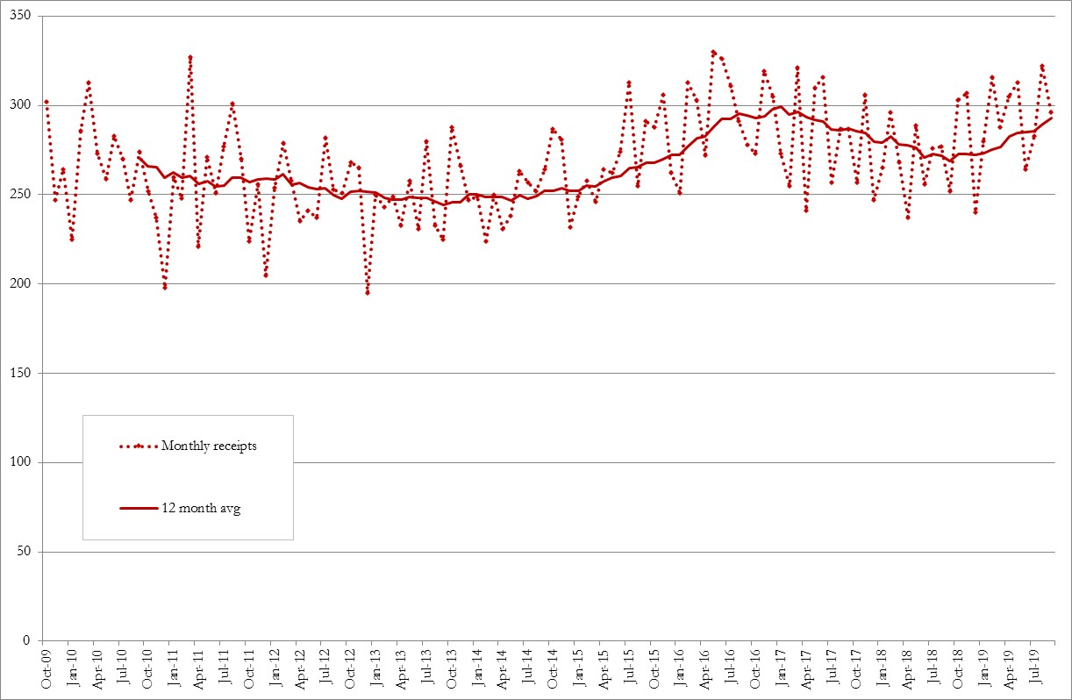

- In immigration and asylum when A&A intimations are combined with ABWOR, the 12 month total has now reached its peak in July 2018.

Figure 2: Immigration and asylum – monthly receipts
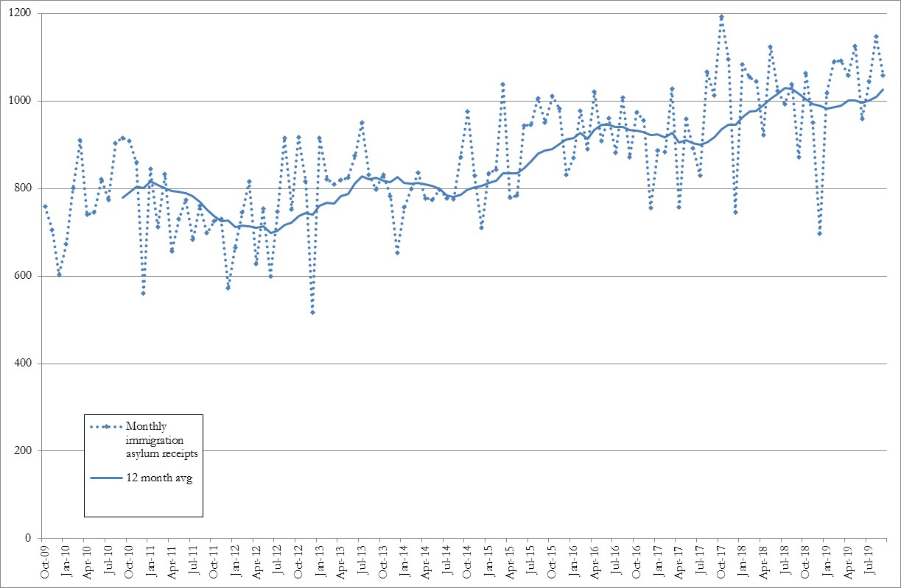

Civil A&A and ABWOR Expenditure

- As with intimation figures a clearer picture of trends can be obtained through analysing A&A and ABWOR expenditure together. Expenditure on civil A&A and ABWOR increased 4% to £20.2 million.

- The three largest subject areas by value were:
  - Immigration and asylum which increased by £1.2 million (16%) to £9.1 million which is 45% of all civil A&A and ABWOR spending;
  - Mental health is the next largest subject area by value at £2.8 million (14% of the total) having increased by 2%;
  - Contact/parentage is the third largest area by value at £2.4 million (12% of the total) having increased by 3%.

- The overall 16% cost increase for immigration/asylum cases was made up of a 5% increase in case numbers paid and an apparent 11% increase in average costs. Solicitor’s fee costs increased by 14% and outlays by 21%. Within outlays the largest component of cost is other outlays which increased 24%. Expenditure on counsel (via outlays) increased by 28%.

- Detailed analysis of immigration/asylum payments has shown that an increasing percentage of outlay payments are happening as pre or interim payments to solicitors. Under the old accounts system the highest level of outlays paid as reimbursements was 17% (£265,000 out of £1.5 million). In 18/19 36% of outlays were paid as an interim payment £993,000 out of £2.8 million. In particular no counsel outlays were paid as interim payments under the old system. The bulge in counsel outlay payments we have seen recently is partly a bring-forward effect but it remains a relatively small factor in the overall increase. The total cost of counsel whilst having increased is still only 5% of the total spend in this area.

- Other outlay costs (e.g. translation or medical reports) have also increased – up 14% at a case level in 18/19. They now comprise 25% of the total spend.

- Analysis at the category level shows some marked differences. Compared with a baseline of 2011-2015 the volume of asylum cases paid has increased 12% but the volume of immigration/nationality has increased 32%. The average cost of asylum cases has increased more. This has gone up 64% from £732 to £1204. For immigration/nationality the same figures are a 13% increase from £432 to £491.

- The increase in average costs may be linked to the increase in the length of time it is taking for decisions to be made. In May 2019 it was reported that the UK government had dropped a target to deal with most asylum cases within six months. It has now been reported that the percent meeting this target fell from 80% in 2014 to 25% in the last quarter of 2018.

- Mental health cases saw a 2% increase in total costs with case numbers paid effectively unchanged. A large number of mental health accounts are currently being negotiated. Once these negotiations are concluded there may be increased payments resulting.

Civil Legal Aid

- Civil legal aid applications received were 18,500 in the 12 months to Sep’19. This is a 4.3% increase on the position in Sep’18.

- Applications not including Adults with Incapacity (AWI) cases had been falling since July 2013 but they are now showing an increase of 3.4% on 1 year ago.

- Over the same time the numbers of AWI cases continue to increase. They are 4.3% higher than 12 months ago, Figure 3 below.

- The three subject matters with the largest increases have been:
- Adults with incapacity (AWI) up 330 cases (+7%);
- Other up 200 cases (+35%);
- and Family/matrimonial-other up 120 cases (+3.2%).

- The increase in Other is because of a large number of interdict cases which have been raised since June 2019 to prevent lock changes and eviction for failed asylum seekers in Glasgow.

- The number of Discrimination cases has also increased from just 1 in the 12 months to Sep’18 to 15 in the recent 12 months. Inspection of a few of the recent 15 has revealed disability based cases against Glasgow council housing and against the Department for Work & Pensions.

- The number of AWI applications was 5264 which was 29% of all applications - unchanged in proportion from the last Trends report.

Figure 3: Civil legal aid applications received, rolling 12-month total
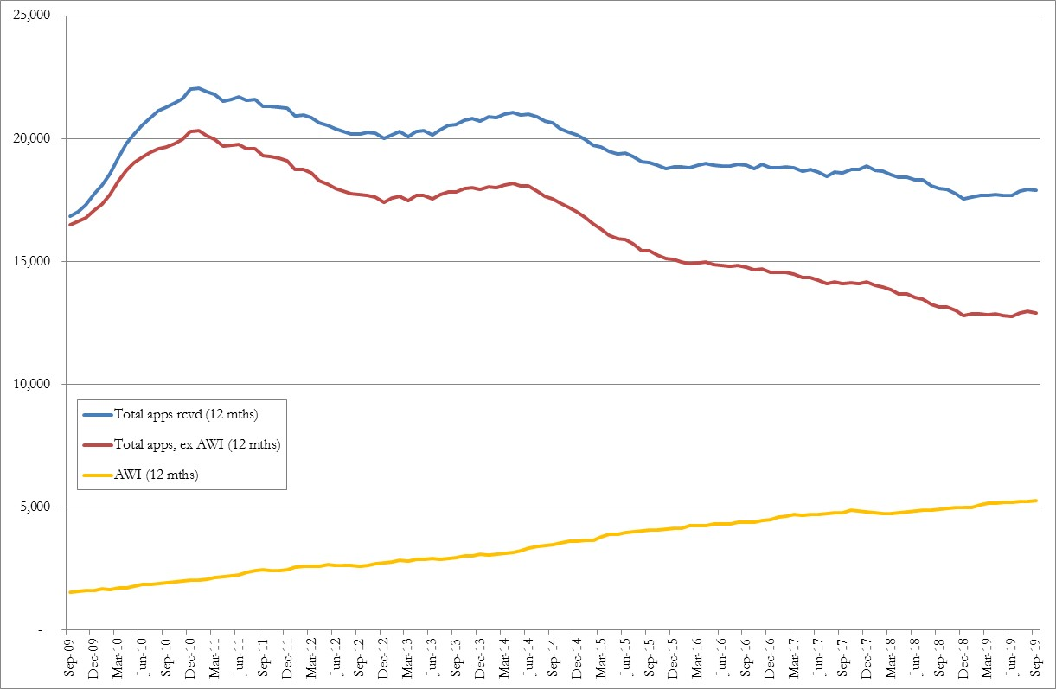

- The three subject matters with the largest falls are:
- Housing/recovery of heritable property down 142 applications (-10%);
- Immigration/asylum down 49 applications (-13%);
- and Property/monetary down 29 applications (-7%).

- Civil full legal aid certificates issued were 14,200 - a 7% increase on the previous 12 months. Adults with incapacity (AWI) cases saw a 12% increase, to 5,100, and comprise 36% of all certificates.

- Excluding AWI there was a 4% rise in certificates issued to 9100. Nine other subject groupings saw an increase in the number of certificates granted. The two largest were Contact/parentage which increased by 5% to 2863 certificates and Residence which increased by 18% to 1485 certificates.

Civil Legal Aid Decision Rates

- We have seen a rise in the number of certificates larger than the rise in the number of applications. We are therefore granting an increasing proportion of applications. This is partly due to the increasing proportion of cases which are AWI which have a very high grant rate.

- But we have also been working to clarify and strengthen our guidance so solicitors know what to put in an application and we have been working directly with a number of firms helping them to improve their interactions with us which encompasses help with applications.

- Table 1 below presents analysis of initial and review decision volumes and grant rates. Subject areas are sorted by decreasing size. Looking at the Total excluding AWI we have seen a 1% rise in the number of initial decisions taken. But there has been a 21% fall in the volume of review decisions taken. The difference is due to the emphasis by SLAB on getting the initial decision right first time.

- Contact has seen an 11% point rise in the initial grant rate and consequently a 33% fall in the number of reviews submitted with a 4% point rise in the overall grant rate. Residence has seen a 9% rise in initial decision volumes and a 7% point rise in the initial grant rate and a 1% fall in the number of reviews with a 6% point rise in the overall grant rate.

- The increase in Discrimination cases is being seen in decisions taken. In the previous 12 months we saw 2 cases decided with no grants. In the past 12 months we have seen 7 cases decided with 6 granted (86%).

- The initial grant rate, excluding AWI, has increased 6 percentage points. But the overall grant rate has only increased 3 points. This indicates that the emphasis on getting it right first time is not being achieved by excessively inflating the number of grants we make.

Table 1: Civil legal aid combined grant rates
 | 12 months to Sep-18 |  |  |  | 12 months to Sep-19 |  |  |  | Change
Subject areas | Num initial decisions | Initial grant rate | Num reviews | Overall grant rate | Num initial decisions | Initial grant rate | Num reviews | Overall grant rate | Num initial decisions | Initial grant rate | Num reviews | Overall grant rate
Adults with incapacity | 4709 | 96% | 73 | 97% | 5231 | 97% | 31 | 98% | 11% | 2% | -58% | 1%
Contact/parentage | 3382 | 61% | 862 | 79% | 3405 | 72% | 578 | 83% | 1% | 11% | -33% | 4%
Divorce/separation | 1934 | 78% | 209 | 86% | 1891 | 80% | 209 | 87% | -2% | 2% | 0% | 1%
Residence | 1586 | 69% | 243 | 79% | 1732 | 75% | 241 | 85% | 9% | 7% | -1% | 6%
Family/matrim - other | 1016 | 60% | 274 | 77% | 1105 | 71% | 170 | 80% | 9% | 10% | -38% | 3%
Housing/recov herit prop | 1020 | 68% | 73 | 72% | 1004 | 68% | 54 | 72% | -2% | 0% | -26% | 0%
Other | 484 | 33% | 177 | 50% | 461 | 43% | 147 | 59% | -5% | 10% | -17% | 9%
Protective order | 383 | 65% | 59 | 74% | 360 | 65% | 46 | 73% | -6% | 0% | -22% | -2%
Property/monetary | 342 | 57% | 73 | 70% | 324 | 61% | 55 | 73% | -5% | 4% | -25% | 3%
Immigration and asylum | 294 | 84% | 23 | 92% | 293 | 78% | 34 | 88% | 0% | -6% | 48% | -3%
Reparation | 245 | 15% | 136 | 38% | 205 | 24% | 111 | 48% | -16% | 9% | -18% | 10%
Appeals - other | 125 | 26% | 61 | 42% | 127 | 29% | 63 | 43% | 2% | 4% | 3% | 2%
Debt | 164 | 29% | 74 | 51% | 127 | 23% | 56 | 43% | -23% | -6% | -24% | -9%
Judicial review | 116 | 47% | 40 | 62% | 115 | 40% | 39 | 58% | -1% | -7% | -3% | -4%
Medical negligence | 94 | 50% | 34 | 70% | 87 | 52% | 27 | 68% | -7% | 2% | -21% | -2%
Appeals - family | 52 | 63% | 10 | 69% | 59 | 53% | 15 | 64% | 13% | -11% | 50% | -5%
Breach of contract | 24 | 33% | 15 | 58% | 29 | 10% | 18 | 38% | 21% | -23% | 20% | -20%
Fatal accident inquiries | 15 | 80% | 0 | 80% | 20 | 85% | 1 | 90% | 33% | 5% | n/a | 10%
Discrimination | 2 | 0% | 1 | 0% | 7 | 43% | 5 | 86% | 250% | 43% | 400% | 86%
Total ex AWI | 11278 | 63% | 2364 | 76% | 11351 | 69% | 1869 | 79% | 1% | 6% | -21% | 3%

Civil Legal Aid Expenditure

- Gross expenditure on civil legal aid in the 12 months to Sep’19 rose 6%, plus £1.9 million, to £31.5 million. Within this rise, by type of expenditure the changes were:
  - total solicitors’ fees paid increased by £1.1 million (up 6%) to £19.3 million ;
  - outlays increased £376,000 (up 5%) to £8.6 million;
  - and total counsel’s fees paid increased £372,000 (up 11%) to £3.6 million.

- By subject matter the largest rises were:
- Medical negligence plus £833,000 (32%);
- Contact/parentage plus £408,000 (4%);
- Residence plus £392,000 (10%).
AWI whilst the largest grouping within applications (36% of certificates) remains a much smaller component of gross expenditure at 11%. Family/relationship matters comprise 62% of gross expenditure, Figure 4 below.

Figure 4: Civil legal aid gross expenditure by subject matter
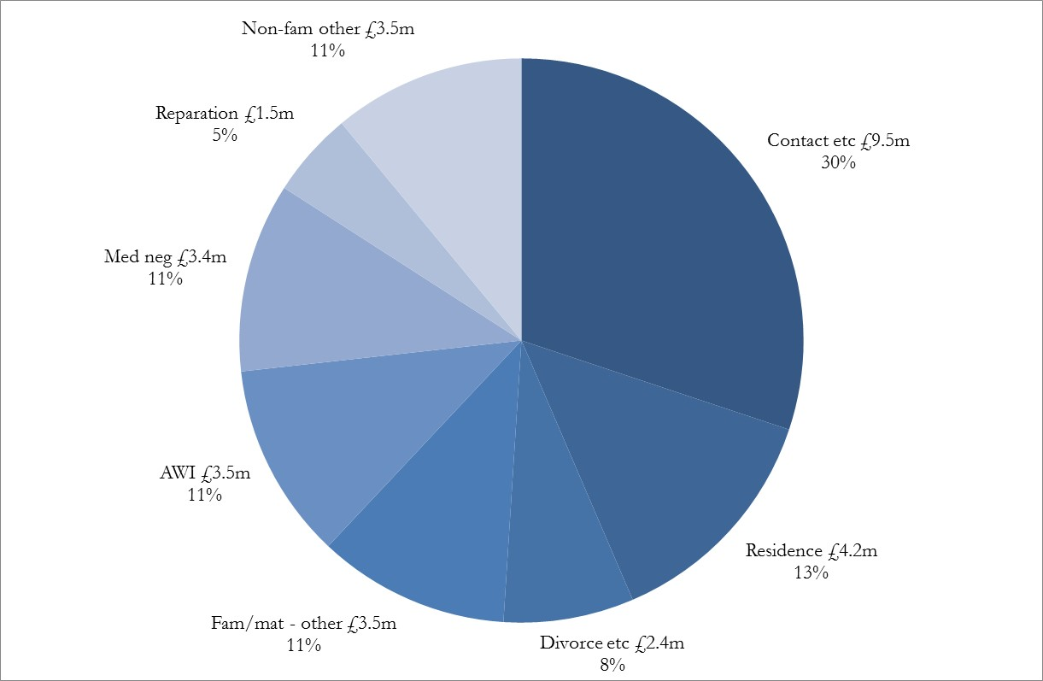

Criminal legal assistance

Criminal Advice and Assistance and Criminal Justice Act

- The number of grants of criminal advice and assistance, including those under the Criminal Justice Act, in the 12 months to Sep’19 have increased 12% to 27,000 compared with the previous 12 months. A new system of advice & assistance under Part 1 of the Criminal Justice (Scotland) Act 2016 was implemented on 25 January 2018, bringing in new police station procedures and rights to legal advice by persons detained in police stations.

- The volume of grants of police station advice under the CJA scheme increased rapidly in the first few months of the scheme’s operation. We now have a 12 month total to Sep’19 of 17,334 (a monthly average of 1445) Figure 5 below.

Figure 5: Police station interview (CJA) receipts by month
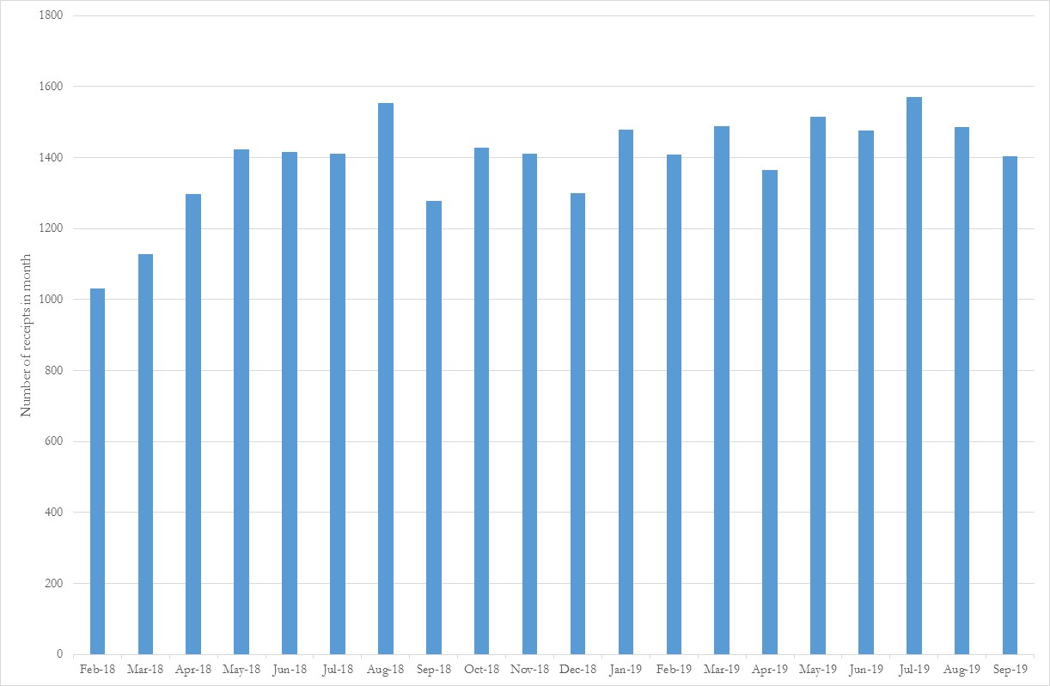

Criminal Advice & Assistance & Criminal Justice Act Expenditure

- Spending on criminal advice and assistance, including the Criminal Justice Act, in the 12 months to Sep’19 increased 20% to £1.9 million. Case numbers paid increased 23% and the average expenditure of a case decreased 2% to £102.

- The increase in the expenditure on these cases is expected because of the introduction of new legal assistance for the Criminal Justice Act. These cases are more costly than they were previously under A&A. The system has also been designed to be a lot easier for the profession to use and fee for – we are now seeing 96% of all CJA cases intimated by private firms to have been invoiced. We expected that a higher percentage of cases would be invoiced for and that they could be paid more quickly as well. All these factors have contributed to the increase in expenditure.

- The average cost has decreased slightly whilst the overall cost has increased because private firms are doing more lower average cost CJA phone call work.

Criminal ABWOR and Summary criminal legal aid

- For the 12 months to Sep’19 the number of criminal ABWOR intimations received has decreased 1.9% to 25,900. Within criminal ABWOR, intimations for summary complaint proceedings have increased 0.8% to 16,550, whereas those for non- summary complaint proceedings (mostly breach matters) have decreased by 6%. See Figure 6 below.

Figure 6: Criminal ABWOR – summary complaint & non-summary/breach
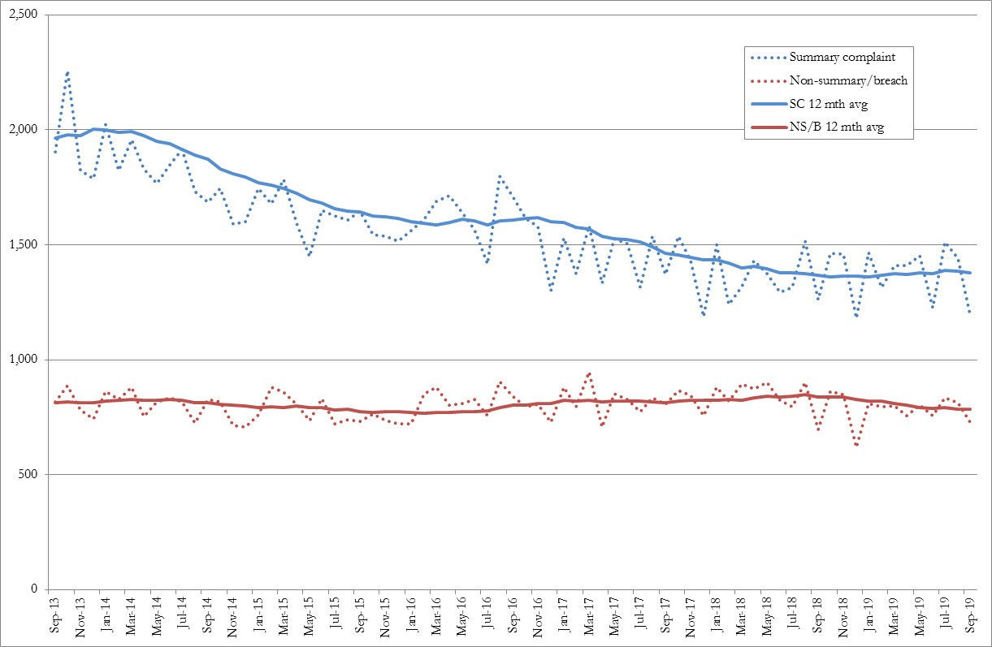

- It was previously reported that the decrease in summary complaint ABWOR had lessened and the 12 month rolling average was showing a clear levelling off. This is now the first 12 month increase in summary ABWOR for many years.

- Within summary complaint ABWOR there are increases for:
- theft cases are up 160 (4%) to 3,840;
- breach of bail up 80 (4%) to 2070;
- and other criminal cases are up 67 (33%) to 270.

- The Domestic Abuse (Scotland) Act 2018 came into force on 1st April 2019. It introduced a new offense of coercive and controlling behaviour. There are eight cases in the Other Criminal category that mention domestic abuse since April 2019.

- Drugs have seen a 7% fall to 1580 and road traffic a 5% decrease to 2000.

- Within non-summary ABWOR the largest changes have been falls in breaches and reviews of community payback order – both down 9% to 3580 and 2680 respectively.

Summary criminal legal aid

- The fall in the number of summary criminal applications received has slowed - it decreased by 3% to 44,600 in the 12 months to Sep’19. Sheriff court applications fell by just 0.6%. In fact the low point for the 12 month summary total was March 2019 since then it has been slowly increasing.

- The number of summary certificates has decreased by 3.2% from Sep18 to 39,850. But the lowest 12 month total was seen in April 2019 at 38,800 since then we have seen a 2.7% rise. See Figure 7 below.

Figure 7: Summary receipts and certificates & court complaints
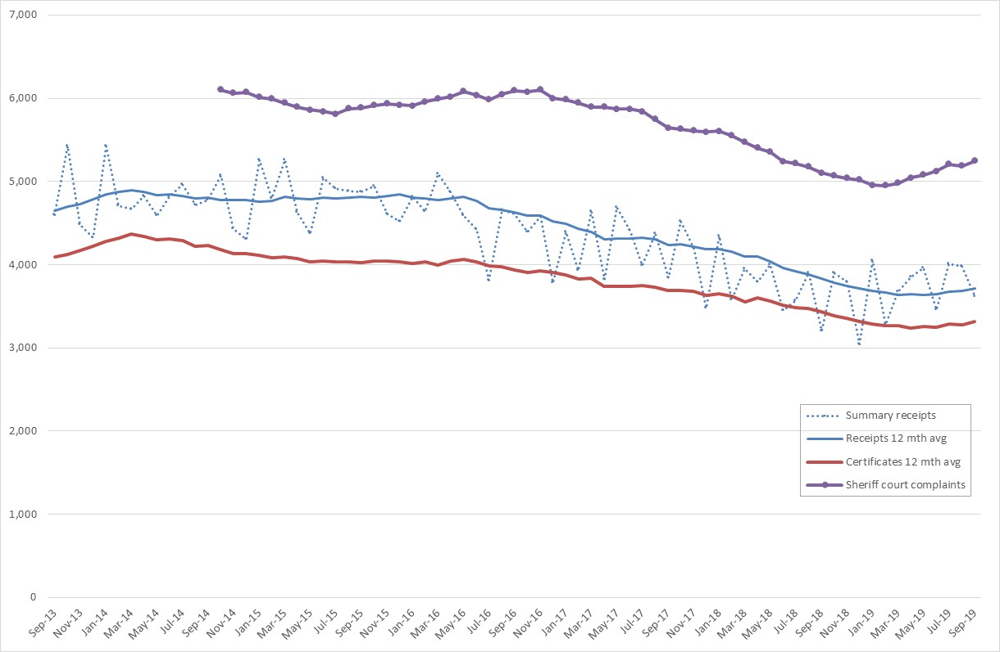

- Figure 7 also shows the average (12 month) number of court complaints registered. These show a similar pattern in that there was a decline from late 2016 to a low point of Feb19. Since then there has been a 6% increase, it is 3% higher than 12 months ago.

- Certificates issued for the JP court decreased 16% whereas those for the sheriff court fell 0.8%. The combined figure for intimations of ABWOR summary complaints plus summary grants has decreased 2.1% to 56,400. This is up 700 from the last trends report which was for the 12 months to May’19.

- The largest falls in summary certificates issued by subject matter were:
- Assault – down 630 (5%) to 11,290;
- Criminal Justice & Licensing Act down 390 (5%) to 7460;
- Embezzlement/fraud down 91 (16%) to 470.

- Drugs rose 84 (2%) to 3620. Other criminal rose 60 (16%) to 440. The number of other that mention domestic abuse rose from 2 in the 12 months to Sep18 to 62 since April 2019.

- It is not thought that the Domestic Abuse (Scotland) Act 2018 (DASA) will have much effect, especially initially, on overall volumes. Cases that were marked under other acts, e.g. Criminal Justice & Licensing Act, may now be being marked as DASA but this is just a category switch. For the new offense of “course of conduct” to be charged requires all the individual offenses to have happened after 1/4/19. If the new offense is being charged it may be in addition to what would have been individual offenses previously. The seriousness of the case may therefore increase.

Criminal ABWOR & Summary Expenditure

- Spending on total criminal ABWOR in the 12 months to Sep’19 has risen 1.6% to £11.0m. Fixed fee ABWOR (i.e. for summary complaints) was level at £8.2m and the expenditure on time and line ABWOR rose 6% to £2.8m.

- Expenditure on summary criminal legal aid fell 10% to £23.8 million. The number of cases paid has fallen 11% but the average cost has increased 1.2%. Even though these cases are mostly fixed fee the average cost may change for a number of reasons including a change in the mix of case court types or a change in the number of fee add-ons. Another reason is that cases may be granted exceptional status because of the nature of the case allowing them to be paid on a time-and-line basis.

Criminal legal aid in solemn & court granted cases

- The number of applications for solemn criminal legal aid has increased by 10% to 11,760. The largest growth by volume has been in:
- Assault rose by 380 (12%) to 3610;
- Offensive weapons rose by 190 (53%) to 540;
- Firearms rose by 50 (29%) to 220;
- Attempted murder rose by 60 (29%) to 280;
- Sexual offences rose by 130 (9%) to 1580.

- The number of solemn certificates issued has increased in line with receipts – by 10% to 10,760 in the 12 months to May’19, Figure 8 below. This is the highest level since August 2016.

Figure 8: Solemn legal aid certificates issued
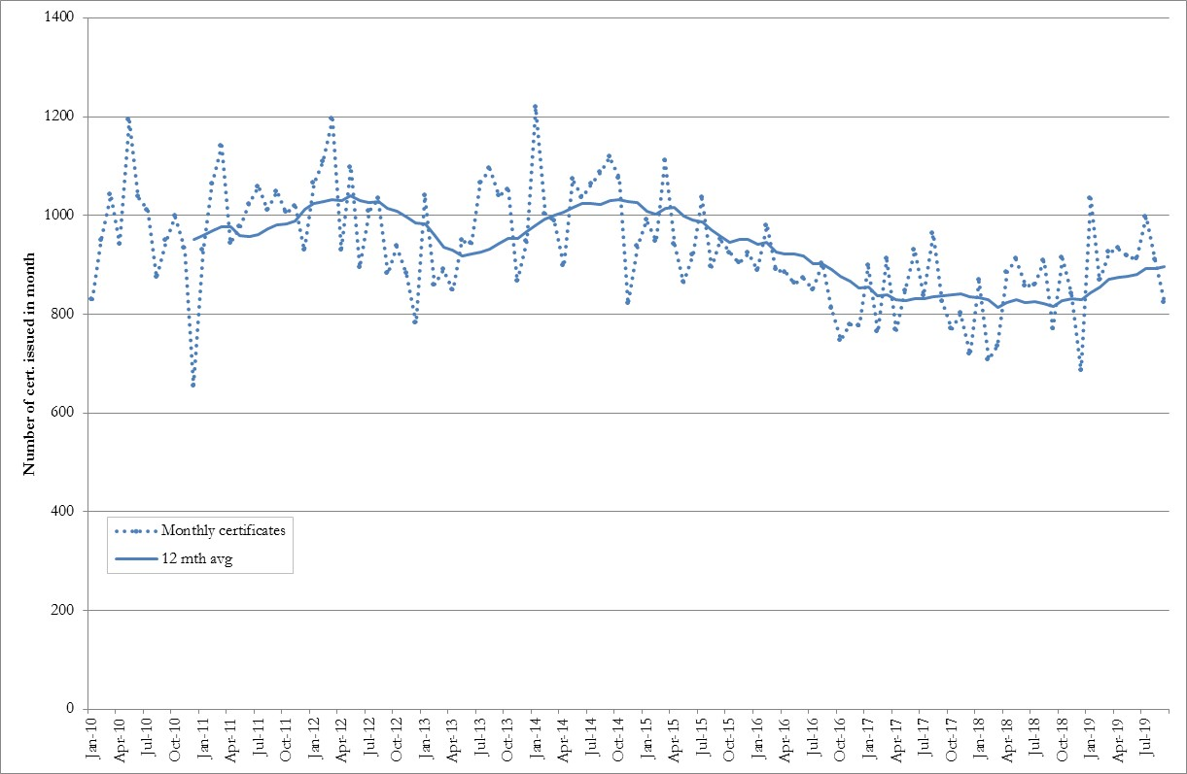

Solemn expenditure

- The expenditure on solemn cases rose by 3.8% to £30.9 million and the number of cases paid increased 5%. Solicitor’s fees paid increased 4% to £18.1 million. The cost of counsel was unchanged at £10.1 million. Outlays increased 15% to £2.7 million.

- Due to the length of solemn cases it will be much more than a year before we see the full cost effect of the current increase in certificates.

Other criminal legal aid expenditure

- For the 12 months to Sep’19:
- the expenditure on appeals was up 23% to £1.3 million;
- expenditure on contempt of court was down 5% to £208,000;
- expenditure on duty increased 2% to £758,000.

- The increase in expenditure in appeals was due to some very expensive cases being paid – such as following a long running fraud trial appealing against conviction and sentence. There was no overall increase in the volume of cases being paid.

Children’s legal assistance

- For the 12 months to Sep’19 the number of grants of children’s A&A by solicitors decreased by 4% to 3810 grants. The downwards trend seen since winter 2014/15 is continuing although it is lessening – this is the smallest percentage decrease for 2 years.

Children’s ABWOR and legal aid

- Children’s ABWOR is available for representation at children’s hearings. The total number of children’s ABWOR cases registered in the 12 months to the end of Sep’19 was 4750. This was a 5% rise on the 12 months to Sep’19 – Figure 9 below.

- The number of applications for legal aid for Sheriff Court cases received in the 12 months to Sep’19 was 2664 which is a 1.5% decrease on the previous 12 months (also Figure 9).

- With the introduction of children’s ABWOR with the new act it is thought that fewer legal aid cases are having to be applied for as applicants now have representation at the children's hearings instead of being involved with appeals to the sheriff.

- The volumes of Sheriff Court cases granted were combined with ABWOR volumes and compared with the previous 12 months. We have seen a 2.7% increase in volumes to 7026.

Figure 9: Children’s ABWOR & Sheriff Court – Monthly Receipts
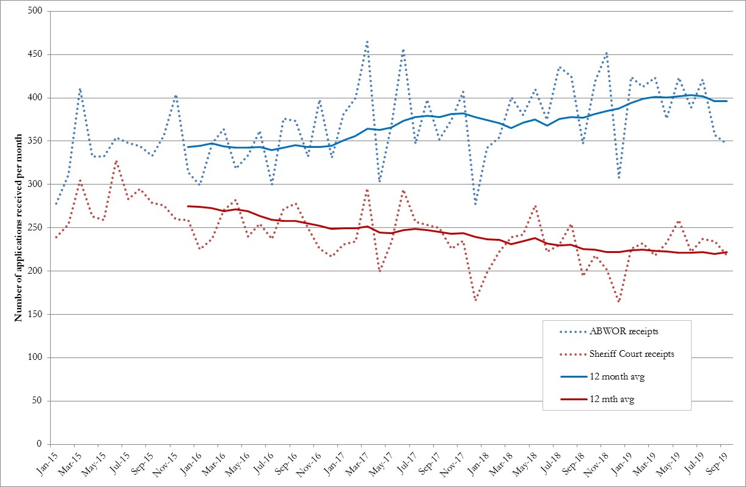

Children’s Expenditure

- Total children’s legal assistance expenditure decreased 1.3% to £5.2 million. Within this the cost of children’s advice and assistance fell 5% to £200,000. The total paid for children’s ABWOR cases was level at £2.4 million. The total paid for children’s sheriff court legal aid was also level at £2.4 million.

- Expenditure on children’s ABWOR is now the same as on legal aid for the sheriff court but the average cost of ABWOR cases is much less - £468 vs £1156. Accordingly a far greater number of cases can be paid for a similar overall cost – 5164 cases were paid under ABWOR in the recent 12 months compared with 2105 sheriff court cases.

Notes

The figures in this management report are draft figures. Headline application & grant volumes are rounded to two significant figures. Payment values are also rounded to two or three significant figures and always include VAT unless otherwise stated.

Figures for applications and grants do include PDSO, CLAO & SCL. But the payments do not include payments for block-allocated funding such as CLAO, PDSO or grant funding.

 | Governance Links
1 | Finance and Resources  N/A
2 | Risk  Our analysis of trends is our key mitigation for one of our corporate risks:  Risk 5: Leadership and management does not respond to changing trends in legal assistance, including impact on workforce planning.  Trend analysis also provides valuable insight to enable us to manage our other corporate risks concerned with failure to deliver improvements in legal aid processes that deliver improvements and efficiencies.
3 | Legal and Compliance  N/A
4 | Performance  The paper provides a context within which performance information can be assessed. Some of the analysis supports and extends on points within the Performance paper.
5 | Equalities Impact  N/A
6 | Privacy Impact and Data Protection  N/A
7 | Communications and Engagement  This paper has been agreed for publication. Trends issues for external or internal communication are considered as appropriate. For example, we have just published an article on our intranet on a recent Scottish Government update on the latest Scottish criminal proceedings statistics.

Appendices/Further Reading
None.

https://www.bbc.co.uk/news/uk-50336157
The factors taken into account by SLAB in considering whether a case should be exceptional include – the number, nature and location of witnesses; the number and nature of productions; the complexity of the law (including procedural complexity); whether the assisted person, or any witnesses, may be unable to understand the proceedings because of age, inadequate knowledge of English, mental illness, other mental or physical disability or otherwise.

