Report to: | The Board
Meeting Date: | 4th October 2021
Report Title | Performance Report
Report Category | For Information
Issue status: | Business as usual

Written by: | Marie-Louise-Fox & Graeme Hill
Director responsible: | Marie-Louise Fox
Presented by: | Marie-Louise Fox
Contact details: | foxma@slab.org.uk

Delivery of Strategic Objectives
Select the Strategic Objective(s) relevant to the issues | - We deliver a high quality user focussed service  - We embed ways of working across the organisation that enhance the quality, consistency and transparency of our decisions and delivery  - We engage with users and delivery partners across the legal aid and justice system to inform good design of our system and services
The purpose of this paper is to report on operational performance as at 30th June 2021.

Link to Board or Committee Remit
To monitor the performance of the operational departments.

Publication of the Paper
The Board has previously agreed that this paper should be published as a matter of course. It will be published on our website in due course.

Executive Summary
Members should note that the figures reported are a three month average i.e. reflect the position for June, July and August 2021 as a whole.

Applications – The performance across Applications was good and there are no particular concerns or issues to highlight.

Accounts – The reported performance remains very good with most measures being reported as “met” or “better than” the benchmark and some slight improvements being seen. There are no particular concerns or issues to highlight.

Previous Consideration
Meeting | Detail
10th August 2021 | Applications – The performance across Applications was good and there are no particular concerns or issues to highlight.  Accounts – The reported performance remains very good with most measures being reported as “met” or “better than” the benchmark and some slight improvements being seen. There are no particular concerns or issues to highlight.

Report

Applications Performance
- Civil Applications
The overall performance in civil applications is good with most civil benchmarks recorded as “better than”.
The solicitor’s satisfaction survey results were good. The response rate has reduced. The satisfaction level of 73% is an improvement from the previous survey in June 2019 and an increase of 6%. More solicitors are very satisfied. The June 2021 survey highlighted issues some firms are having contacting us by telephone. We were aware of these issues and have been working with IS to implement a new telephone system which will overcome the issues.
- Criminal Applications
The overall performance in criminal applications is very good with most criminal benchmarks recorded as “better than”.

For the satisfaction surveys, the response rate has reduced. The 67% satisfaction level is a slight reduction of 2% compared to the previous survey in August 2019. Levels of those very satisfied and those very dissatisfied both slightly increased.

There were comments in relation to difficulties with contacting staff, as mentioned above and the new phone system will improve this.

- Children’s Applications
The overall performance of children’s applications is very good with most benchmarks being recorded as “better than”.

For the satisfaction surveys, the response rate has reduced. There has been a reduction from 85% to 62% with greater levels of dissatisfaction. The phone system was raised.

Accounts Performance
- Civil Accounts
The overall performance in civil accounts remains good with all civil indicators reported as “met” benchmark or “better than” benchmark. As commented on in the fund paper there has been an increase in the processing durations for civil (incl. A&A) accounts that has impacted our cash-flow. However, we are confident that we will be able to manage the performance to generally remain at least as “met” benchmark.

- Criminal Accounts
The overall performance in criminal accounts is good with all criminal indicators reported as “better than” or “met” the benchmark. The processing durations in Solemn has also increased but again we are confident that that we will be able to manage the performance to generally remain at least as “met” benchmark.

- Children’s Accounts
The overall performance of children’s accounts is very good with all bar one of the indicators being reported as “better than” the benchmark. Negotiations in children’s has improved to now being reported as “met”.

- Customer Satisfaction
Satisfaction surveys have been carried out in each of the areas in the last three months. Whilst the satisfaction in each area has dropped to lower levels the survey response levels have been very low. It is likely that an element of the responses may be due to how firms are feeling generally about the pandemic and wider legal aid policy issues such as fees

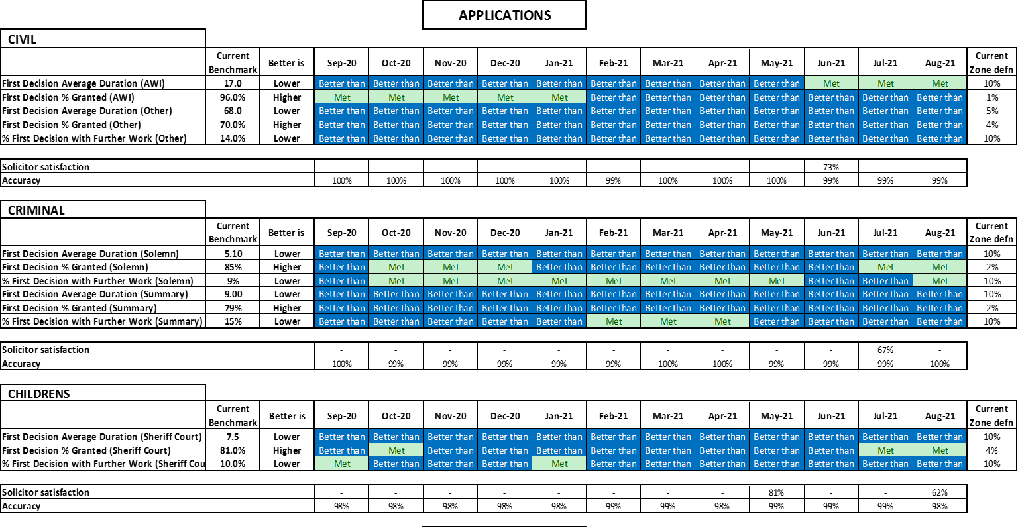

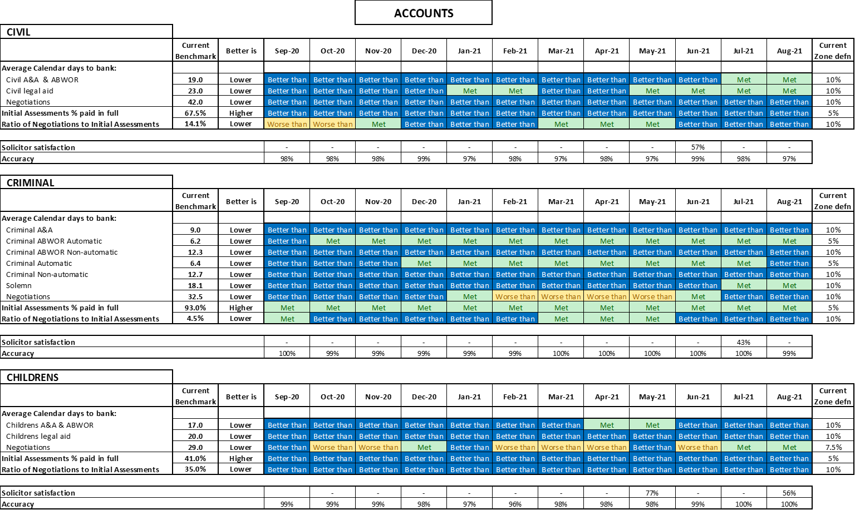

 | Governance Links
1 | Finance and Resources  Resources are key to the delivery of good performance. There are no resourcing issues to flag to the Board which have affected the performance reported.
2 | Risk  Applications  This report gives assurance that we are managing the functional risks identified in relation to: (i) Failure to accurately assess applications and increases in accordance with SLAB's policies and procedures; and (ii) Failure to take operational decisions within agreed service standards.  Accounts  This report gives assurance that we are managing the functional risks identified in relation to: (i) Failure to pay solicitors within a timeframe that is acceptable to the profession and enables management of the Legal Aid Fund; and (ii) Inconsistent approach to assessment of accounts.
3 | Legal and Compliance  No issues of note.
4 | Performance  No issues of note.
5 | Equalities Impact  An impact assessment is not required for this paper.
6 | Privacy Impact and Data Protection  No privacy or data protection issues identified.
7 | Communications and Engagement  This paper has been agreed for publication and we are also publishing separate information regarding our performance via our website.

Conclusion and next steps
Members are asked to note the report.

Appendices
Appendix 1: - Guide to the SLAB Operation Performance Overview Report (SOPOR)

Appendix 1

Guide to the SLAB Operation Performance Overview Report (SOPOR)

STRUCTURE

Information is grouped by operational area and type of measure. The first 3 reports are on Applications areas: Civil; Criminal and Children’s, and the bottom 3 on Accounts areas.

In Civil we report Adults with Incapacity cases separately. These are high in volume and we take decisions on these in a much shorter timescale because the statutory tests are more straightforward. These are separated out to avoid a disproportionate impact on performance statistics.

In Criminal we report on summary and solemn cases separately: SL = Solemn cases; SC= Summary cases.

PERFORMANCE REPORTING IN THE SOPOR

Benchmarks for performance reporting for financial year 2021-22 were presented to the Board in March 2021. The benchmarks proposed balanced the aim of being challenging but achievable but also the need to manage the risks and uncertainty around the coming year of 2021-22. They were based on performance during the pandemic in 2020/21 and also pre the pandemic in 2019/20.

The new benchmarks were introduced into the reporting from April 2021 onwards.

A rolling 3-month average (i.e. a mean) is the basis for calculating and reporting performance. This is compared against a static benchmark with performance reported in terms of three zones:

- Met (the benchmark)
- Worse than (the benchmark)
- Better than (the benchmark)

A green-yellow-blue colour highlighting scheme is used. Green indicates a benchmark is being met. Yellow highlights the ‘Worse than’ zone and Blue highlights the ‘Better than’ zone.

The Met zone is defined initially as the benchmark plus or minus 5%. The ‘Better than’ and ‘Worse than’ zones are above or below the Met zone – depending on the type of measure. For example with the First Decision % Granted measure in general higher figures are better. So the ‘Better than’ zone is above the Met zone, i.e. above 105% of benchmark. But we aren’t necessarily aiming to be as high as possible – we may find issues with accuracy and quality if we get too high or we may need to expend a disproportionate amount of effort.

With the Duration and Further Work ratio measures the ‘Better than’ zones are below the benchmark (less than 95% of benchmark).

The starting point for defining the width of the Met zone is plus or minus 5%. In some cases it has been necessary to adjust it. This adjustment is because of the differences in application and account types and processes which produce different distributions for the different measures – some are more variable than others. This is especially so in relation to the size of the measure value. For example plus or minus 5% covers a wider range of values at 90% than it does at 20%.

The benchmark approach has facilitated the re-inclusion of AWI within civil and a more detailed breakdown of accounts to be presented.

All measures are calculated for the most recent 3 month period and the 11 previous results are also shown so that trends over 1 year can be seen.

DESCRIPTION OF MEASURES IN THE SOPOR

Duration

The key duration shown for applications is the average time, in calendar days, from receipt of a main legal aid application by SLAB, to when we take the first official decision on it. This duration includes all weekends and holidays. It also includes any period where we are asking the solicitor, or applicant, for more information to help us take the decision.

This indicator measures both the workflow performance of SLAB but also the degree to which solicitors and applicants are managing to provide all necessary information.
Simply put lower is better.

In accounts the first instance duration is a very similar measure – it is from registration of the account to the date payment is received into the solicitor’s bank account. It is in calendar days and again includes any period where we are asking the solicitor for more information to help us assess the account.

The negotiation duration is the same measure but for accounts that are follow-up accounts to negotiate sums that we have abated from initial accounts.

Grant / paid in full rate

The first official decision on a legal aid application can be one of 3 main types: grant; refuse; or not consider due to lack of information. The percent granted measure is the number of grants divided by (i.e. indexed) by the total number of first decisions in the period and expressed as a percentage.

This indicator measures the effectiveness with which SLAB and the profession are facilitating solicitors to make appropriate and complete applications.
Simply put higher is better.

In accounts the equivalent measure is the percent of accounts that we are able to pay all that solicitors are claiming, i.e. without abating them.

‘Abatement’ describes the process by which the amount paid by SLAB includes one or more deductions from the amount claimed by a solicitor. This can occur for many different reasons. Subsequent negotiations with firms can result in part or all of the sum abated being reinstated, often because we are provided with further information that allows us to be satisfied that a claim is valid or reasonable. This can be additional information (such as vouching) to support a claim, or an explanation to justify a particular activity which had appeared to us on the face of it to be unnecessary, unreasonable or uneconomical.

SLAB needs to protect the Legal Aid Fund from unjustified expenditure; however this needs to be undertaken in a manner that is seen to be fair, transparent and done in a consistent and efficient manner.

Ultimately we will be using the information on what we finally pay against, the original lodged amount and the initial payment to understand how we can ensure more could be paid at the first instance.

Ratio of Further Work (Negotiation) to First Decision (First Instance)

In applications this indicator is the number of cases requiring further work divided by the total number of first decisions in the period and expressed as a percentage. In accounts it is the number of negotiation accounts paid compared with the number of first instance accounts.

This indicator measures a number of different key elements of the process:

- the effectiveness with which SLAB is getting correct applications/accounts in the first instance;
- that SLAB is making correct decisions;
- The effectiveness with which SLAB is communicating those decisions.

Poor performance in any of those areas could result in an increase in this ratio. Simply put lower is better.

For more information please see Board paper SLAB-2019-11 Benchmark Proposals for 2019-20.

