Report No: **SLAB/2022/10**

Agenda Item: **14**

|  |  |
| --- | --- |
| **Report to:** | The Board |
| **Meeting Date:** | March 2022 |
| **Report Title** | The Civil Legal Assistance Office Update |
| **Report Category** | For Discussion |
| **Issue status:** | Business from a project |

|  |  |
| --- | --- |
| **Written by:** | Jennifer Laughland – Head of Service |
| **Director responsible:** | Colin Lancaster |
| **Presented by:** |  |
| **Contact details:** | laughlandje@clao.org.uk |

|  |  |
| --- | --- |
| **Delivery of Strategic Objectives** | |
| Select the Strategic Objective(s) relevant to the issues | 1. We deliver a high quality, user-focussed service  2. We embed ways of working across the organisation that enhance the quality, consistency and transparency of our decisions and delivery  3. We engage with users and delivery partners across the legal aid and justice system to inform good design of our system and services |

|  |
| --- |
| **Link to Board or Committee Remit** |
| This is linked to the Board’s role in overseeing organisational performance. |

|  |
| --- |
| **Publication of the Paper** |
|  |

|  |  |
| --- | --- |
| **Previous Consideration** | |
| **Meeting** | **Detail** |
| Board – December 2020 | The Board was presented with a report on business activity through the CLAO in the previous 12 months.  It was reported that although the pandemic had seen a decrease in evictions it was anticipated that there would be a rise in debt and welfare benefit cases in the coming months. Appropriate training for the CLAO team in those areas of work would be carried out. The pandemic has also offered an opportunity to test new ways of working.  The Board commented on the large number of changes and developments in relation to resources, case types, case volumes, processes and procedures that CLAO have adapted to in response to the challenges presented by the pandemic. |
| Board – November 2019 | The Board noted the CLAO update. The Board queried whether the remote working arrangements for Argyll and Bute were working and it was confirmed that this is operating well.  It was also noted that CLAO is in the last year of a three year business plan and that the management team is new, with a new Head of Service, and heads of office in Aberdeen, Edinburgh and Inverness. |
| Board – September 2018 | The Board considered progress against the business plan as at July 2018, including establishing links with NHS Lothian and Improvement Service for referral processes and updates on individual office projects.  Members discussed and noted the paper. |
| Board – September 2017 | The Board considered the progress towards implementation of the business plan, including an update on the development of a business case for a new case management system and plans to review CLAO business processes and practices.  Members discussed and noted the paper. |

|  |
| --- |
| **Report** |

1. The Civil Legal Assistance Office network comprises three offices located in Inverness, Edinburgh and Aberdeen, covering four geographical areas: Highland and Islands, Edinburgh and the Lothians, Argyll and Bute and Aberdeen and Aberdeenshire.
2. We have continued to develop temporary arrangements and adjustments as a result of coronavirus and we are now reviewing those arrangements to ensure that equalities impacts are assessed and learning is captured to help us to develop and improve our services in the longer term.
3. Some of the changes we have made are:
   1. **Telephone appointments**

During the pandemic we shifted to a model whereby most appointments were by telephone rather than face to face. Options were available for face to face or VC appointments where these were essential and can now also be offered where that is preferred. However telephone appointments mean less travel for our solicitors and clients and make it easier to utilise resource across the network. It has resulted in fewer missed appointments, and the majority of clients and contacts (including ones who had had the opportunity to have both face to face and telephone appointments) have indicated it is their preferred method of meeting with their solicitor in our most recent survey

* 1. **Direct advice line service for homeless people**

This allows us to offer immediate legal advice and same day urgent casework to people sleeping rough, resulting in suitable accommodation being made available for people that day. It has now been rolled out to advice and solicitor services across Edinburgh and the Lothians

* 1. **Network Centres of expertise**

We have a new Court of Session and Sheriff Appeal Court service, based in Edinburgh and a new Child Law Hubbased in Aberdeen, which provide services throughout the network

* 1. **Transition to electronic files**

During the pandemic, solicitors were mainly working from home and relying on electronic files. This has been successful and will help solicitors and support staff adjust to a new Case Management System and the phasing out of paper correspondence files.

The adaptations we made to our service to respond to the coronavirus pandemic have supported a more client focussed and resource effective delivery model, which will support increased demand for our services and a continued network approach, as staff begin to return to offices.

## PROGRESS REPORT

1. The past year has continued to present challenges. When we last reported to the Board in December 2020 we had anticipated more frequent visits to the office and in-person court hearings and a more settled way of working in 2021. Instead we continued to face a changed operational landscape, giving us an opportunity to continue to trial different ways of working and gather data about that, as well as to look for ways to increase our efficiency.

**Recruitment**

1. A number of vacancies arose in CLAO in 2019 and early 2020. Recruitment was on hold in SLAB for a period during 2020, due to the pandemic and we subsequently took the decision not to replace vacancies immediately due to reduction in new business as a result of the pandemic.
2. That gave us the opportunity to stagger recruitment, prioritising Aberdeen and Inverness over Edinburgh, as recruitment has historically been more difficult in those locations. Posts in Edinburgh were not filled until summer 2021.
3. It also gave us the opportunity to reconsider how to structure the service, to utilise our staffing resource in the most effective way. Grade 7 and Grade 6 posts in Inverness and Edinburgh were replaced with Grade 6 and 5 solicitors, allowing us to use the savings to create two internal Grade 7 posts, one specialising in Court of Session and Sheriff Appeal Court work and one specialising in child law.
4. We had also decided to recruit a trainee for the network, to be attached to the Inverness office. We had an excellent pool of candidates and the savings we had achieved allowed us to recruit an additional trainee for Aberdeen from that pool. This will allow us to equip two individuals with social welfare law skills in geographical areas where few solicitors have that background. Assuming that they continue to do social welfare work outside the central belt, post–qualification, this will help SLAB contribute to Scottish Government aims around tackling inequalities as well as enabling us to potentially fill future solicitor vacancies without relying on external recruitment.

**Training and Development**

1. We have created new materials to use for carrying out inductions with new staff and a structured process for doing so. This has helped the successful induction of all our new staff.
2. We are taking a network approach to training and development, making sure that our solicitors and support staff have the skills that we need as a network, through staff attending courses and cascading what they have learned to colleagues, or buying in tailored training where this is needed. We have had recent CLAO network wide training on Court of Session procedures and advocacy skills and dampness and disrepair workshops, as well as a cascade session on various topics, including benefits.
3. We have also carried out training for and received training from colleagues in SLAB and other partner organisations.
4. We are exploring entering a partnership with Legal Services Agency whereby CLAO staff provide training as part of LSA’s programme.

**Casework**

1. We have been involved in some strategically important cases, for example in relation to guardianship, kinship care, benefits and homelessness and will be presenting some case studies on homelessness at the next Equality Act and Housing Legal Strategy Group.

**Quality Assurance**

1. Our Edinburgh and Aberdeen offices assisted SLAB in a trial of carrying out children’s peer reviews remotely (although this work is not core for Edinburgh our Edinburgh solicitors have assisted with this work while housing cases were less active). We achieved excellent results with all solicitors peer reviewed achieving very high scores.

**Inverness Premises Move**

1. Our Inverness team were not asked to participate in the children’s peer review, at this time, as they were in the process of moving premises. The move to new premises, shared with PDSO, took place in May/June 2021, and should better support the services that both CLAO and PDSO provide. Both services are now located in a more accessible and configurable environment. This allows us to consider both how we work together to increase resource effectiveness and the client experience, and how we can use the premises to best meet the needs of our clients and other stakeholders. An EQIA has been carried out and a survey of law firms, advice and support agencies who may wish to use our premises. Preparatory work is being done on a survey of clients and contacts, specific to their experience of our premises.

**Operational Changes**

1. We have continued the process of developing the CLAO offices to operate as a network, rather than a number of standalone offices. We have set up specialist network wide services, focussing on child law and on Court of Session and Sheriff Appeal Court work.
2. The Court of Session and Sheriff Appeal court service has new processes and procedures for undertaking Edinburgh agency work for other CLAO offices. The service has acted as Edinburgh agents in judicial review cases, giving us an opportunity to test the new procedure which worked well. We have also been able to recover expenses which will include the fee for the agency work normally done by other firms.
3. We have continued to carry out other work to improve the resources that staff have to guide them in carrying out their work, including developing processes for use of the new case management system.
4. We are developing new referral pathways into our service with Child Poverty Action Group (CPAG) in relation to judicial review of social security decisions and with various stakeholders in Argyll and Bute to increase referrals from that area more generally.
5. We are also working to improve referrals and signposting out of our service in areas where we have seen increased demand, but which are not core for us or in areas where other services can complement ours.
6. We have done work with a number of services who work with homeless people, with Victim Support in Highland and Islands, with the EU Citizens Rights project, with the EHRC and with private solicitors to encourage referrals both in and out of our services.
7. We have reviewed, updated and improved all our signposting information, to target it more effectively at the type of problem the person is contacting us about and include more information about the non-legal help available with some problems.
8. We have resumed routine face to face services, but with procedures in place at our offices to keep staff and our clients safe. Most of our business continues to be conducted by telephone or online.
9. Work on procuring a new case management system was completed. Work on implementing that system within our direct services in a way that will improve our operational efficiency, our ability to handle data correctly and securely and our ability to collect and analyse data is ongoing.

### KEY STATISTICS

1. With the direct services’ new case management system not yet in place, we still rely on our contact handling data from our current contact management database and information from solicitor monthly file reviews to produce management information which supports individual and office level performance management, casework allocation decisions and contact handling processes. File review data, which is checked and assessed by managers, is subject to a lag in reporting. Accordingly the statistics drawn from file reviews are behind data from the contact database.
2. We are currently in the implementation phase of the new case management system which will improve our capacity to report on key trends and use data to inform operational decision making significantly.
3. The key statistics about levels of contact and new casework matters are:
4. Overall numbers of contacts remain much lower than before the pandemic.
5. However, the number of core contacts has increased since our last report, while non-core contacts have decreased. This means that the majority of contacts who approach us are eligible to receive a service from us.
6. Casework capacity (measured by open caseload) has continued to increase gradually since our last report.

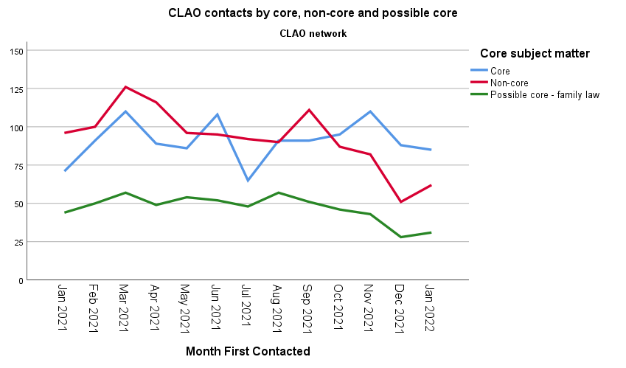

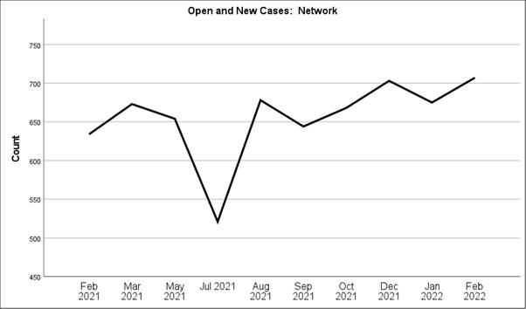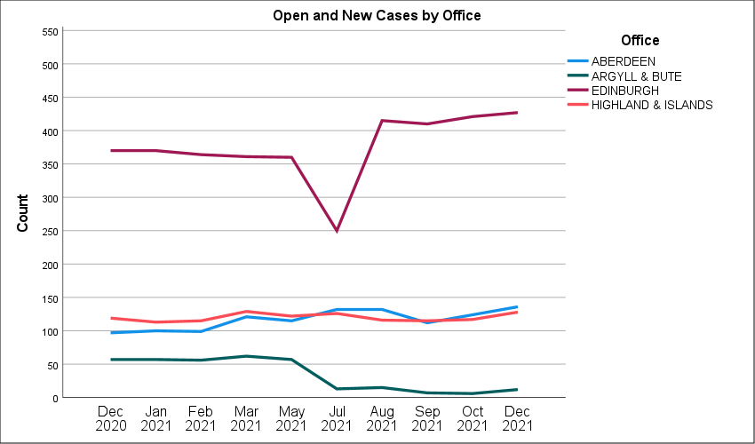

1. The limitations of our current reporting capabilities do not reflect all the complexities and nuances of our more agile, network based approach where solicitors work together to cover the work of all offices. The sharp dip in cases in in Edinburgh, Argyll and Bute and in the network as a whole is the result of cases being transferred from case lists of existing Edinburgh and Argyll and Bute solicitors to new Edinburgh solicitors. The caseload of the Argyll and Bute solicitor has been kept low since then, to allow her to focus on development work with advice agencies in Argyll and Bute, before she goes on maternity leave next month.
2. Broadly speaking, our Edinburgh office has continued to carry a very high caseload. Edinburgh office’s focus on fewer case types and on housing continues to maximise the capacity of solicitors in that office to take on work by concentrating on a narrow area of expertise and having systems to support that work. We are seeing more private tenancy eviction cases, homelessness and disrepair work, which tend to be more complex than social rented sector eviction cases.
3. It can be more difficult to manage capacity in children’s work, particularly when acting for an adult with multiple children due to the potential for a high number of hearings to take place and the nature, frequency and timetabling of those hearings. Covering rural courts and children’s hearing centres can also impact capacity. The increase in remote hearings may lessen this effect, but often it is not known from the outset if hearings will be conducted remotely or not. Much of the children’s work being taken on is increasingly complex.
4. There will be advantages to resource management based on the sort of data recording and reporting that can be made possible from a case management system. It will allow us to far more easily understand and quantify the impact of various factors and take appropriate action.

**USER FEEDBACK**

**Client and Contact Survey**

1. We carried out a full user feedback survey this year. The report has not yet been finalised but responses were mainly positive, with findings similar to those in the previous survey.
2. Telephone is by far the most preferred method of contacting the service, with 75% selecting it. There were no sizeable differences in preference for either ‘first’ or ‘preferred’ contact methods by the demographic variables collected.
3. There was an increase in numbers of contacts, but not clients, who had contacted more than one solicitor prior to approaching our service.
4. Clients were still far more likely to be satisfied with our service than contacts. In some respects this is unsurprising, given that clients are offered a fuller service than contacts. However, the work that we have done on improving our signposting information, together with work with private practice solicitors and colleagues within SLAB to try to make services more joined up may help to improve this.

## Complaints

1. Evidence from complaints received over the past year (March 2021 – February 2022) would suggest that a continued source of dissatisfaction among CLAO users is an unfulfilled and sometimes unrealistic expectation that CLAO will be able to resolve their problem (14 out of 15 complaints were from a contact or a third party, rather than a client. The 1 client complaint was about being contacted by a researcher in relation to our client survey, rather than about CLAO).
2. CLAO continues, in line with SLAB’s policy, to treat all expressions of dissatisfaction as a complaint, to ensure that we record the issue, and use learning from that process to help us to make improvements to our own services where we can. Not all recorded complaints therefore relate to a formal complaint, or are about our standard of service. The complaints largely related to dissatisfaction with or not fully understanding the remit of CLAO’s service (often compounded by information received from other services that led them to believe CLAO would be able to resolve the issue). They include complaints about decisions not to take on a particular piece of work and dissatisfaction with other services, such as solicitors in private practice.
3. CLAO’s service is designed to identify and inform contacts at the earliest possible opportunity whether we can offer a casework service or not, which ought to minimise opportunities for misunderstandings to arise. Further work to review how our service remit is communicated to potential contacts and other services was carried out this year, resulting in improved signposting information being developed, ongoing improvements to our website and engagement work with advice agencies and solicitors which we hope will help with this in future.

**NEXT PHASE OF DEVELOPMENT**

1. We are entering an exciting new phase in the development of CLAO, as we come together with the other direct services under a single director of Client Legal Services. This will create opportunities to share learning, to work more closely with PDSO and SCL to provide more comprehensive services and to pool resources where this would be effective.
2. The immediate focus for CLAO the period between now and 2023 will be creating a bridging plan to give direction until the new Director of Client Legal Services is in post, there is further clarity on the government’s strategy and a new three year plan for all the direct client legal services is in place.
3. We will use the information we have gathered from the changes made during the pandemic, from our client and contact survey and from the survey of stakeholders carried out as part of the Inverness premises move to help inform the direction of travel longer term. We will, gather further evidence from a small scale client survey about client and contact experiences of our premises and from the new Case Management System and will consider what further evidence we need about patterns of supply and demand and how we will gather that. We will also consider how we might work more closely with PDSO and SCL. We will carry out an EQIA of any proposed changes and develop a recruitment and training strategy to support our ability to respond to any likely changes.

|  |  |
| --- | --- |
|  | **Governance Links** |
| 1 | **Finance and Resources**  There are no specific finance and resources issues linked with this paper. |
| 2 | **Risk**  Two new risks were identified in this period, both of which are being adequately managed.   * Some casework is not cost effective; Caused by additional work required to explore new ways of working through projects and other changes to the way we deliver our service. This is managed by any innovation being overseen by the Head of Service/CEO and its effectiveness evaluated. The case management system will assist us to do this. * There is a danger that in the current climate we are not able to demonstrate that the resource of the new Inverness premises can be utilised in a way that it supports advice provision directed at government priorities. We carried out an EQIA of the move, consulted stakeholders about use of the premises and will be carrying out further user feedback.   There is a functional risk register for the CLAO network which is monitored regularly. |
| 3 | **Legal and Compliance**  There are no specific legal and compliance issues linked with this paper. |
| 4 | **Performance**  Performance considerations are covered within the main body of this paper. |
| 5 | **Equalities Impact**  An Equalities Impact Assessment was carried out before the implementation of the 2017-20 business plan, for the implementation of the Case Management System and for the Inverness premises move. Any interim plans and the next full three year plan will require a further Equalities Impact Assessment in respect of any proposed changes, as well as providing an opportunity to consider changes needed to the Equalities Impact Assessment for the service. |
| 6 | **Privacy Impact and Data Protection**  There are no issues relevant to this paper. |
| 7 | **Communications and Engagement** |

|  |
| --- |
| **Conclusion and next steps** |
| Members are invited to comment on our assessment of delivery. |

|  |
| --- |
| **Appendices/Further Reading** |
|  |