Report No: **SLAB/2018/03**

Agenda Item: **09**

|  |  |
| --- | --- |
| **Report to:** | The Board |
| **Meeting Date:** | 11th February 2019 |
| **Report Title** | Trends Analysis |
| **Report Category** | For Information |
| **Issue status:** | Business as usual |

|  |  |
| --- | --- |
| **Written by:** | Manager of Analysis and Management Information |
| **Director responsible:** | Director of Strategic Development |
| **Presented by:** | Manager of Analysis and Management Information |
| **Contact details:** |  |

|  |  |
| --- | --- |
| **Delivery of Strategic Objectives** | |
| Select the Strategic Objective(s) relevant to the issues | 1. to deliver improvements to legal aid processes that increase efficiency and improve the experience of system users and customers.  2. to advise Scottish Ministers on strategic development pf legal assistance and its contribution to Scotland in which rights are supported and disputes are resolved fairly and swiftly  3. to ensure that our organisation has the culture and capability to be responsive to our customers, the justice system and developments in legal and advice sectors. |

|  |
| --- |
| **Link to Board or Committee Remit** |
| This information enables the Board to understand the environment that the organisation is operating in. It influences strategic direction and is a key element of oversight |

|  |
| --- |
| **Publication of the Paper** |
| The Board has previously agreed that this paper should be published as a matter of course. It will be published on our website in due course. |

|  |
| --- |
| **Executive Summary** |
| Total gross expenditure has decreased 3% to £126 million in the 12 months to Dec’18. Applications are mostly level or decreasing. |

|  |  |
| --- | --- |
| **Previous Consideration** | |
| **Meeting** | **Detail** |
| Board – July 2018 | Total gross expenditure had fallen 6% to £126 million in the 12 months to July’18. Applications were mostly level or decreasing. |

|  |
| --- |
| **Report** |

# SUMMARY OF KEY TRENDS

Total gross expenditure has decreased 3% to £126 million in the 12 months to Dec’18.

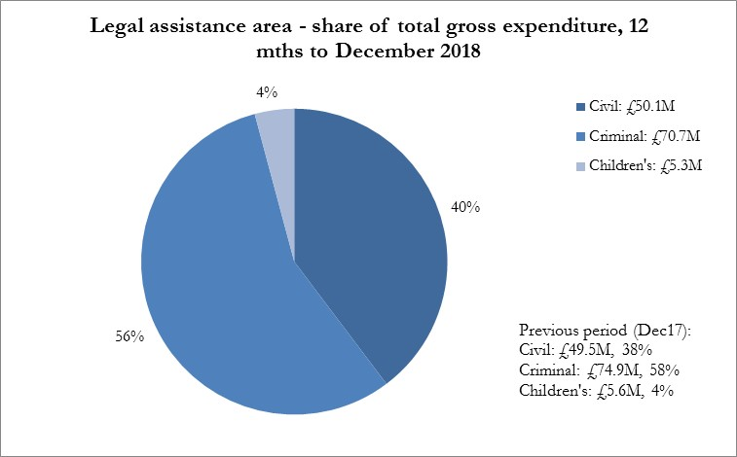

***Civil legal assistance***

* The total gross spend on civil legal assistance increased 1.1% - to £50.1 million.
* Intimations of civil advice and assistance have decreased 5% to 56,000.
* Civil ABWOR intimations have decreased 4.2% to 5,700.
* The total spent on civil A&A, including ABWOR and hardship, decreased 0.5% to £19.3m.
* Civil legal aid applications received were 17,700 – a 3.7% decrease on the previous 12 months.
* Gross expenditure on civil legal aid in the 12 months increased 2.2% to £30.8 million.

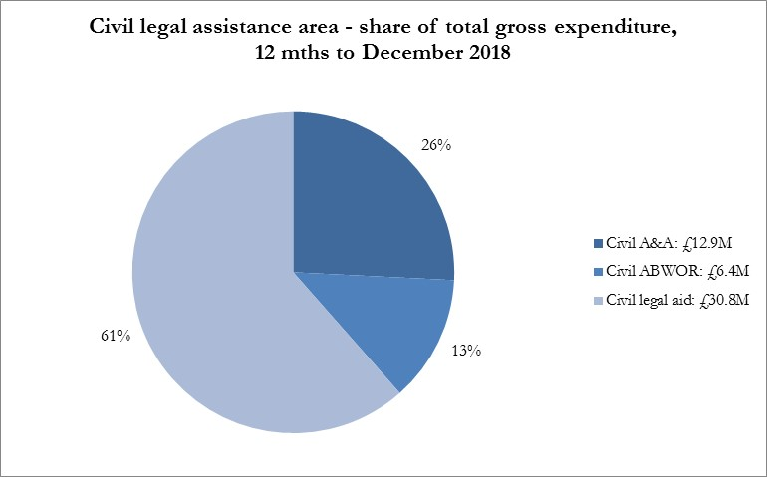

***Criminal legal assistance***

* Criminal A&A and CJA combined shows a 25% increase to 25,900.
* The number of grants of criminal ABWOR has decreased 3% to 26,300.
* The number of summary criminal cases granted decreased 9% to 39,800.
* The number of grants of solemn criminal legal aid is down 0.9% to 9,900.
* Overall expenditure on criminal assistance decreased 6% to £70.7 million. This included:
  + A 101% increase in the expenditure on criminal A&A (inc CJA) to £2.0 million;
  + expenditure on criminal ABWOR fell 8% to £10.6 million;
  + expenditure on summary criminal legal aid fell 7% to £25.8 million;
  + the amount spent on solemn proceedings fell 6% to £30.0 million;
  + the expenditure on criminal appeals fell 10% to £1.2 million.

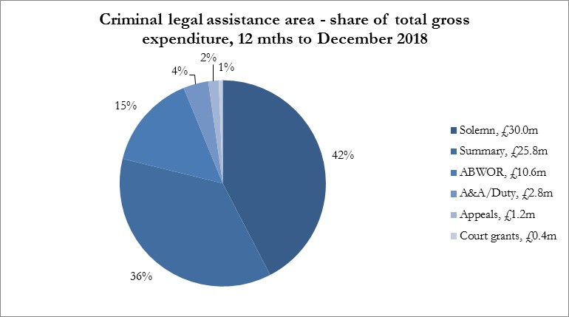

***Children’s legal assistance***

* The number of children’s A&A intimations decreased 13% to 3900.
* Intimations of children’s ABWOR, increased 2.6% to 4650.
* Receipts of children’s legal aid cases decreased 7% to 2650.
* The total gross spend on children’s legal assistance declined 6% to £5.3 million.
  + There has been a 19% decrease in children’s A&A expenditure, to £206,000.
  + The amount spent on children’s ABWOR increased 4% to £2.4m.
  + The amount spent on children’s sheriff court legal aid fell 12% to£2.5m.

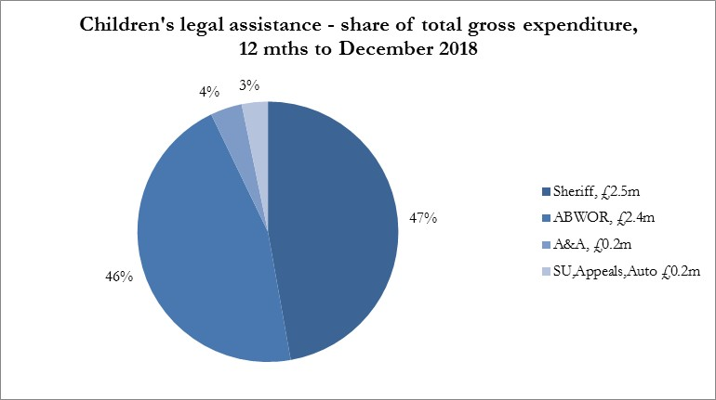

**Notes**

# The figures in this management report are draft figures. Headline application & grant volumes are rounded to two significant figures. Payment values are also rounded to two or three significant figures and always include VAT unless otherwise stated.

# Figures for applications and grants do include PDSO, CLAO & SCL. But the payments do not include payments for block-allocated funding such as CLAO, PDSO or grant funding.

# 

# TREND ANALYSIS BY AID TYPE

## Civil legal assistance - Civil advice and assistance

1. Over the 12 months to Dec’18 the total number of civil advice and assistance (A&A) intimations received has decreased 5% to 56,000. The largest volume year-on-year decreases were in cases with subject matters of:

* Benefit-appeals = down 19% to 3400 cases;
* Contact = down 5% to 10,500 cases;
* Divorce = down 12% to 2800 cases.

1. The subject areas with the most sizeable rises in volume have been:

* immigration/nationality up 480 (8%) to 6200;
* asylum up 220 (7%) to 3200;
* adults with incapacity up 180 (8%) to 2400.

1. The immigration/nationality category is considered alongside those of asylum and ABWOR for these subject matters below. The judicial review subject category can relate to many different types of proceeding. From analysing their brief subject matter descriptions or firm intimating a large number of these are also related to immigration and asylum proceedings. Judicial review increased by 140 (18%) in 2018.

## Civil ABWOR

1. In civil ABWOR, where the solicitor can represent people in certain types of tribunal and other hearings, the number of grants intimated has decreased 4.2% to 5700. The key areas within ABWOR are immigration and asylum and mental health. Many cases in these subject matters start out as advice and assistance before becoming ABWOR once tribunal proceedings are underway. A clearer picture of trends in these areas can therefore be obtained by looking at the numbers for A&A and ABWOR combined.
2. In mental health the combined figure for A&A and ABWOR started to show a decline in growth in Feb’17. This has continued. The annual decrease to Dec’18 was 3% to 3300 cases, Figure 1 below.

Figure 1

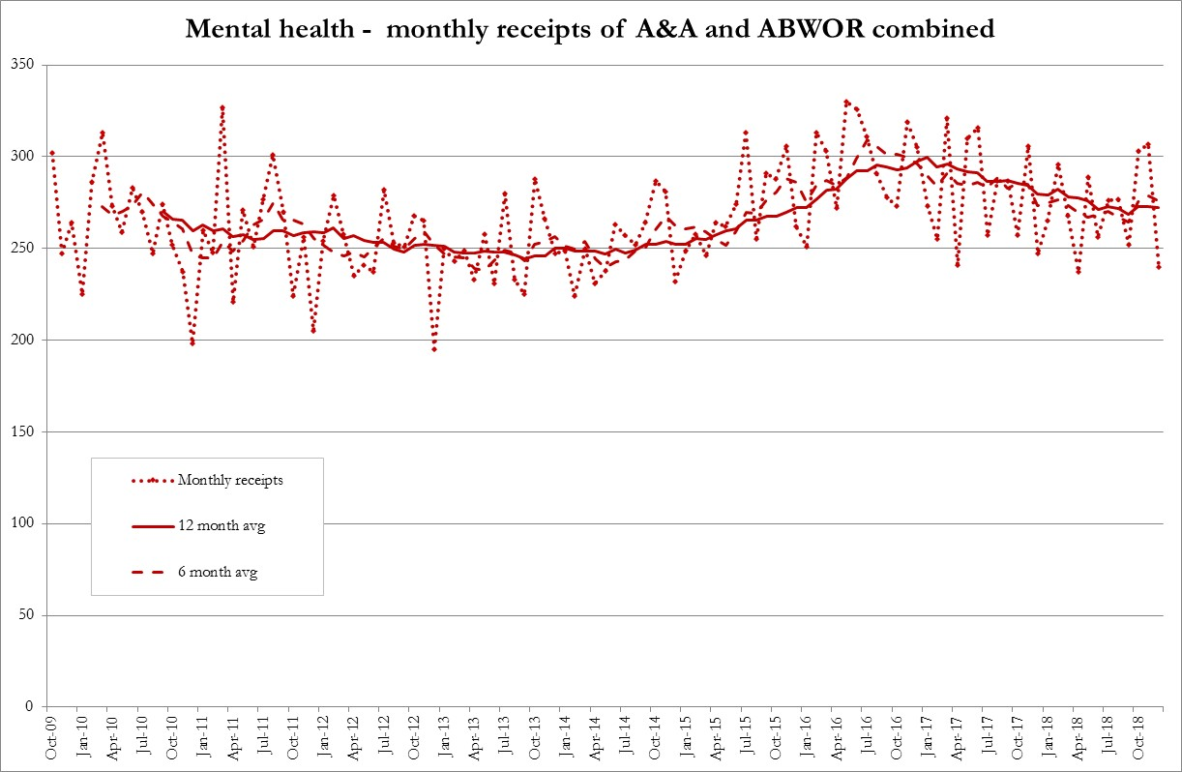

1. In immigration and asylum when A&A intimations are combined with ABWOR, case volumes were showing a large annual increase in the summer of 2018 of 14%. Volumes are still higher (5% up) than they were a year ago but there are signs that the increase has lessened. Average intimations per month are now at 990, Figure 2 below.

Figure 2

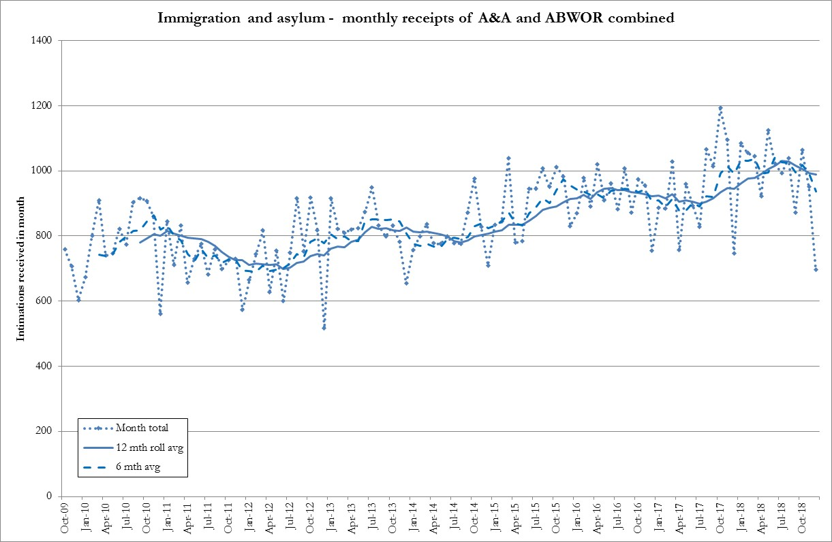

## One possible cause for an increase in the summer were the moves to evict some unsuccessful asylum seekers from their accommodation. Legal aid applications have been received relating to this issue but only 1 immigration or asylum A&A case that mentions eviction was received from January to August 2018.

## Civil A&A and ABWOR Expenditure

1. Expenditure on civil A&A and ABWOR decreased 0.5% to £19.3 million. As with intimation figures a clearer picture of trends can be obtained through analysing A&A and ABWOR expenditure together.
2. The largest increase by value at a subject level was Immigration and asylum which increased by £0.9 million (13%) to £8.0 million. The next largest increase at a subject level was Family/matrimonial – other which increased by just £40,000 to £534,000.
3. Within the immigration & asylum grouping we have two categories: asylum application/appeal and immigration/nationality. Looking at the past 8 years asylum application/appeal expenditure has more than doubled from £2.1 million to £4.7 million. Over the same period immigration/nationality expenditure has increased from £2.4 to £3.3 million.
4. More extensive analysis of the immigration & asylum area is planned looking at individual firms, their behaviour and the drivers for expenditure. Mental health expenditure fell by 12% to £2.7 million. Contact/parentage decreased 4% to £2.3 million. State benefit expenditure increased 2% to £1.1 million.

# Civil Legal Aid

1. Civil legal aid applications received were 17,900 – a level position on 12 months ago. Applications not including Adults with Incapacity (AWI) cases have been falling since July 2013. Over the same time the numbers of AWI cases have been increasing, but the combined figures have still been decreasing.
2. However the past few months have seen a levelling off of non-AWI applications – the 12 month low point was March 2018. Combined with AWI we have therefore seen a clear, albeit small, increase in volumes received since March 2018, Figure 3 below.

Figure 3

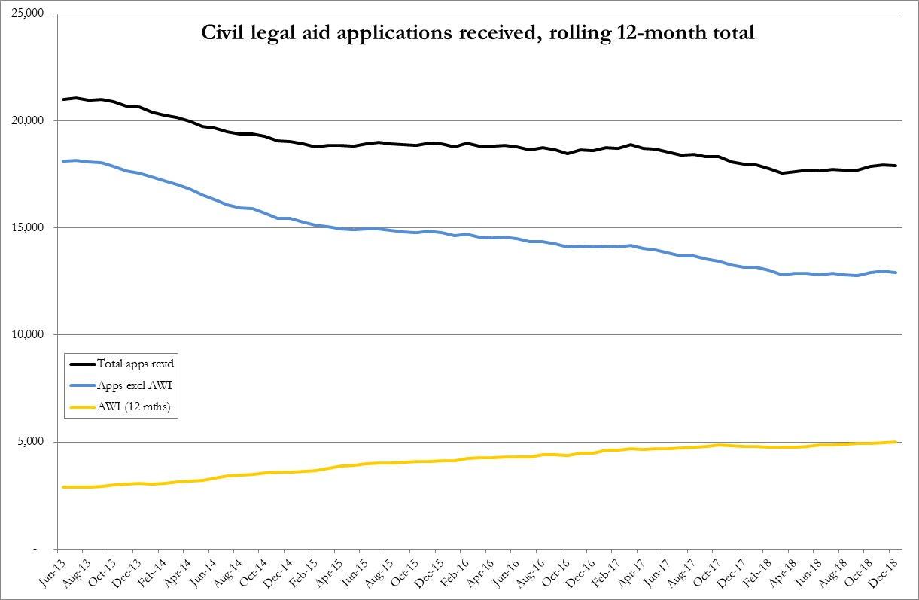

1. The three subject matters with the largest falls are:

* Housing/recovery of heritable property down 410 applications (-24%);
* Other down 100 applications (-16%);
* Divorce/separation down 60 (-3%).

1. The fall in Housing/recovery of heritable property has been examined further. The subject matter is mostly related to rent arrears cases. There appear to be a number of issues at play here:
   1. some shift by some of the larger providers of legal aid with more of a focus at the moment on homelessness as an issue;
   2. known staff vacancies at providers;
   3. changes in approach by landlords.

The fall does not necessarily indicate a drop in need or demand.

1. In A&A the recovery of heritable property category has decreased but not by as much - by 5% to 220. Two of the cases in 2018 mention the first-tier housing tribunal. There were no mentions in 2017. It is possible that some legal aid work from the private rental sector is now being addressed under A&A but this legal aid work from the private rental sector was never very large anyway.
2. The three subject matters with the largest increases have been:

* Adults with incapacity (AWI) up 190 cases (+4%);
* Residence up 170 cases (+10%);
* and Immigration and asylum up 120 cases (+44%).

1. The number of AWI applications was 4493 which was 28% of all applications - a slight increase in the proportion from the last Trends report but a significant increase from 15% in 2013.
2. Civil full legal aid certificates issued were 13,200 - a 1.0% increase on the previous 12 months. Adults with incapacity (AWI) cases saw a 5% increase, to 4,700, and now comprise 36% of all certificates.
3. Excluding AWI there was a 1.4% fall in certificates issued to 8,500. Five other subject groupings saw an increase in the number of certificates granted. The two largest were Immigration and asylum which increased by 66% (+116) to 291 certificates and Residence which increased by 9% (+100) to 1265 certificates.
4. The increase in Immigration and asylum legal aid cases (judicial review of immigration) is concentrated amongst just 4 firms. The view of SLAB Legal Services is that cases are covering a range of matters, and the accommodation eviction cases have not featured particularly highly. There does not appear to be any one issue which is featuring more than others. It could be that there have been more refusals by the Home Office, and so there are more challenges.

# Civil Legal Aid Decision Rates

1. We have seen a slight rise in the number of certificates whilst the number of applications is level. We are therefore granting an increasing proportion of applications. This is partly due to the increasing proportion of cases which are AWI which have a very high grant rate.

1. But we have also been working to clarify and strengthen our guidance so solicitors know what to put in an application and we have been working directly with a number of firms helping them to improve their interactions with us which encompasses help with applications.
2. Looking at the first decision, excluding AWI, we have seen a fall in the refusal rate from 32% in 2017 to 29% in 2018. The level of cases abandoned (due to lack of information) declined slightly from 7.4% to 7.1% and the first instance grant rate has risen from 61 to 63%.
3. The number and relative proportion of civil cases requiring further work after being abandoned has also fallen. In 2017 228 notifications stating *Civil Solicitor Application Under Consideration Again* were issued from the online system. This is 25% of the 903 cases that were abandoned at first instance. In 2018 190 notifications were issued which is 22% of the 849 cases abandoned in 2018.
4. Taking grants from reviews into account as well we have seen a 1.7% increase in the overall combined grant rate for civil cases (ex AWI), Table 1 below.

Table 1: Civil legal aid combined grant rates



# Civil Legal Aid Expenditure

1. Gross expenditure on civil legal aid in the 12 months to Dec’18 rose 2.2%, plus £0.66 million, to £30.8 million. Within this slight rise, by type of expenditure the changes were:
   * total solicitors’ fees paid increased by £330,000 (up 1.8%) to £18.9 million ;
   * outlays increased £0.53 million (up 7%) to £8.5 million;
   * and total counsel’s fees paid decreased £180,000 (down 5%) to £3.4 million.
2. By subject matter the largest rises were Residence at plus £485,000 (14%) and Contact/parentage at plus £456,000 (5%). AWI whilst the largest grouping within applications (36% of certificates) remains a much smaller component of gross expenditure at 11%. Family/relationship matters comprise 61% of gross expenditure, Figure 4 below.

Figure 4

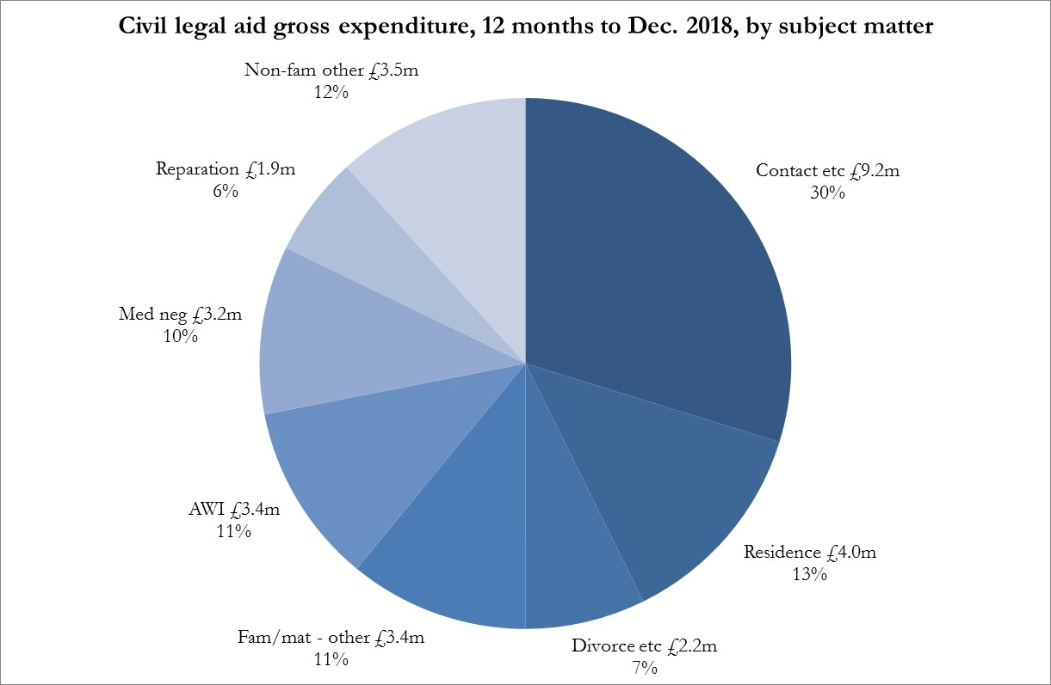

# Criminal legal assistance

## Criminal Advice and Assistance and Criminal Justice Act

1. The number of grants of criminal advice and assistance, including those under the Criminal Justice Act, in the 12 months to Dec’18 have increased 25% to 25,900 compared with the previous 12 months. A new system of advice & assistance under Part 1 of the Criminal Justice (Scotland) Act 2016 was implemented on 25 January 2018, bringing in new police station procedures and rights to legal advice by persons detained in police stations.
2. Previously solicitors could make use of the general advice & assistance scheme to consult with clients in police stations. In 2017 approximately 9100 intimations of A&A were received under the general scheme for police station work. In 2018 the combined figure for cases under the general scheme and under the new scheme was 15,500 which represents an increase of 70%.
3. The volume of weekly receipts of grants under the CJA scheme increased rapidly in the first few months of the scheme’s operation. While there is quite a lot of variation between weeks, the 6 weekly-trend seems to be stabilising around the 320 mark which is equivalent to approx. 16,600 per year, Figure 5 below. Non police station A&A fell 11% from 11,700 in 2017, to 10,500 in 2018.

Figure 5

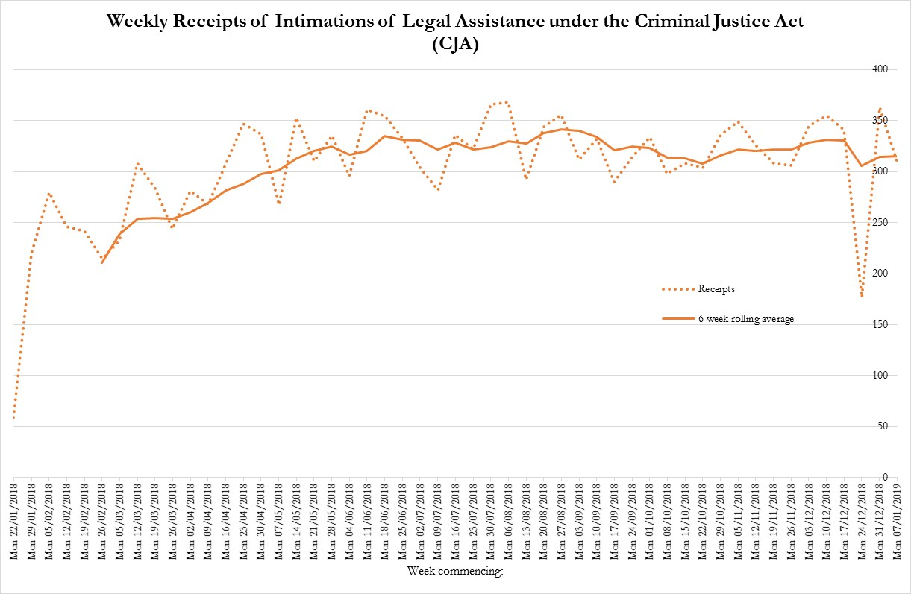

## Criminal Advice & Assistance & Criminal Justice Act Expenditure

1. Spending on criminal advice and assistance, including the Criminal Justice Act, in the 12 months to Dec’18 increased 101% to £2.0 million. Case numbers paid increased 60% and the average expenditure of a case increased 25% to £115.
2. This increase in the volume and average expenditure of these cases is expected because of the introduction of new legal assistance for the Criminal Justice Act. These cases are more costly than they were previously under A&A. The system has also been designed to be a lot easier for the profession to use and fee for – we are now seeing 96% of all CJA cases intimated by private firms to have been invoiced. We expected that a higher percentage of cases would be invoiced for and that they could be paid more quickly as well. All these factors have contributed to the increase in expenditure.

**Criminal ABWOR and Summary criminal legal aid**

1. For the 12 months to Dec’18 the number of criminal ABWOR intimations received has decreased 3% to 26,300. Within criminal ABWOR, intimations for summary complaint proceedings have fallen 5% to 16,350, whereas those for non- summary complaint proceedings (mostly breach matters) have increased slightly by 0.3%. See Figure 6 below.

Figure 6

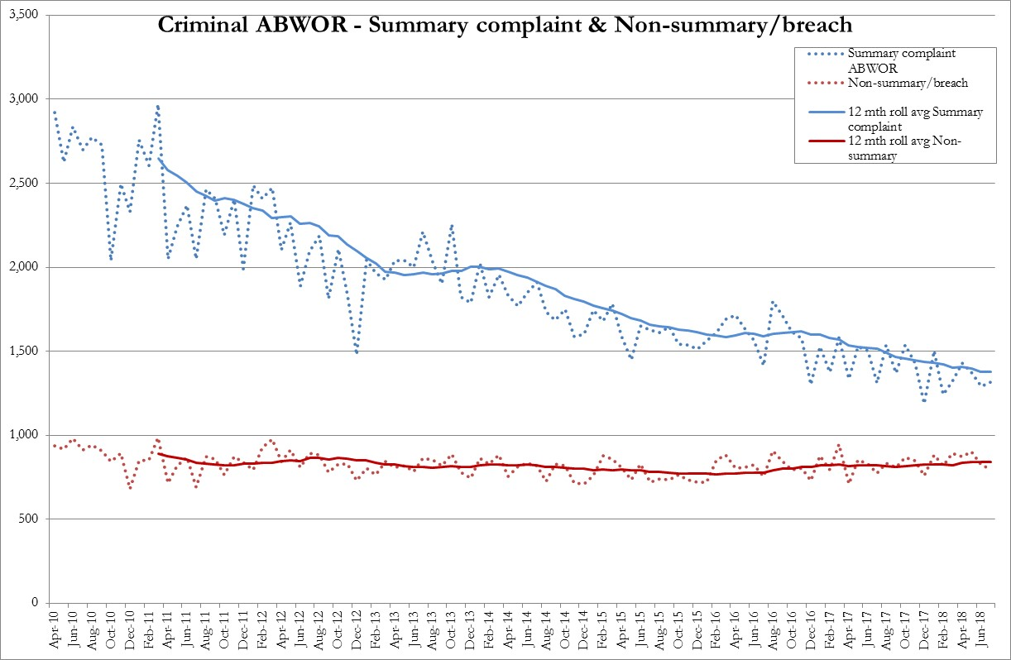

1. The decrease in summary complaint ABWOR has lessened from previous periods. The 12 month period to Mar’18 was 11% lower than the previous 12 months. Within summary complaint ABWOR there are big differences by subject matter. Theft cases are down 181 (-5%) to 3,800 and CJLA(Criminal Justice & Licensing Act cases)[1] are down 29% to 2,300.
2. At the same time Police & Fire cases[2] have increased 127% to 948 – i.e. more than doubled – from 417. Drugs cases have increased 9% to 1650. Within non-summary the largest changes have been in BRLO (Variation/revocation/breach of restriction of liberty order) up 19% to 1150, and DTTO (Drug treatment testing order) up 9% to 554. RCPO (Review of community payback order) decreased % to 2876.
3. The number of summary criminal applications received has decreased by 11% to 44,500 in the 12 months to Dec’18. The number of summary certificates has decreased by 9% to 39,800. Certificates issued for the JP court decreased 4% whereas those for the sheriff court fell 10%. The combined figure for intimations of ABWOR summary complaints plus summary grants has decreased 8% to 56,200.
4. The largest falls in summary certificates issued by subject matter were:

* Offensive weapons/vandalism/breach of the peace – down 12%;
* Assault – down 10%;
* Drugs – down 9%.

One subject matter saw a rise - Theft/housebreaking – up 1.5% to 5300 cases.

### **Criminal ABWOR & Summary Expenditure**

1. Spending on total criminal ABWOR in the 12 months to Dec’18 has fallen 8% to £10.6m. Fixed fee ABWOR (i.e. for summary complaints) fell 11% to £7.9m and the expenditure on time and line ABWOR rose 1.5% to £2.6m.
2. Expenditure on summary criminal legal aid has decreased 7% to £25.8 million. The number of cases paid has fallen 9% but the average cost has increased 2.2%. Even though these cases are mostly fixed fee the average cost may change for a number of reasons including a change in the mix of case court types or a change in the number of fee add-ons. Another reason is that cases may be granted exceptional status because of the nature of the case[3] allowing them to be paid on a time-and-line basis.
3. Less than 1% of summary cases receive applications for exceptional status. In 2017 we received 290 exceptional applications, i.e. just 0.58% of all summary applications, and 62% were granted. In 2018 we received 289 applications on a reduced number of summary applications so the percent received increased to 0.65%. The percent granted decreased slightly to 59%.

# Criminal legal aid in solemn & court granted cases

1. The number of applications for solemn criminal legal aid received is effectively level – 10951 in 2018 as opposed to 10935 in 2017. The number of solemn certificates issued has decreased 0.9% to 9,941 in the 12 months to Dec’18. The two largest falls by subject matter are:
   * Assault cases down 177 (-5%) to 3152 cases;
   * Theft/housebreaking is down 154 (-14%) to 947 cases.
2. The subject areas that are increasing the most are:
   * Drugs – up 11% (+120) to 1222 cases;
   * Bail (including breach of bail) certificates have increased by 28% (+104 cases) to 481;
   * Murder/attempted murder/culpable homicide up 19% (+54 cases) to 334.
   * Sexual offences have increased by 4% (+53 cases) to 1272.

### **Expenditure**

1. The total expenditure on solemn cases fell by 6% to £30.0 million in the 12 months to Dec’18. The number of cases paid decreased 11% on the previous 12 months; but there was a 6% increase in average case cost. Figure 7 below illustrates the expenditure by subject matter. Sexual offences remains the largest area by expenditure at 26% of the total.

Figure 7

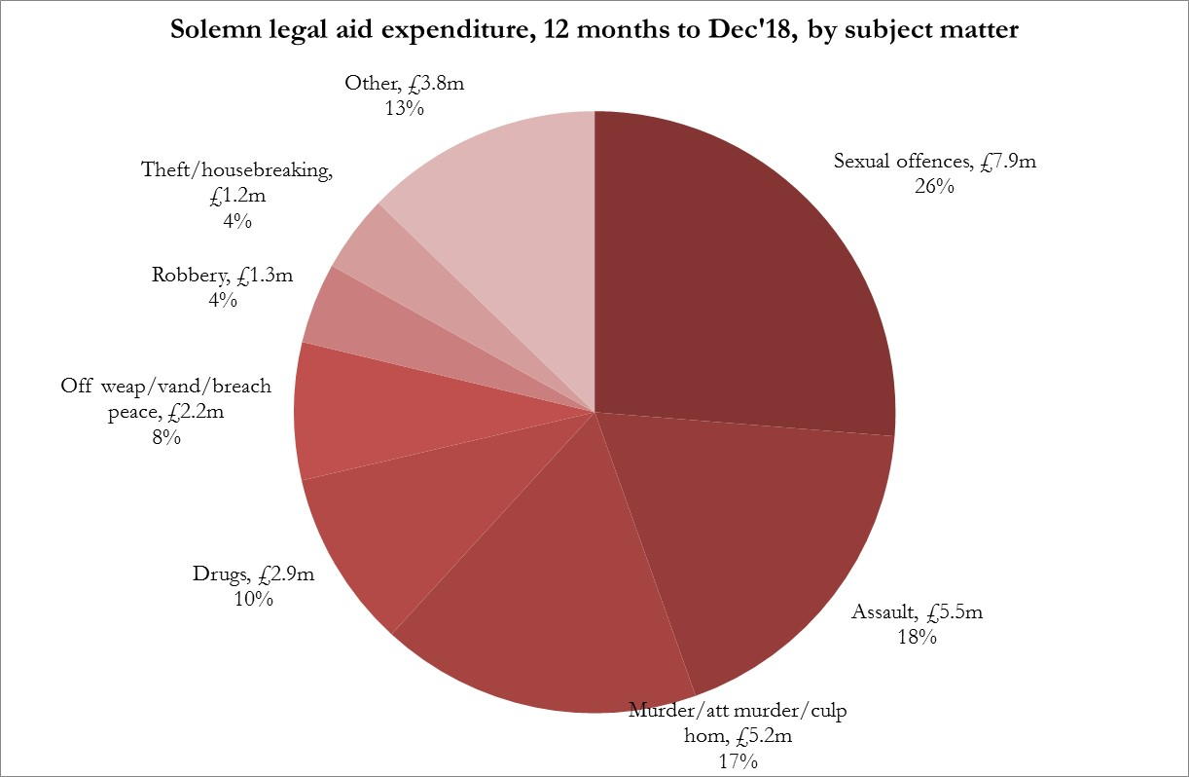

**Court granted legal aid**

1. There has been a 6% fall in the number of court grants received to 2700. This is primarily due to a 14% fall in the number of Domestic Court cases to 1173. There was a 13% rise in Section 22(1)(dd)[4] cases received from 152 to 172.

Other criminal legal aid expenditure

1. For the 12 months to Dec’18:

* the expenditure on appeals was down 10% to £1.2 million;
* expenditure on contempt of court is down 18% to £203,000;
* expenditure on duty decreased 13% to £744,000.

# Children’s legal assistance

1. This section is specifically about children’s legal assistance, which means legal assistance before, at and after children’s panel hearings and for related court proceedings[5]. Major changes came into force on 24 June 2013 that extended the scope and availability of legal assistance for children’s hearings. Under the previous arrangements, no form of legal aid or advice and assistance was available to enable a solicitor or counsel to represent a child or an adult at a children’s hearing.
2. The Children’s Hearings (Scotland) Act 2011 changed that and introduced a number of provisions relating to children’s legal assistance. In particular this established a scheme for legal representation to be provided, subject to certain tests, at children’s hearings and associated court proceedings under the label “children’s legal assistance”.

1. In addition responsibility for assessing entitlement to children’s legal aid was transferred from sheriffs to SLAB. In some circumstances children’s legal aid was made available automatically to a child without application of a legal merits or financial eligibility test.

## Children’s advice and assistance

1. For the 12 months to Dec’18 the number of grants of children’s A&A by solicitors decreased by 13% to 3900 grants (Figure 8 below). The downwards trends seen since winter 2014/15 is continuing.
2. Latest figures from the Scottish Children’s Reporters Association[6] (SCRA) show a similar downwards trend. The number of individual children/young people referred in 2017-18 was 13,250 a 12% decrease on the figures for 2016-17. The number of referrals fell by 6% to 25,131. Children and young people may have multiple referrals to the Reporter throughout the year. Police Scotland, who originate the large majority of all referrals, referred 8506 individuals with 18,836 referrals – an average of 2.2 per individual.

Figure 8

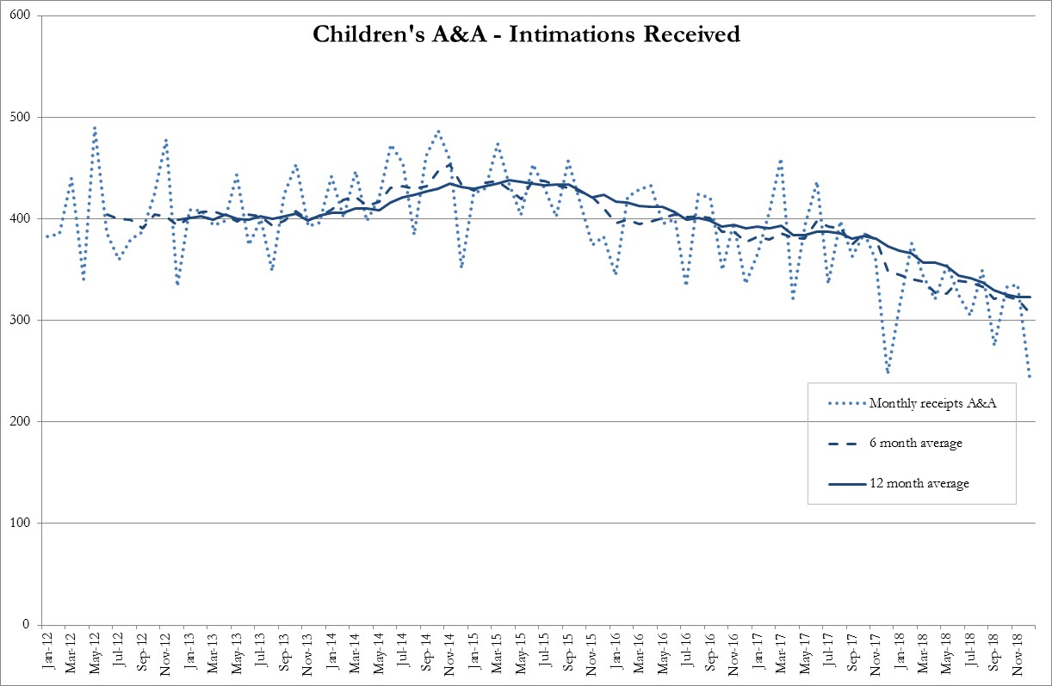

## 

## Children’s ABWOR and legal aid

1. Children’s ABWOR is available for representation at children’s hearings. The total number of children’s ABWOR cases registered in the 12 months to the end of Dec’18 was 4650. This was a 2.6% rise on the 12 months to Dec’17 – Figure 9 below.

Figure 9

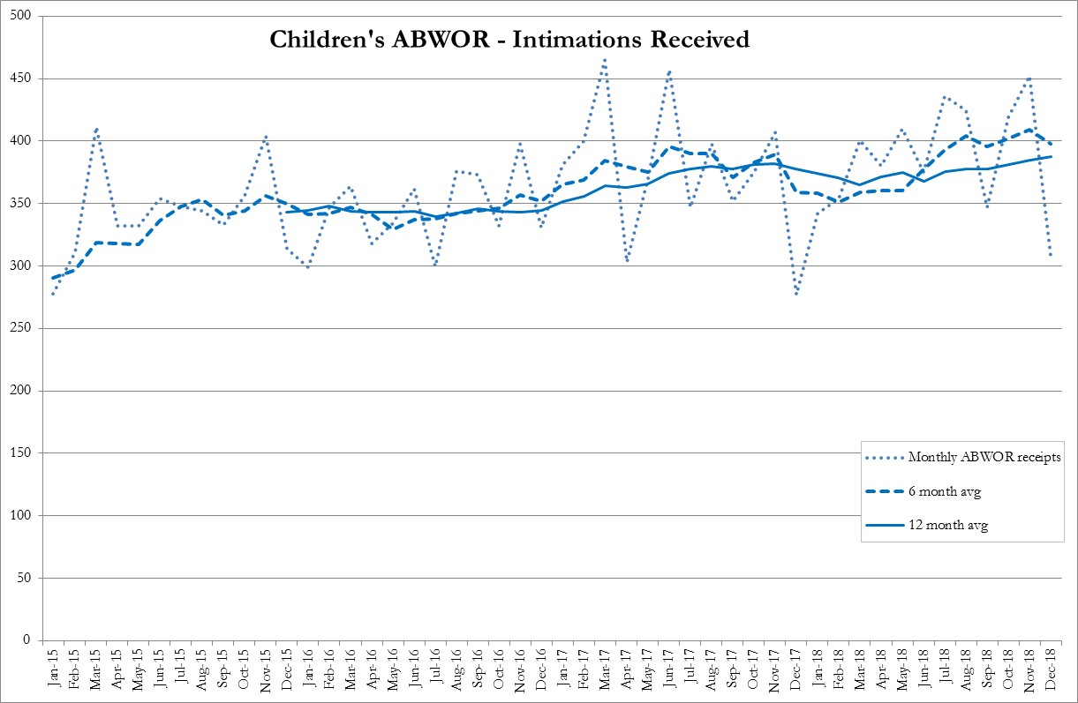

1. The number of applications for legal aid for Sheriff Court cases received in the 12 months to Dec’18 was 2662 which is a 7% decrease on the previous 12 months. The number of Sheriff Court cases granted in the 12 months to Dec’18 was 2261 which is an 8% decrease on the previous 12 months.
2. With the introduction of children’s ABWOR with the new act it is thought that fewer legal aid cases are having to be applied for as applicants now have representation at the children's hearings instead of being involved with appeals to the sheriff. If the volumes of Sheriff Court cases granted are combined with ABWOR volumes and compared with the previous 12 months we have seen a 1.2% decrease in volumes to 6910.

## Children’s Expenditure

1. The total children’s legal assistance expenditure decreased 6% to £5.3 million. Within this the cost of children’s advice and assistance fell 19% to £206,000. The total paid for children’s ABWOR cases rose 4%, to £2.4 million. The total paid for children’s sheriff court legal aid decreased 12% to £2.5 million.
2. Expenditure on children’s’ ABWOR is now almost the same as on legal aid for the sheriff court but the average cost of ABWOR cases is much less - £480 vs £1195. Accordingly a far greater number of cases can be paid for the same overall cost – 4993 cases were paid under ABWOR in 2018 compared with 2076 sheriff court cases.

|  |  |
| --- | --- |
|  | **Governance Links** |
| 1 | Finance and Resources  N/A |
| 2 | Risk  Our analysis of trends is our key mitigation for one of our corporate risks:  Risk 5: Leadership and management does not respond to changing trends in legal assistance, including impact on workforce planning.  Trend analysis also provides valuable insight to enable us to manage our other corporate risks concerned with failure to deliver improvements in legal aid processes that deliver improvements and efficiencies. |
| 3 | Legal and Compliance  N/A |
| 4 | Performance  The paper provides a context within which performance information can be assessed. Some of the analysis supports and extends on points within the Performance paper. As the general trend is one of falling volumes there should be a positive impact on performance. |
| 5 | Equalities Impact  N/A |
| 6 | Privacy Impact and Data Protection  N/A |
| 7 | Communications and Engagement  This paper has been agreed for publication. Trends issues for external or internal communication are considered as appropriate. For example, we have just published an article on our intranet on a recent Scottish Government update on the latest Scottish criminal proceedings statistics. |

|  |
| --- |
| **Conclusion and next steps** |
| We have been unable to prioritise investigations into the fall in benefit appeals. If this remains a matter of interest to the Board we can take it forwards to the next Trends Update. |

|  |
| --- |
| **Appendices/Further Reading** |
| N/A |

1. Most cases here are under Section 38 Threatening and abusive behaviour.
2. Police and Fire Reform (Scotland) Act 2012 – typically assaulting or resisting, obstructing or hindering police officers or staff.
3. The factors taken into account by SLAB in considering whether a case should be exceptional include – the number, nature and location of witnesses; the number and nature of productions; the complexity of the law (including procedural complexity); whether the assisted person, or any witnesses, may be unable to understand the proceedings because of age, inadequate knowledge of English, mental illness, other mental or physical disability or otherwise.
4. an appointment of a solicitor by the court to a person accused of a sexual offence under section 288D of the 1995 Act, or under section 288E where an order has been made prohibiting the personal conduct of the defence in certain cases involving child witnesses under the age of 12, or under section 288F in other cases involving vulnerable witnesses, or in connection with a trial in absence under sections 92(2), (2B)(b) or (2E) of the 1995 Act (solemn).
5. Civil or criminal legal assistance, as opposed to children’s legal assistance, is available for children involved in civil or criminal legal proceedings. Those figures are not included in this section.
6. <https://www.scra.gov.uk/resources/?type=statistics>