Report No: SLAB/2021/19
Agenda Item: 09

Report to: | The Board
Meeting Date: | 17th May 2021
Report Title | Trends Update May 2021
Report Category | For Information
Issue status: | Business as usual

Written by: | Matt Taylor
Director responsible: | Anne Dickson
Presented by: | Matt Taylor
Contact details: | taylorma@slab.org.uk

Delivery of Strategic Objectives
Select the Strategic Objective(s) relevant to the issues | - We deliver a high quality user focussed service  - We embed ways of working across the organisation that enhance the quality, consistency and transparency of our decisions and delivery  - We engage with users and delivery partners across the legal aid and justice system to inform good design of our system and services

Link to Board or Committee Remit
This information enables the Board to understand the environment that the organisation is operating in. It influences strategic direction and is a key element of oversight.

Publication of the Paper
The Board has previously agreed that this paper should be published as a matter of course. It will be published on our website with the other relevant papers from this meeting.

Executive Summary
Many application types are now at the same level as 19-20 or higher, notably mental health ABWOR, civil legal aid, police station advice, sheriff summary, and solemn.

Payments remain similar to the lower level of 20-21. The use of interim fee accounts in civil, and especially solemn, legal aid in 20-21 has increased considerably compared with 19-20.

Previous Consideration
Meeting | Detail
Board – Dec 2020 | Many application areas had recovered on a weekly basis. Large cumulative differences remained apart from in solemn criminal which was 10% up on 2019. Payments levels were well down on 2019.

Report

Introduction

The environment in which legal aid operates has seen considerable change over the past year. To illustrate current trends the reporting is using a weekly period basis for analysis but this is set in the context of the last 2 years.

Weekly application volumes received, and payments made, in 2021/22 are compared with the 2 previous years:
- 2019/20 as the last Normal year is defined as the 52 weeks from w/c 01-Apr-19 to w/c 23-Mar-20;
- 2020/21 as Pandemic Year 1 is defined as the 52 weeks from w/c 30-Mar-20 to w/c 22-Mar-21.

The 2 previous years are shown as 52-week averages so are horizontal lines. A 2 week current average has been used as the basis for comparing the current year with the 2 previous years. The relative colouring has stayed the same. I.e. blue is the current year – now 21/22. Orange is last year and black is the year before.

The horizontal axis shows weeks (w/c Monday), w/c 26 Apr is the week ending on Sunday 2nd May 2021.

Civil Applications

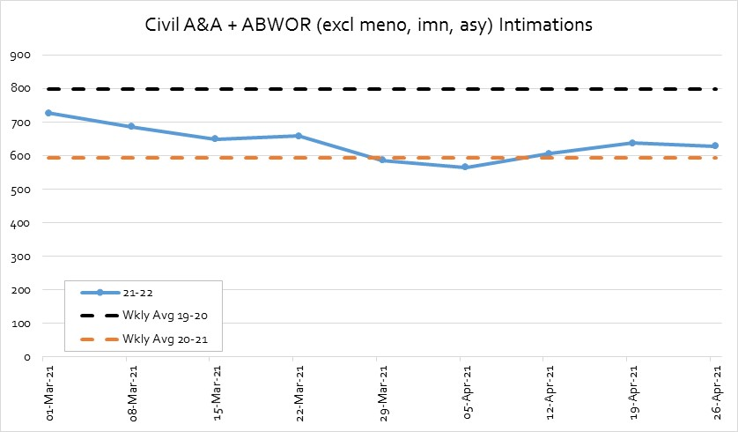 | Civil A&A and ABWOR combined excl mental health & immigration/asylum.  20/21 volumes are 26% below 19/20 volumes.  Avg volumes are currently 79% of 19/20 and 107% of 20/21.
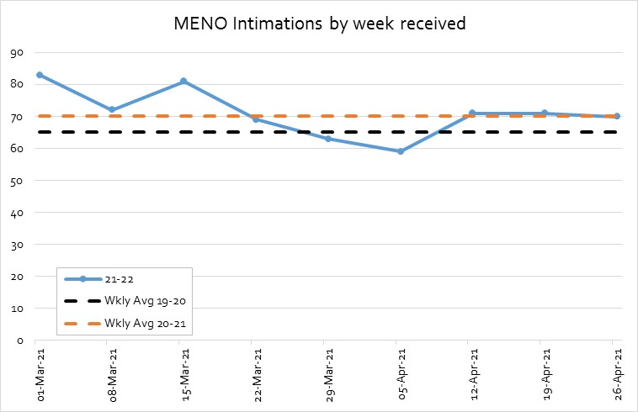 | Mental health A&A/ABWOR  20/21 volumes are 8% above 19/20 volumes.  Current level is 108% of 19/20 and 100% of 20/21.
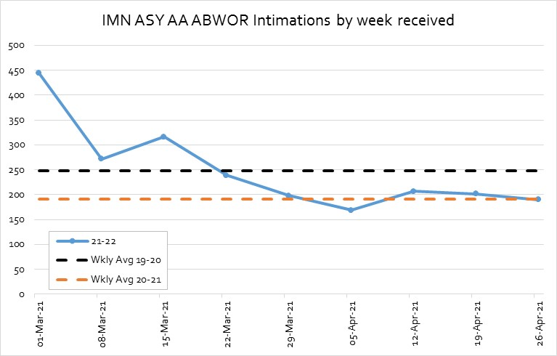 | Immigration/asylum A&A/ABWOR  20/21 volumes are 23% below 19/20 volumes.  Current level is 79% of 19/20 and 103% of 20/21.
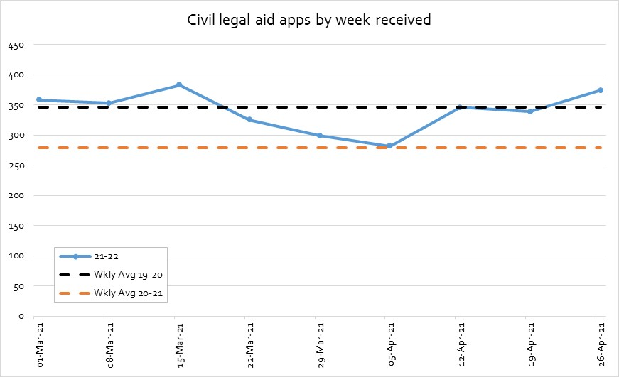 | Civil Legal Aid ALL  20/21 volumes are 20% below 19/20 volumes.  Now at 103% of 19/20 levels and 128% of 20/21.
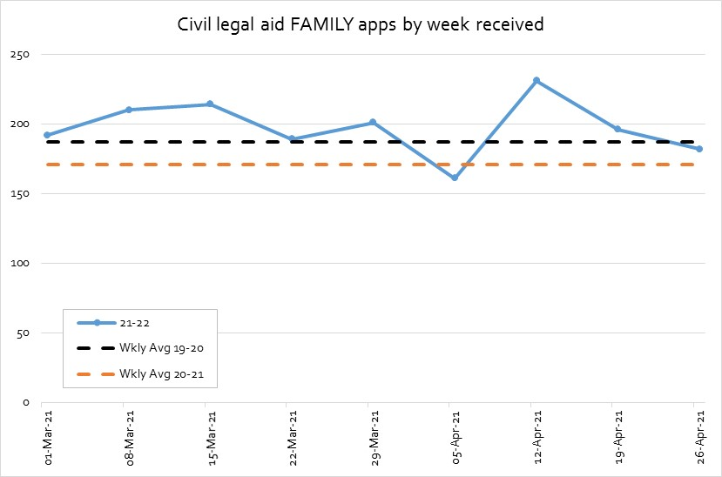 | Civil Legal Aid FAMILY only  20/21 volumes are 9% below 19/20 volumes.  Currently at 101% of 2019/20 levels and 111% of 20/21.
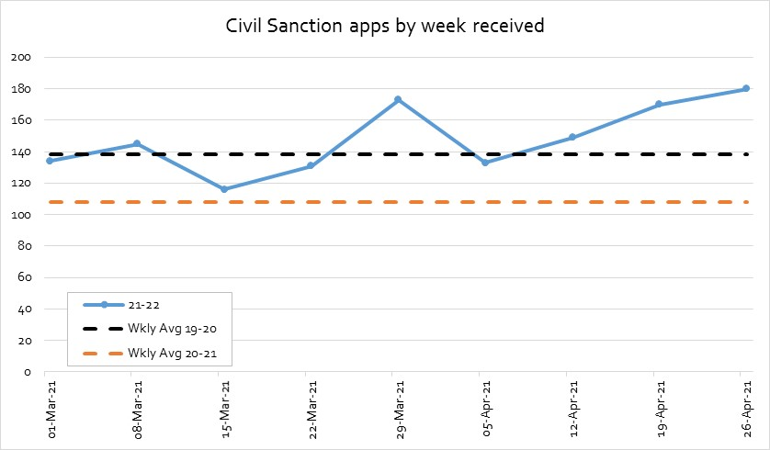 | Civil Sanction  20/21 volumes are 22% below 19/20 volumes.  Two wk avg currently 126% of 19/20 and 162% of 20/21.
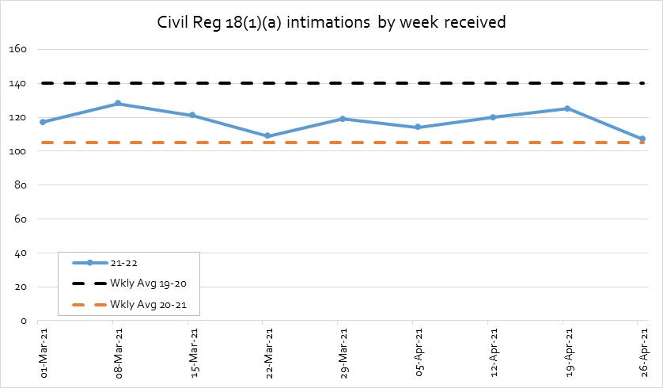 | Civil Reg 18(1)(a)  20/21 volumes are 25% below 19/20 volumes.  Two wk avg is currently 83% of 19/20 and 111% of 20/21.
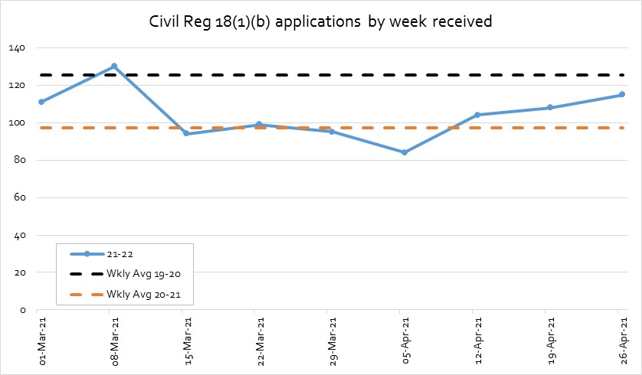 | Civil Reg 18(1)(b)  20/21 volumes are 23% below 19/20 volumes.  Two wk avg is currently 89% of 19/20 and 115% of 20/21.
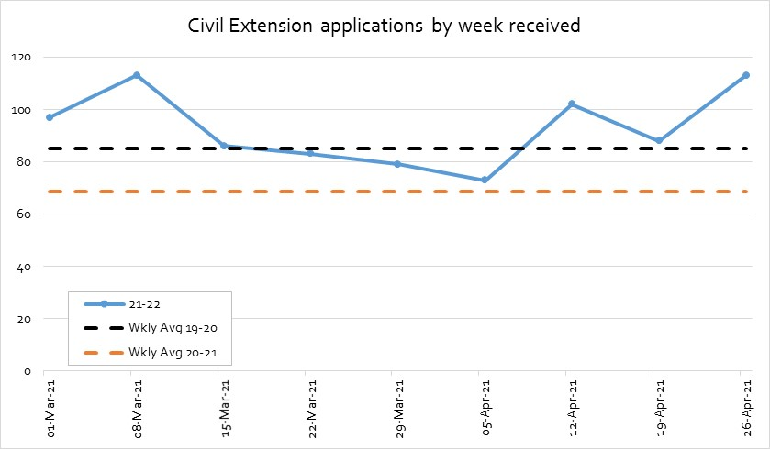 | Civil Extension Apps  20/21 volumes are 20% below 19/20 volumes.  Two wk avg is currently 118% of 19/20 and 147% of 20/21.

Criminal Applications

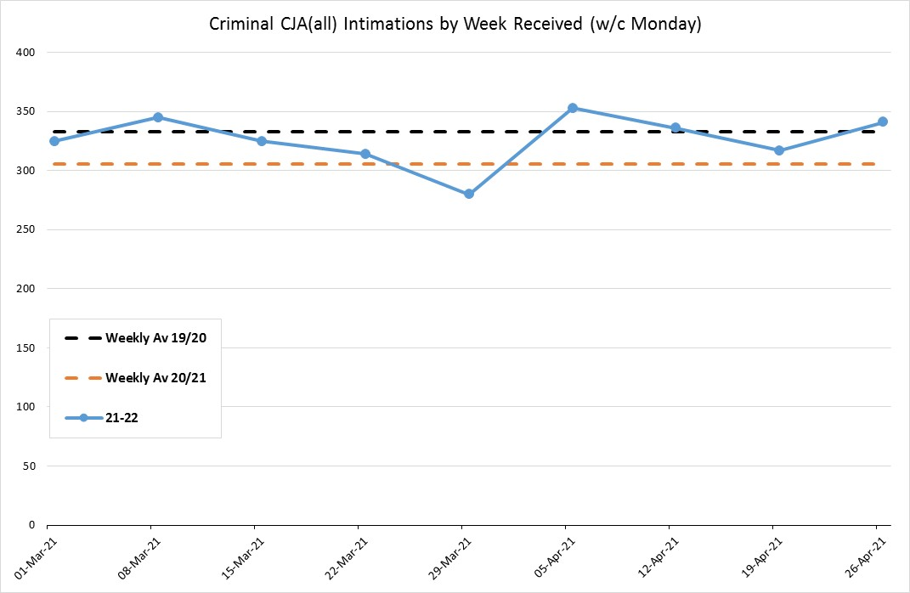 | All CJA Intimations Received [Police Station]  20/21 volumes are 8% below 19/20 volumes.  Two wk avg currently 104% of 19/20 and 113% of 20/21.
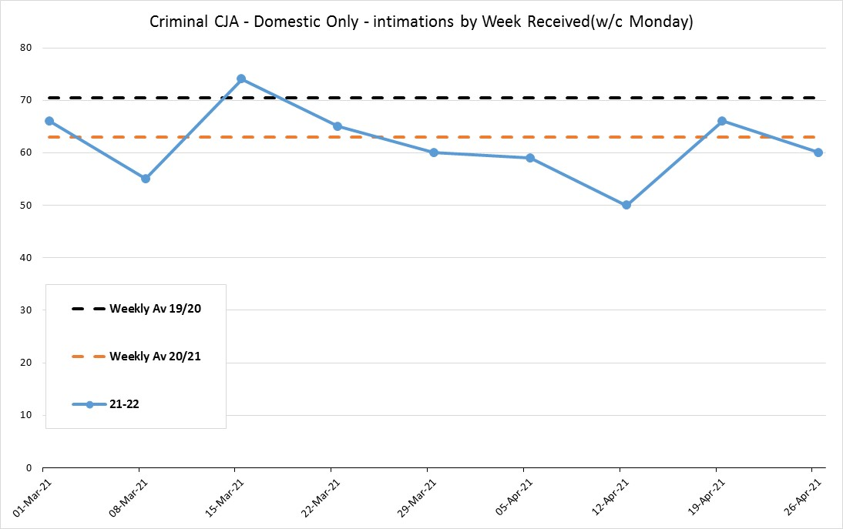 | CJA Intimations Received – Domestic Only  20/21 volumes are 23% below 19/20 volumes.  Two wk avg currently 77% of 19/20 and 87% of 20/21.
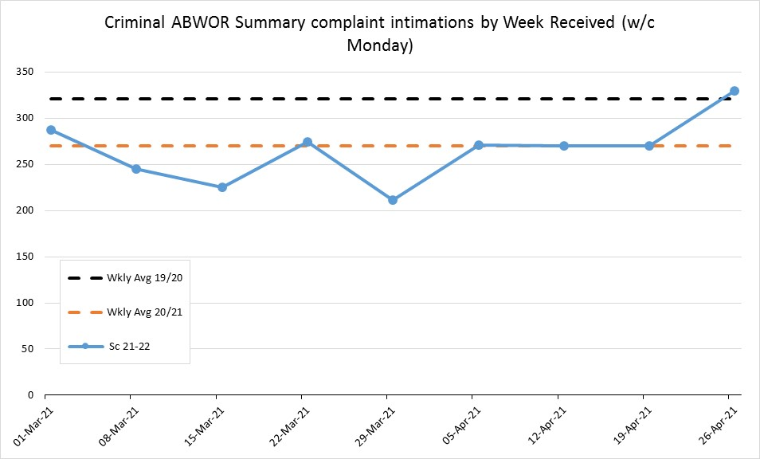 | ABWOR summary complaint  20/21 volumes are 16% below 19/20 volumes.  Two wk avg currently 93% of 19/20 and 111% of 20/21.
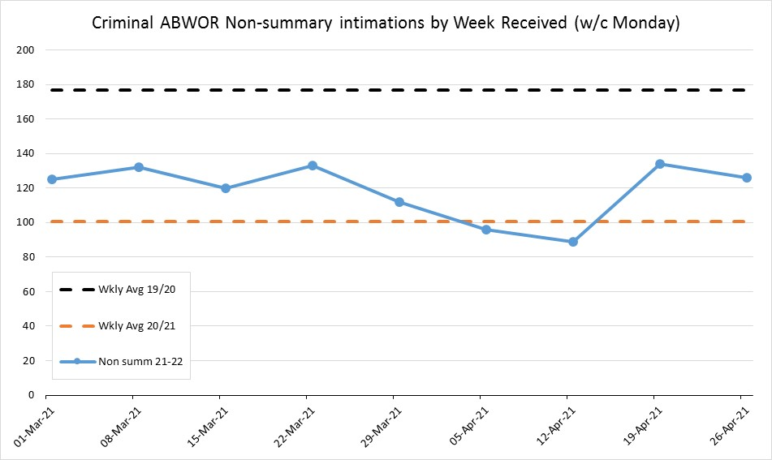 | ABWOR non-summary  20/21 volumes are 43% below 19/20 volumes.  Two wk avg currently 74% of 19/20 and 129% of 20/21.
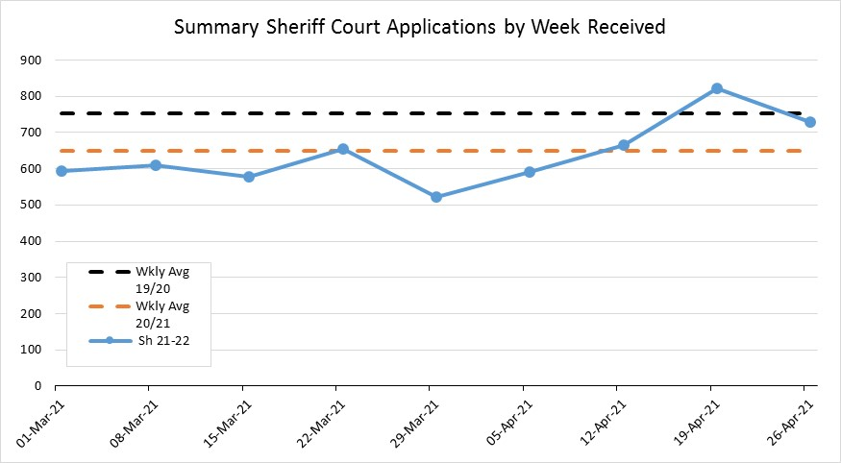 | Summary Sheriff  20/21 volumes are 14% below 19/20 volumes.  Two wk avg currently 103% of 19/20 and 119% of 20/21.
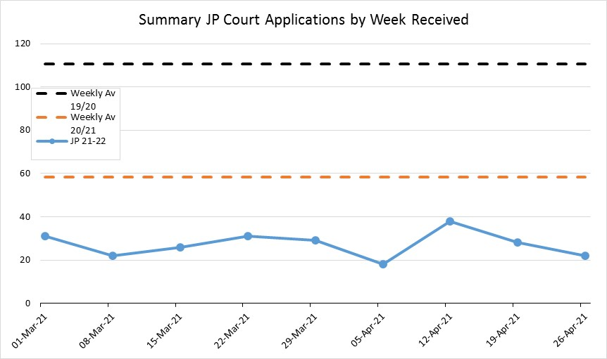 | Summary JP  20/21 volumes are 47% below 19/20 volumes.  Two wk avg currently 23% of 19/20 and 43% of 20/21.
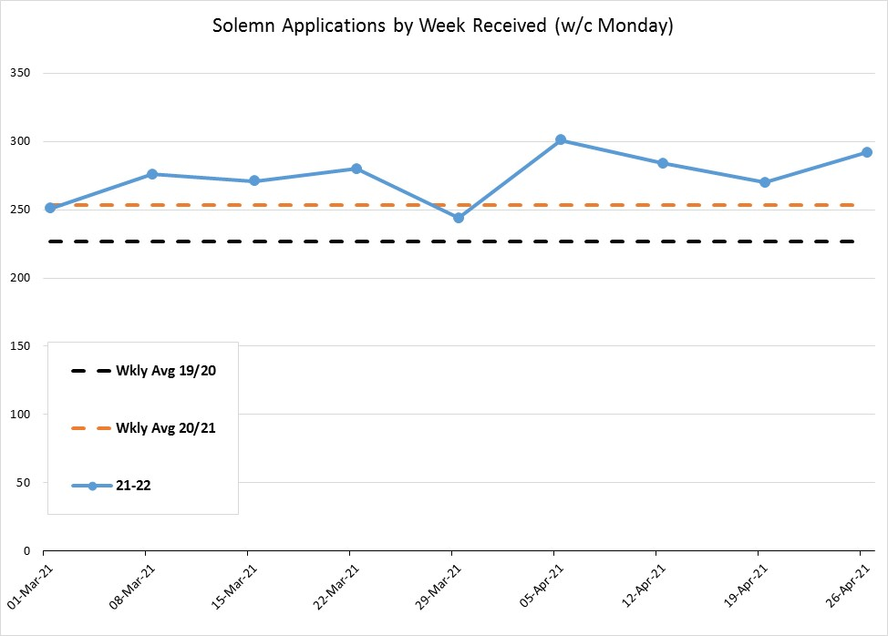 | Solemn applications  20/21 volumes are 12% above 19/20 volumes.  Two wk avg currently 124% of 19/20 and 111% of 20/21.
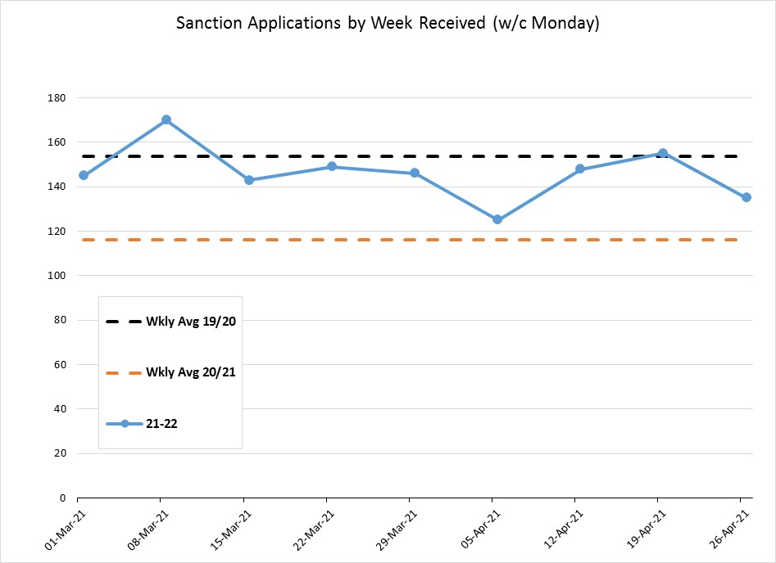 | Sanction applications  20/21 volumes are 24% below 19/20 volumes.  Two wk avg currently 94% of 19/20 and 125% of 20/21.
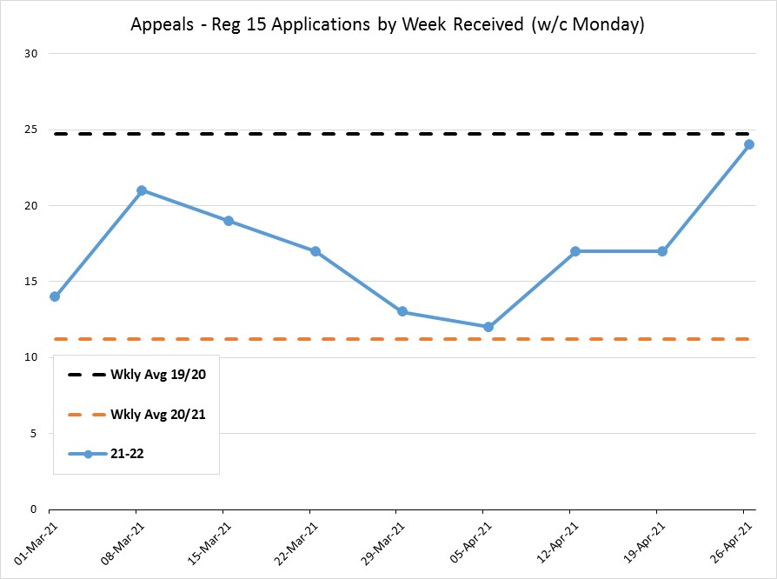 | Criminal Appeals – Reg 15 apps.  20/21 volumes are 55% below 19/20 volumes.  Two wk avg currently 83% of 19/20 and 183% of 20/21.

Children’s Applications
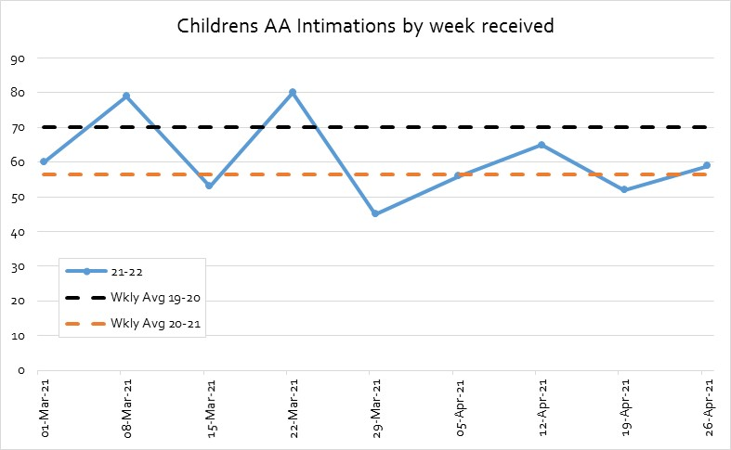 | Children’s A&A  20/21 volumes are 20% below 19/20 volumes.  2 week avg volumes are currently 79% of 19/20 and 98% of 20/21.
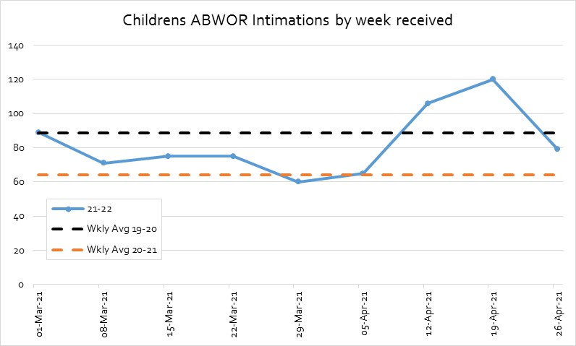 | Children’s ABWOR  20/21 volumes are 28% below 19/20 volumes.  Two week average volumes are currently 112% of 19/20 and 155% of 20/21.
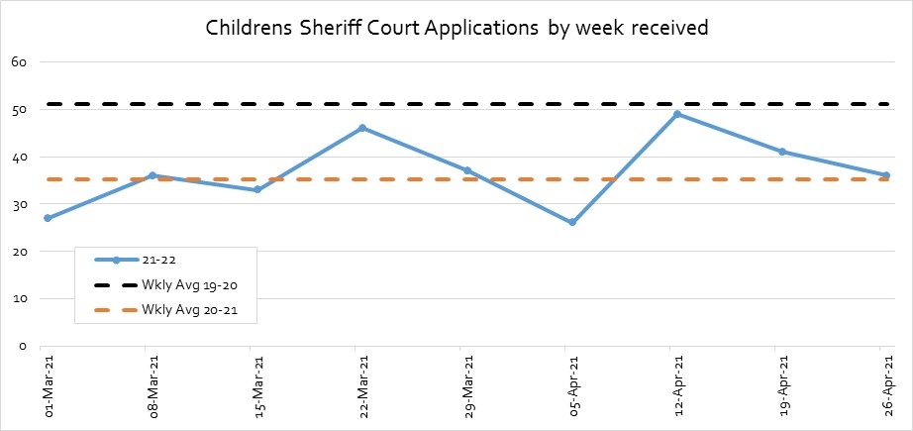 | Sheriff Court Applications  20/21 volumes are 31% below 19/20 volumes.  Two week average volumes are currently 75% of 19/20 and 109% of 20/21.

Payments

Payments made are firm fees exc VAT. They are solicitor and solicitor-advocate fees paid directly to firms.
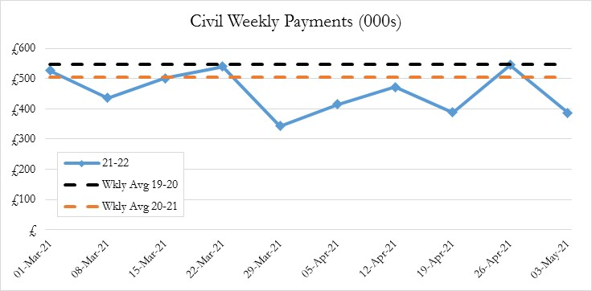 | Civil Payments  20/21 payments are 8% below 19/20 payments.  2 week avg payments are currently 85% of 19/20 and 93% of 20/21.
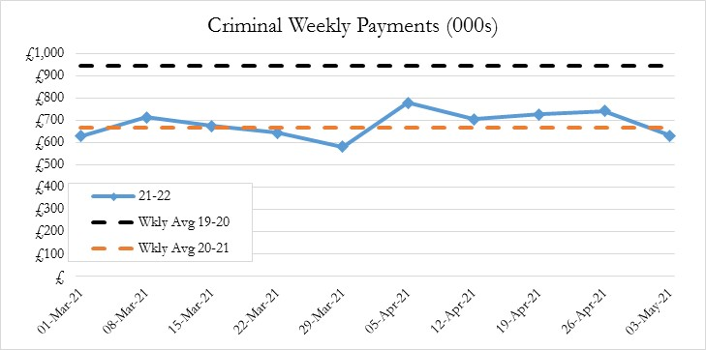 | Criminal Payments  20/21 payments are 30% below 19/20 payments.  Two week average payments are currently 72% of 19/20 and 103% of 20/21.
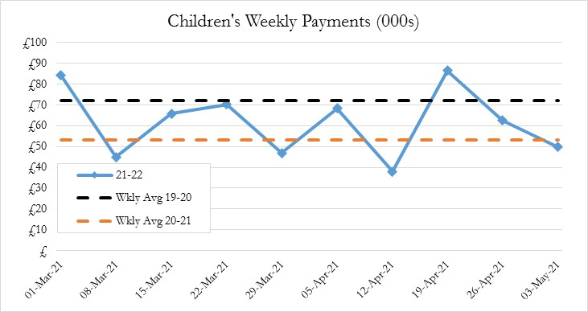 | Children’s Payments  20/21 payments are 26% below 19/20 payments.  Two week average payments are currently 78% of 19/20 and 105% of 20/21.
Total Payments

20/21 payments are 22% below 19/20 payments.

Two week average payments are currently 77% of 19/20 and 99% of 20/21.

Use of Interim Fee Accounts

The use of interim fee accounts has been of importance during the pandemic to help firms with their cash flow management.

Analysis was conducted of active civil and solemn legal aid granting firms in 2020/21 compared with 2019/20. An active firm was defined as having made 5 or more grants of legal aid in the year.

In 19/20 54% of active civil firms made use of the interim fees system. This increased to 63% in 20/21. Tables 1 & 2 below.

It can also be seen that the total number of civil certificates granted fell by 18%. This fall was most pronounced amongst the largest firms (band C) i.e. those granting more than 30 certificates as year. There was a 6% fall in the overall number of firms granting civil legal aid (from 476 to 449) but there was an 18% fall in the number of firms in band C, from 159 to 130.

Table 1: Use of Interim Fee Accounts in Civil in 19/20
Num Certs Banded | Count of Firm Code | % of firms | Sum of Num Civil Certs | % of certs | Sum of Use of Interims | % using interims
A) < 5 | 95 | 20% | 204 | 1% | 10 | 11%
B) 5 - 30 | 222 | 47% | 3490 | 24% | 88 | 40%
C) 31+ | 159 | 33% | 10964 | 75% | 118 | 74%
Grand Total | 476 | 100% | 14658 | 100% | 216 | 45%
B&C | 381 | 80% | 14454 | 99% | 206 | 54%

Table 2: Use of Interim Fee Accounts in Civil in 20/21
Num Certs Banded | Count of Firm Code | % of firms | Sum of Num Civil Certs | % of certs | Sum of Use of Interims | % using interims
A) < 5 | 90 | 20% | 198 | 2% | 19 | 21%
B) 5 - 30 | 229 | 51% | 3284 | 27% | 121 | 53%
C) 31+ | 130 | 29% | 8576 | 71% | 105 | 81%
Grand Total | 449 | 100% | 12058 | 100% | 245 | 55%
B&C | 359 | 80% | 11860 | 98% | 226 | 63%

In 19/20 only 6% of active solemn firms made use of the interim fees system. This increased considerably to 47% in 20/21. Tables 3 & 4 below.

In contrast with civil legal aid it can be seen that the total number of solemn certificates granted increased by 13%. This increase was most pronounced amongst the largest firms (band C) i.e. those granting more than 30 certificates as year. There was an 8% fall in the overall number of firms granting solemn legal aid (from 356 to 328) but there was a 9% increase in the number of firms in band C, from 127 to 139.

The concentration of certificates in band C solemn firms increased from 78% to 81% in 2020-21. The largest solemn firm in 2019/20 granted 283 solemn certificates. The same firm remained the largest solemn firm in 2020/21 and they granted 342 solemn certificates.

Table 3: Use of Interim Fee Accounts in Solemn in 19/20
Num Certs Banded | Count of Firm Code | % of firms | Sum of Num Sol Certs | % of certs | Sum of Use of Interims | % using interims
A) < 5 | 83 | 23% | 172 | 2% | 0 | 0%
B) 5 - 30 | 146 | 41% | 2222 | 20% | 4 | 3%
C) 31+ | 127 | 36% | 8479 | 78% | 12 | 9%
Grand Total | 356 | 100% | 10873 | 100% | 16 | 4%
B&C | 273 | 77% | 10701 | 98% | 16 | 6%

Table 4: Use of Interim Fee Accounts in Solemn in 20/21
Num Certs Banded | Count of Firm Code | % of firms | Sum of Num Sol Certs | % of certs | Sum of Use of Interims | % using interims
A) < 5 | 62 | 19% | 123 | 1% | 9 | 15%
B) 5 - 30 | 127 | 39% | 2157 | 18% | 46 | 36%
C) 31+ | 139 | 42% | 10012 | 81% | 78 | 56%
Grand Total | 328 | 100% | 12292 | 100% | 133 | 41%
B&C | 266 | 81% | 12169 | 99% | 124 | 47%

The use of interim fee accounts increases in both years and both aid types as firm activity increases.

PDSO & CLAO have been excluded from this analysis of interim fees.

Notes

The figures in this management report are draft figures. Headline application & grant volumes are rounded to two significant figures. Payment values are also rounded to two or three significant figures and always include VAT unless otherwise stated.

Figures for applications and grants do include PDSO, CLAO & SCL. But the payments do not include payments for block-allocated funding such as CLAO, PDSO or grant funding.

 | Governance Links
1 | Finance and Resources  N/A
2 | Risk  Our analysis of trends is our key mitigation for one of our corporate risks:  Risk 5: Leadership and management does not respond to changing trends in legal assistance, including impact on workforce planning.  Trend analysis also provides valuable insight to enable us to manage our other corporate risks concerned with failure to deliver improvements in legal aid processes that deliver improvements and efficiencies.
3 | Legal and Compliance  N/A
4 | Performance  The paper provides a context within which performance information can be assessed. Some of the analysis supports and extends on points within the Performance paper.
5 | Equalities Impact  N/A
6 | Privacy Impact and Data Protection  N/A
7 | Communications and Engagement  This paper has been agreed for publication. Trends issues for external or internal communication are considered as appropriate.

Appendices/Further Reading
None.

Weeks are defined as week commencing w/c Monday.
I.e. they had been paid for at least 1 interim fee account.

